1st Class Work 25th-29nd May
1st Class Group (Buddies)
Monday
- RAH p. 114 and answer comprehension questions fully in copy
- Spellings List 12 (4 spellings per day, put words into sentences)
- Exercise Your English p.69 Write out B 6-10 in your copy (Remember your date and heading)
- Irish reading p. 46 (I have emailed an audio clip of me reading to help with pronunciation)
- Revision of +1, -1 tables and finish your tables book this week if you have not done so already.
- Maths: Number- Go to p. 118 of your book (hopefully you will have your books by now) Ask the following questions:
  - Q. 1- How many tens are in the number?(7)
  - Give me another name for 7 tens (70)
  - How many units are in the number? (7)
  - What is the correct name for 7 tens and 7 units? (77)-do the same for the rest of the questions.
  - Now do number 1 and 2 in your book.
Complete activity online.
  - Go to the following link- https://my.cjfallon.ie/dashboard/student-resources
  - Fill in the areas on top- Level: Primary, Class: 1st class, subject: Maths, series: Busy At Maths, title; busy At Maths 1st class.
  - From there scroll to weblink- activity 118A. This will play an interactive game for the children based on tens and units.

Tuesday
- RAH p. 115 and answer comprehension questions fully in copy
- Spellings List 12 4 spellings per day ( put words into sentences)
- Exercise Your English p. 71 A and B (if you have your book you can write into it)
- Irish reading p. 47 (I have emailed an audio clip of me reading to help with pronunciation)
- Revision of +1, -1 tables
- Maths: Number- Look at p. 119 of your book. Point to the first row of the grid in q. 1 (a) and ask the following questions
  - What is the first number shown in the first row? (6 units or 6)
  - What is the second number shown in the first row? (6 tens or 60)
  - What is the third number shown in the first row? (60)
  - Which of the three numbers are the same/have the same value?
  - Which of the three numbers is the odd one out? Why? - 6 units is the odd one out as the other two numbers represent 60.
  - Ask the above qs for b-j
  - Now, complete q. 1 in your book.
  - Do the online activity 119A-https://my.cjfallon.ie/dashboard/student-resources

Wednesday
- RAH p. 116 and answer comprehension questions fully in copy
- Spellings List 12 4 spellings per day ( put words into sentences)
- Exercise Your English p. 71 C (write into your book if you have it)
- Irish reading p. 48 (I have emailed an audio clip of me reading to help with pronunciation)
- Revision of +2, -2 tables
- Maths: Number p. 119 of book-look at q. 2 and ask the following questions:
  - What is the first number shown? (56)
  - What is the value of the six? (units)
  - What is the value of the five? (tens)
  - What is the written word? (six)-so we circle the digit 6. Complete q. 2 in your books

Thursday
- RAH p. 117 and answer comprehension questions fully in copy
- Spellings List 12 4 spellings per day ( put words into sentences)
- Exercise Your English p. 72 Read The Story of the Dragonfly and answer qs 1-6 of p. 73 in your book
- Irish reading p. 46, 47, 48 (I have emailed an audio clip of me reading to help with pronunciation)
- Revision of +2, -2 tables
- Maths: Revision
  - Complete 1-20 on p. 120 of your book.

Friday
- Revise RAH stories from the week and pick one WOW word from each story and put each word in a sentence. Take a photo and send it to me.
- Revise spellings from the week and complete the following dictation test:
  - I sang along with the gang.
  - Who would like to bang on the drum?
  - Who rang the doorbell?
  - I use my rubber to rub out words I spell wrong.
- Do a tables test based on +1, -1, +2, -2.
- Art: Making a Mandala using nature.
  - Go to the following link
https://childhoodbynature.com/mandalas-a-practically-perfect-form-of-nature-art/
Here is an example:
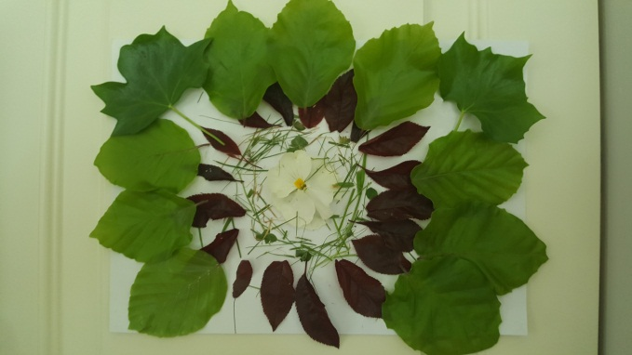

Online Resources
- Twinkl- suitable for all classes
Twinkl are offering all parents a One Month FREE Ultimate Membership to Twinkl.ie. This will allow parents unlimited access to every single resource for every single curriculum subject from Junior Infants to Sixth Class- www.twinkl.ie/offer

- World Book- suitable for all classes

The World Book is a resource offered by the PDST. It’s like a virtual encyclopedia except a lot more interactive.
https://www.worldbookonline.com/wb/products?ed=all&gr=Welcome%21

- https://www.scoilnet.ie/- Scoilnet Primary is another website with a wealth of worksheets and topics for researching.

- Oxford Owl Ebook Reader Library - Junior Infants to 2nd Class
Oxford Owl has an ebook library with over 250 books in it and offers free access to parents once you create an account at www.oxfordowl.co.uk They also have some vocabulary and comprehension activities for most of the books.

- https://www.vooks.com/ is another reading resource

- Mathletics
Join Mathlethics. This is a website packed full of maths games. Children can play against each other and work on all the skills that they will have already covered this year!!- https://login.mathletics.com
- Multiplication.com- suitable from 3rd class up- http://www.multiplication.com
- Top Marks - suitable for all levels
https://www.topmarks.co.uk/

