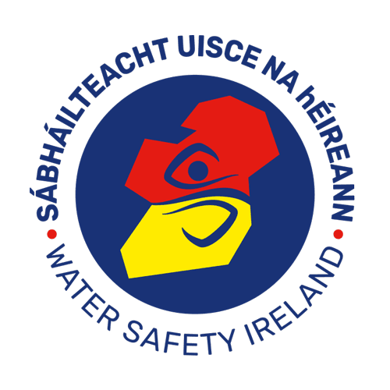
I hope you enjoy these lessons. Stay safe around water.

Have a look at this video:
https://youtu.be/-t6hiNyf58g

For water safety Lessons for 1st and 2nd Class click on the following link:
https://watersafety.ie/wp-content/uploads/2019/10/Land-PAWS-Lesson-2-LP.pdf

For water safety Lessons 3rd Class click on the following link:
https://watersafety.ie/wp-content/uploads/2019/10/Land-PAWS-Lesson-3-LP.pdf

