2nd Class (Amigos) 25th-29th May 2020
Monday
- RAH p. 115 read and answer comprehension questions fully in English homework copy
- Spellings List 30 (4 words per day and put words into sentences)
- Cairde Le Chéile lch. 54 Eilifint
  - Answer the following questions orally:
    - Cén dath atá ar an eilifint? Tá an eilifint…
    - Cad a ólann sí? Ólann sí…
    - Cad a itheann sí? Itheann sí…
- Fuaimeanna lch. 62 An Aimsir box 1 Scríbhneoireacht lch. 62
- Wordwise p. 62 Phonics tch words
  - Read A and write out B in your copy. (Remember your date and heading)
- Learn the prayer after Communion 4th verse:
I’m ready now, Lord Jesus,
To show how much I care.
I’m ready now to give your love
At home and everywhere.
Amen.

- Revise +1, -1 tables
- Maths: Subtraction p. 136
- Go to link https://my.cjfallon.ie/dashboard/student-resources Interactive 136A

  - Click the Tutorial 18 tab and watch the tutorial.
  - Switch back to activity 136A tab and play game.

Tuesday
- RAH p. 116 read and answer comprehension questions fully in your copy.
- Spellings List 30 (4 words per day and put words into sentences)
- Cairde Le Chéile lch. 54 Eilifint
- Fuaimeanna lch. 62 An Aimsir box 2 Scríbhneoireacht lch. 63
- Learn the prayer after Communion 4th verse:
I’m ready now, Lord Jesus,
To show how much I care.
I’m ready now to give your love
At home and everywhere.
Amen.

- Revise +1, -1 tables
- Wordwise p. 63 Jumbled Sentences
  - Write out the sentences in your copy so that they make sense. (Remember your date and heading)
- Maths: Subtraction- open p. 136 of your book. Look at the first picture and ask the following questions:
  - How many loose lollipop stick are there? (6)
  - How many groups of 10 lollipop sticks are there? (1)
  - How many lollipop sticks are there altogether? (16)
  - So, one ten and six units is the same as 16 units.
  - Ask the above qs for no. 1 and 2 on this page.
  - Complete p. 136 in your book.

- Wednesday
- RAH p. 117 read and answer comprehension questions fully in English homework copy
- Spellings List 30 (4 words per day and put words into sentences)
- Cairde Le Chéile lch. 54 Eilifint
- Fuaimeanna lch. 62 An Aimsir box 3
- Learn the prayer after Communion 4th verse:
I’m ready now, Lord Jesus,
To show how much I care.
I’m ready now to give your love
At home and everywhere.
Amen.

- Revise +2, -2 tables
- Wordwise p. 64 The Wishes
  - Read the story and answer A 1-6 in your copy. ( Remember your date and heading).
- Maths: Subtraction p. 137
Go to link https://my.cjfallon.ie/dashboard/student-resources Interactive 137A

  - Click the Tutorial 19 tab and watch the tutorial.
  - Switch back to activity 137A tab and play game.
  - Look at p. 137 and ask the following questions:
    - How many crayons did Zeta have? (45)
    - How many crayons did Zeta give to her friend? (9)
    - How will we find out how many crayons Zeta has left?-Will we add or subtract? We will subtract.
    - How many units will we take away? (9)
    - How many units are there in the units’ column now? (6)
    - How many tens are in the tens column now? (3)
    - So, 45 take away 9 is 36.
    - What is the value of the 3? (30)
    - What is the value of the 6? (6 units)
    - Do No. 1 and 2 in your book.

- Thursday
- RAH p. 118 read and answer comprehension questions fully in English homework copy
- Spellings List 30 (4 words per day and put words into sentences)
- Cairde Le Chéile lch. 55 Déan Ceapaire
  - Cad a cuir tú ar an arán?
  - Cad a cuir tú sa cheapaire?
- Fuaimeanna lch. 62 An Aimsir box 4
- Learn the prayer after Communion 4th verse:
I’m ready now, Lord Jesus,
To show how much I care.
I’m ready now to give your love
At home and everywhere.
Amen.

- Revise +2, -2 tables
- Free writing
- Maths: Subtraction-renaming
  - Complete challenge on p. 137
  - Go to p. 138 and play interactive game 138A
  - Then do p. 138 of book.

- Friday
- Revise the RAH stories from the week and pick one WOW word from each story and put it in a sentence. (Remember your date and heading)
- Revise spellings and complete the following dictation test:
  - I have a great interest in going to the theatre.
  - I sweat a lot when I am running.
  - Ice-cream is my favourite treat.
  - The police will arrest the man they think is guilty of the crime.
- Revise Irish Spellings and do a little test.
- Tables test +1, -1, +2, -2
- Maths: Revision
  - Do all of p. 139 of book
- Art: Making a Mandala using nature.
  - Go to the following link
https://childhoodbynature.com/mandalas-a-practically-perfect-form-of-nature-art/
Here is an example:
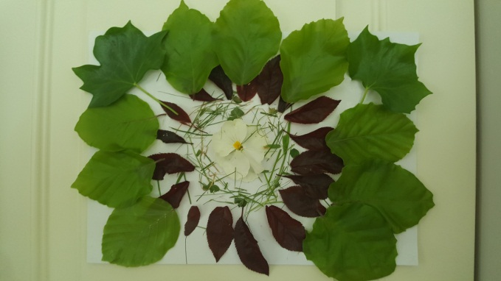

Online Resources
- Twinkl- suitable for all classes
Twinkl are offering all parents a One Month FREE Ultimate Membership to Twinkl.ie. This will allow parents unlimited access to every single resource for every single curriculum subject from Junior Infants to Sixth Class- www.twinkl.ie/offer

- World Book- suitable for all classes

The World Book is a resource offered by the PDST. It’s like a virtual encyclopedia except a lot more interactive.
https://www.worldbookonline.com/wb/products?ed=all&gr=Welcome%21

- https://www.scoilnet.ie/- Scoilnet Primary is another website with a wealth of worksheets and topics for researching.

- Oxford Owl Ebook Reader Library - Junior Infants to 2nd Class
Oxford Owl has an ebook library with over 250 books in it and offers free access to parents once you create an account at www.oxfordowl.co.uk They also have some vocabulary and comprehension activities for most of the books.

- https://www.vooks.com/ is another reading resource

- Mathletics
Join Mathlethics. This is a website packed full of maths games. Children can play against each other and work on all the skills that they will have already covered this year!!- https://login.mathletics.com
- Multiplication.com- suitable from 3rd class up- http://www.multiplication.com
- Top Marks - suitable for all levels
https://www.topmarks.co.uk/

