3rd Class 15th-19th June

.

3rd Class (Mo Chairde)
Monday
- Seo Leat lch. 116 Cuir ord ar na habairtí (Put the words in order in the sentences) Each sentence starts with B’fhéidir (maybe which was covered last week)
  - 1-5 to be done in your copy. Remember your date and heading.
Maths Revision of Time Planet Maths page 162 Read blue box and do B and C
- STEM Activity: To Make a Lava Lamp
You will need: water, vegetable oil, a clear plastic bottle or jar, food colouring, effervescent tablets

Method
- Fill the bottle or jar a quarter full with water.
- Top up, almost to the top with the vegetable oil
- They should separate into two layers, water at the bottom and oil sitting on top.
- Add about 6-8 drops of food colouring once the oil and water separate.
- The colour will mix with the water at the bottom.
- Pop in half an effervescent tablets and watch the bubbles form. Add more effervescent tablets bit by bit to keep the bubbles rising and falling.
The science behind this: Water and oil will not mix. The reason that oil rests on top of the water rather than underneath is because it has a different density to water. When the effervescent tablets are added they react with the water and form carbon dioxide gas and sodium citrate. It is the carbon dioxide bubbles that bring the coloured water to the top.

Tuesday
- Seo Leat lch. 117 Mo Scéal sa Samhradh. This is written in the future tense. There are 15 sentences on the page. Pick 10 and write them out in your copy as a story. Tarraing pictiúr freisin (draw a picture too.)
- Maths Planet Maths page 163 A and B
- Stem Activity: Dissolving
Which solids dissolve in water?
You will need: water, transparent containers, substances to dissolve such as coffee, salt, sand, sugar
Method:
- Add a teaspoon of whichever substance you are testing to a glass of cold water and a glass of hot water. Stir and observe the difference.
- Look to see if the solid dissolves in the hot water and cold water and if one is better than the other.
- Can you design a chart to record your observation?
Things like salt, sugar and coffee dissolve in water. They usually dissolve faster and better in hot water. Pepper and sand are insoluble; they will not dissolve even in hot water.
Everything is made of particles which are also moving. When a soluble solid is mixed with the right liquid it forms a solution. This process is called dissolving. Two things that affect the rates at which solids dissolve are temperature and the size of the grains of the solid. Caster sugar which is made of fine grains will dissolve quickly, but bigger sugar particles will take longer. Solids dissolve faster in hot water. The water molecules are moving faster, so bump into the solid more often which increases the rate of reaction.

Wednesday
- Seo Leat lch. 118 B
  - Freagair na ceisteanna os ard (answer the questions orally)
    - Cad a fheiceann tú? (What do you see?)
    - Cé atá ag súgradh? (Who is playing?)
    - An bhfuil Fionn ag surfáil? (Is Fionn surfing?)
    - An maith leat snámh? (Do you like swimming?)
    - Is fearr liom… (I prefer)
Maths: Planet Maths page 163 C, D E
- Stem Activity: Design and Make a Boat (You don’t have to follow this. If you like use your own design)
- You will need: an empty plastic drinks bottle, 2 chopsticks( or any sticks), various elastic bands of different sizes, things to make a propeller with-lollipop stick, medicine spoon, cardboard and anything else you may want to try.
- Method:
- Put the two chopsticks on either side of the bottle. The ends of the chopsticks should stick out further than the bottle. Keep the chopsticks in place by wrapping lots of elastic bands around them and the bottle. You might need to ask a grown-up to help you with this bit.
- You are going to try a different propeller each time. Put another elastic band around the two ends of the chopsticks. Then put your propeller in the middle between the two chopsticks. Twist the propeller round so the elastic band gets twisted around the propeller. You might need a grown-up to help you with this bit.
- Holding the propeller still, place your boat in the water.
- Let go of the propeller so the boat moves.
- Repeat this for each propeller.

Thursday
- Seo Leat lch. 119
  - C Léamh. Read the sentences and answer fíor (true) nó bréagach (false) orally-no need to write out.
  - D Scríobh Freagair na Ceisteanna. Answer the questions in your copy. Remember your date and heading.
Maths: Planet Maths page 164 A 1-10
- Stem Activity: Sugar Crystal Sparklers
  - You will need: very hot water, a jug, a spoon, wooden skewer(blunt if possible), sugar, food colouring, jar, clothes peg
  - Method:
    - Pour a cup of very hot water into the jug (just boiled). An adult should do this.
    - Add a cup of sugar to the mixture, a spoonful at a time and stir the mixture until all the sugar dissolves. As the water is very hot it is best if an adult does this.
    - Carefully pour the mixture into a clear jar.
    - Add a few drops of the food colouring to the mixture and stir.
    - Dip the skewer into the warm mixture and then sprinkle some extra sugar onto the wet end of the skewer and leave it to dry.
    - Once the mixture in the jar has cooled attach a clothes peg to the clean end of the skewer and balance it on the jar, so that the suagary end of the skewer is in the sugary mixture.
    - Leave the jar in a warm place for a few days and watch as sugar crystals develop on the end of the skewer, making a sugar crystal sparkler!

Friday
Stem Activity: Designing and making a Water Slide
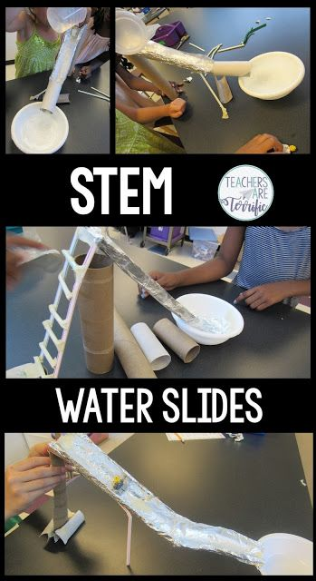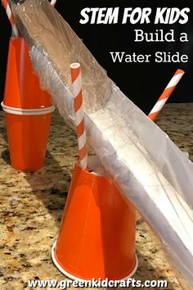
In this STEM challenge, students will be using materials to plan design a working water slide that will take a toy figure down the slide- without leaking water. The main materials for the slide part are not waterproof so students plan ahead for ways to line their slide so it won’t leak. The slide must also resemble a slide and have an access point- like a ladder. I will leave it up to you to see what you come up with. Good luck!

