3rd Class 25th -29th May

3rd Class (Mo Chairde)
Monday
- RAH p. 113 and answer comprehension questions fully in copy
- Spellings List 31 (4 per day and put words into sentences)
- Seo Leat lch. 102, 103 An Samhradh. Léigh na focail (Read the words). Ask the following questions answer orally:
  - Cén séasúr atá ann? (What season is it?) An Samhradh atá ann.
  - Cad a fheiceann tú sa spéir? (What do you see in the sky?) Feicim…
  - An bhfuil báisteach ag titim? (Is rain falling?) Níl…
  - Cén saghas lae atá ann? (What kind of a day is it?) Tá sé grianmhar. Níl sé fliuch.
  - An bhfuil cailín ag imirt cluiche? (Is there a girl playing a game?) Tá…
  - An bhfuil buachaill ag rothaíocht? (Is there a boy cycling a bike?) Tá…
  - An maith leat an pictiúr? (Do you like the picture?) Is/Ní maith liom…. Cén fáth? (Why?)
- Fuaimeanna Ar an Trá box 1 agus scríbhneoireacht lch. 91
- Wordwise p60 Their and There.
  - Read the explanation and do A in your copy. Remember your date and heading.
- Maths Mental maths next test.
- 3D shapes Revision. Watch this video if you can https://www.youtube.com/watch?v=3-QwWFkz5hw
Planet Maths page 152 B and C

Tuesday
- RAH p. 114 and answer comprehension questions fully in copy
- Spellings List 31 (4 per day and put words into sentences)
- Seo Leat lch. 104 A 1-5-answer your questions in your copy. Remember your date and heading.
- Fuaimeanna Ar an Trá box 2 agus scríbhneoireacht lch. 92
- Wordwise p. 60 Two, To, Too
  - Read the example and do B in your copy. Remember your date and heading.
- Maths Mental maths next test.
- Watch this video https://www.youtube.com/watch?v=wxDTrgnyu28
- Planet Maths page 153A 1,2 B, C

Wednesday
- RAH p. 115 and answer comprehension questions fully in copy
- Spellings List 31 (4 per day and put words into sentences)
- Seo Leat lch. 104 B Cuir ord ar an scéal mar shampla q. 1 An samhradh atá ann. Write in your copy and remember your date and heading.
- Fuaimeanna Ar an Trá box 3 agus scríbhneoireacht lch. 93
- Free Writing
- Maths : Mental Maths next test.
- Planet Maths page 154 A 1 and B

Thursday
- RAH p. 116 and answer comprehension questions fully in copy
- Spellings List 31 (4 per day and put words into sentences)
- Seo Leat lch. 105 Teanga o’ bhéal- Éist agus foghlaim (listen and learn)
  - Learn off the phrases.
  - Write out 4 phrases about today in your copy mar shampla, Tá an lá go hálainn. Write your date and heading- An Aimsir.
- Fuaimeanna Ar an Trá box 4
- Wordwise p. 61 Long O Sound
  - Read the example
  - Do A orally and write out B in your copy. Heading: Long O Sound
    - Example: By yourself: alone
Maths next Mental maths test.
Planet Maths Page 155 A and B

Friday
- Revise your RAH stories from the week and pick a WOW word from each story and put it in a sentence.
- Spellings-do the following dictation test:
  - I visited Britain last Autumn.
  - We will applaud the author of the poem when we meet him in the library.
  - It is not my fault the laundry got coloured in the wash.
  - I will help by taking the dirty cups and saucers to the sink.
- Revise Irish Spellings and do test.
- Maths Planet Maths page 156 B and C
- Send your Maths to Mrs Smith please.
mssmithscoilchaitriona@gmail.com
- Art: Making a Mandala using nature.
  - Go to the following link
https://childhoodbynature.com/mandalas-a-practically-perfect-form-of-nature-art/
Here is an example:
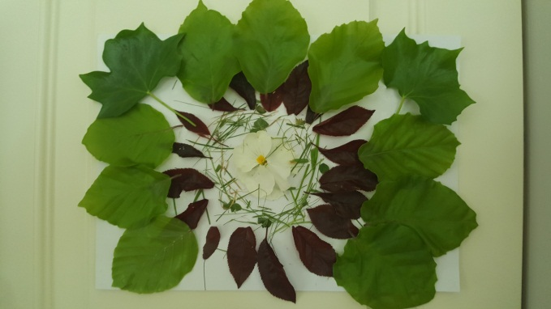

Online Resources
- Twinkl- suitable for all classes
Twinkl are offering all parents a One Month FREE Ultimate Membership to Twinkl.ie. This will allow parents unlimited access to every single resource for every single curriculum subject from Junior Infants to Sixth Class- www.twinkl.ie/offer

- World Book- suitable for all classes

The World Book is a resource offered by the PDST. It’s like a virtual encyclopedia except a lot more interactive.
https://www.worldbookonline.com/wb/products?ed=all&gr=Welcome%21

- https://www.scoilnet.ie/- Scoilnet Primary is another website with a wealth of worksheets and topics for researching.

- Oxford Owl Ebook Reader Library - Junior Infants to 2nd Class
Oxford Owl has an ebook library with over 250 books in it and offers free access to parents once you create an account at www.oxfordowl.co.uk They also have some vocabulary and comprehension activities for most of the books.

- https://www.vooks.com/ is another reading resource

- Mathletics
Join Mathlethics. This is a website packed full of maths games. Children can play against each other and work on all the skills that they will have already covered this year!!- https://login.mathletics.com
- Multiplication.com- suitable from 3rd class up- http://www.multiplication.com
- Top Marks - suitable for all levels
https://www.topmarks.co.uk/

