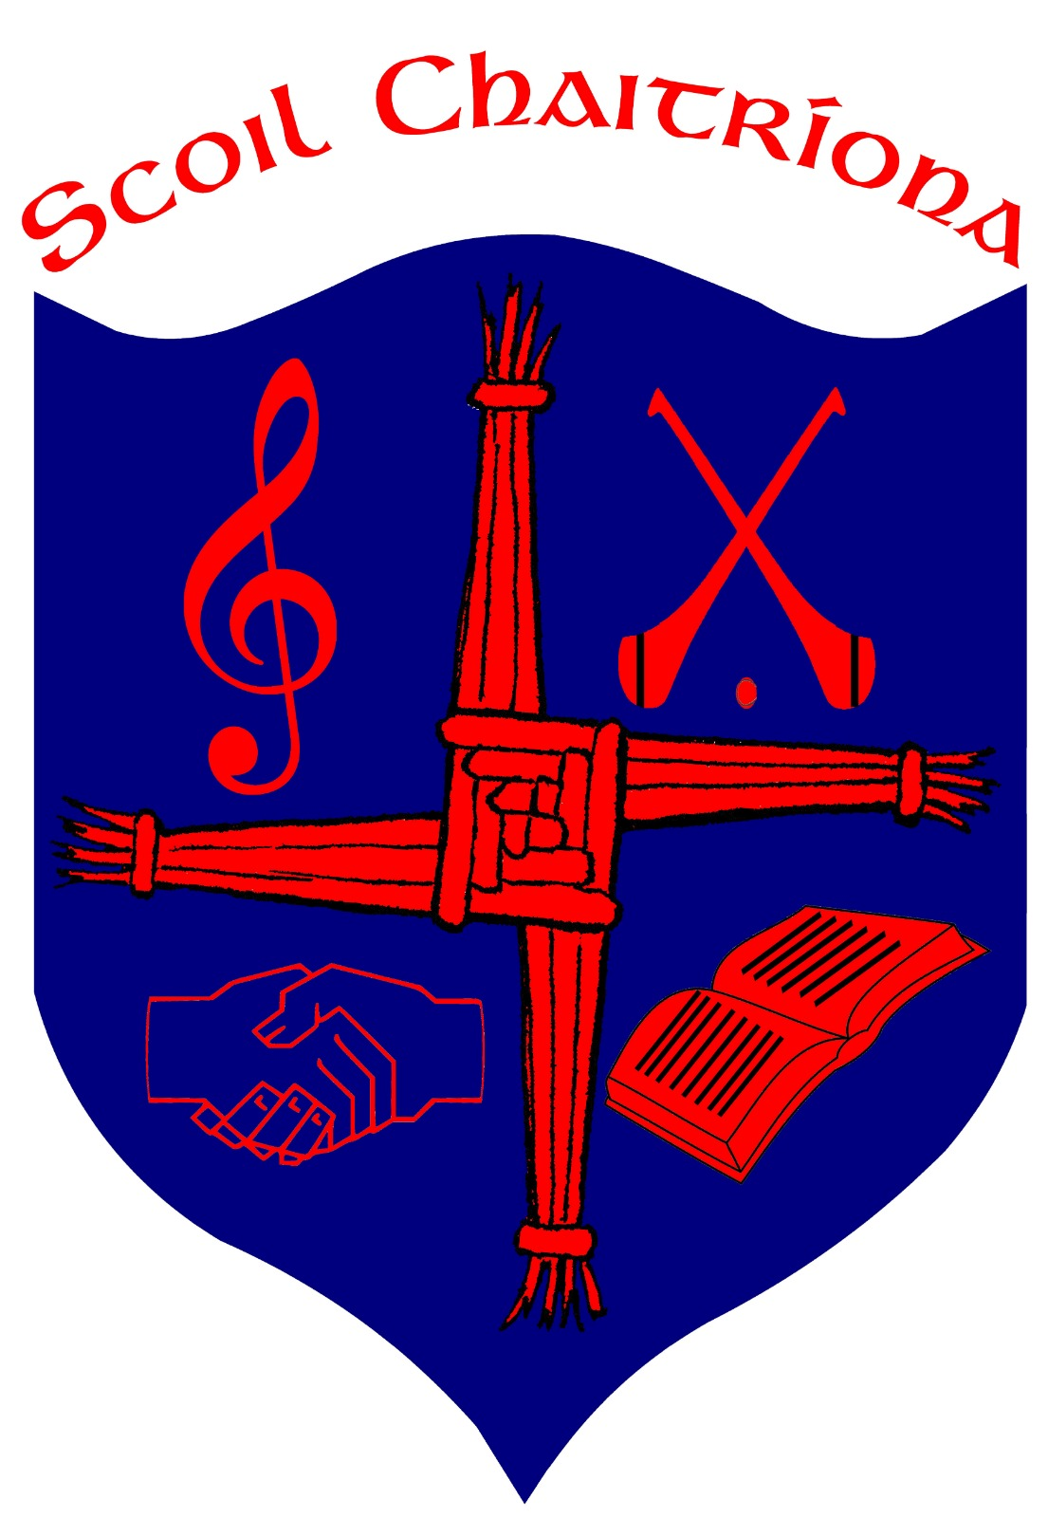
Scoil Chaitríona, Cappamore, Co. Limerick.
Email:secretarysch1@gmail.comWeb:www.scoilchaitríonacappamore.com
Tel: 061-381774 Roll No: 20233L
RCN 20128234

Exemption from Irish Policy

1.Introduction:

This policy was drafted by staff and Board of Management in response to recent changes in special educational provisions. This policy explains how Scoil Chaitríona applies the terms of the Department of Education and Skills Circular 0054/2022 on the exemption from the study of Irish. Irish is a compulsory subject in the primary school curriculum. In rare and exceptional circumstances an exemption to the study of Irish may be sought. An application for such an exemption can be made by the parents or guardians of children who meet the criteria as set out by the Department of Education and Skills.

1.1 Rationale:

The purpose of this policy is to advise parents and guardians, staff of Scoil Chaitríona and other professionals of the revised arrangements for the exemption of pupils from the study of Irish. This Circular results from the initial review of the implementation of circular 0052/2019 which is hereby withdrawn. Existing exemptions from the study of Irish granted under previous circulars and held by pupils will continue to apply until the end of their post-primary education.

1.2 Relationship to the school Ethos:

We, in Scoil Chaitríona, strive to create a secure, happy and caring learning environment where every child has the capacity to reach their full potential. We understand that the needs and circumstances of pupils differ and we aim to meet the requirements of all the students in our school. While we encourage all students to access all areas of the curriculum, we also understand that in rare and exceptional circumstances some children’s overall learning may be maximised by granting an exemption from the study of Irish.

1.3 Aims and Objectives:

The aims and objectives of this policy are:
- to make provisions for all children in our care so that they can access an educational programme most suitable for their needs.
- In exceptional circumstances this may include an exemption from the study of Irish.
- to clarify to parents and guardians the terms of the Department of Education and Skills circular 54/2022 on the exemption from the study of Irish.
- to state the exceptional circumstances in which an exemption from the study of Irish may be sought.
- to explain the process of applying for and granting an exemption.
- to explain what the child with an exemption may do when the class teacher is teaching Irish to the rest of the class.
- to inform parents / guardians on how to appeal a decision.

1.4 Standardised Test and Assessment Used for Irish Exemption

In Scoil Chaitríona the standardised test used is the New Drumcondra Literacy Test in conjunction with the WIAT Word reading and spelling assessment. It is administered by the class teacher or SET.

1.5 The implications of not studying Irish

Parents or guardians seeking an exemption from the study of Irish will be advised to carefully research the possible implications for their child in the future as a result of not studying specific aspects of the Irish language. Choice of third level education courses or careers may be restricted as a result. An Irish language degree course, the direct route to Primary School teaching in state-funded training colleges (though alternative routes into primary school teaching are possible), certain modules of An Garda Siochána training and any linguistically related careers may be extremely challenging without having studied some aspects of the Irish language. A useful reference website to refer to in relation to further education/third level entry requirements is https://www.qualifax.ie/.

1.6 Note:
The decision to exempt a pupil from the study of Irish has very significant implications for his/her future learning and potential employment opportunities. Pupils should therefore be given every reasonable opportunity to participate in the learning of Irish for as long as possible in keeping with the integrated approach to language learning in the Primary Language Curriculum and also acknowledging that pupils at a young age adapt and improve over time. Normally, it is in the interests of the child to continue to study Irish at least to fifth or sixth class level before any decision is made to grant an exemption, so that he/she will have maximum opportunity to participate in the learning of Irish. It should be noted that pupils have the option not to exercise the exemption granted, without any loss of the right to exercise it at a future time.

2 Granting an Exemption from the study of Irish

2.1 Exceptional circumstances required

Exempting a pupil from the study of Irish is considered only in exceptional circumstances. The decision to exempt a pupil from the study of Irish is an important decision that has implications for his/her access to the curriculum and his/her future learning. The decision to grant an exemption from the study of Irish is made following detailed discussion with the pupil’s parent(s)/guardian(s), the class teacher, special education teacher/(s), and the pupil.

2.2 Circumstances permitting Irish Exemption

Exemption from the study of Irish may be allowed in the following exceptional circumstances only:

2.2.1 A pupil moving from a different country without previous experience of learning the Irish language

An exemption from the study of Irish may be granted to a pupil whose education was received outside the State (for a minimum period of three consecutive years) where he/she did not have opportunity to engage in the study of Irish
AND either (a) or (b)
(a) who is not less than 12 years of age on the day of their enrolment or re-enrolment
OR
(b) who is enrolling following the completion of the full course of primary education recognised by another state.

2.2.2. A pupil who experiences significant literacy difficulties which are an obstacle to their learning across the curriculum

An exemption from the study of Irish may be granted to a pupil:
(i) who has at least reached second class
AND
(ii) who presents with significant literacy difficulties that are persistent despite having had access to a differentiated approach to language and literacy learning in all subjects/across the curriculum and over time. Documentary evidence to this effect, held by the school, should include Student Support Plans detailing:

- regular reviews of learning needs as part of an ongoing cycle of assessment
- target-setting
- evidence-informed intervention and review, including test scores (Word Reading, Reading Comprehension, Spelling, other scores of language/literacy) at key points of review
AND
(iii) who, at the time of the application for exemption presents with a standardised score on a discrete test in either Word Reading, Reading Comprehension or Spelling at/below the 10th percentile.
Normally, pupils availing of an exemption under this category should be encouraged to engage with the study of oral Irish language for as long as possible in keeping with the integrated approach in the Primary Language Curriculum and acknowledging that pupils at a young age adapt and improve over time.

2.2.3 A pupil who experiences a high level of multiple and persistent needs that are a significant barrier to the pupil’s participation and engagement in their learning and school life

It is recognised that there is a small cohort of pupils who have a high level of multiple and persistent needs that are a significant barrier to their participation and engagement in their learning and school life. In the case of these pupils, consideration may need to be given to adjusting the range of learning experiences to ensure that their needs are met and that they may engage purposefully in their learning in school. In very exceptional circumstances, this means that consideration may need to be given to exempting them from the study of Irish.

An exemption from the study of Irish may be granted to a pupil:

(i) who has at least reached second class
AND
(ii) who experiences a high level of multiple and persistent needs that are a very significant and continuing barrier to his/her participation and engagement in his/her learning and school life
AND
(iii) whose school has substantial written evidence that these needs persist despite targeted and individualised Student Support Plans to address those needs
AND
(iv) whose school has substantial written evidence that these individualised Student Support Plans have been implemented over not less than two school years, and have been monitored and reviewed by the school in collaboration with the parent(s)/guardian(s) and the pupil
AND
(v) who has been given every reasonable opportunity to participate in the learning of Irish in mainstream classes for as long as possible in keeping with the integrated approach in the Primary Language Curriculum and acknowledging that pupils at a young age adapt and improve over time
AND
(vi) the principal is satisfied that the granting of an exemption is in the overall best interests of the pupil concerned.

Normally, this will mean that the pupil will be expected to engage with the study of Irish at least to the end of fifth class. However, in very exceptional circumstances, where the principal is satisfied that an exemption is warranted to address the high level of multiple and persistent needs of the pupil, and certifies that all of the conditions in (i) to (vi) above have been met, it may be granted at an earlier stage, but in no case may this be earlier than second class.

2.2.4 A pupil in a recognised special school or class or who was previously enrolled in a recognised special school or class or who has a recommendation and has been deemed eligible for a place in a recognised special school and/or in a special class in a mainstream school

(i) Where a pupil is currently enrolled in a recognised special school or special class in a mainstream school or who has previously been enrolled in a recognised special school or special class in a mainstream school and who is transitioning to mainstream provision, that pupil is automatically entitled to an exemption from the study of Irish without an application.
OR
(ii) Where a pupil has a recommendation and has been deemed eligible for a place in a recognised special school and/or in a special class in a mainstream school an application for an exemption from the study of Irish will be required.

Normally, pupils availing of an exemption under (i) OR (ii) of this category should be encouraged to engage with the study of oral Irish language for as long as possible in keeping with the integrated approach in the Primary Language Curriculum and acknowledging that pupils at a young age adapt and improve over time.

2.2.5 A pupil whose parent(s)/guardian(s)is a/are diplomatic or consular representative(s) of another country to Ireland irrespective of age or educational history

An exemption from the study of Irish may be granted to a pupil whose parent(s)/guardian(s)is a/are diplomatic or consular representative(s) of another country to Ireland irrespective of age or educational history.

2.3 Procedures for granting an exemption from the study of Irish

(a) Steps required for a valid application for the exemption from the study of Irish

1. A parent/guardian must make an application in writing to the principal of the school for a Certificate of Exemption from the study of Irish on behalf of a pupil.

2. The school staff shall mark the date of receipt of the application on the application form and issue an acknowledgement to the parent(s)/guardian(s) upon receipt of the application.

3. At the earliest opportunity a school official should contact the applicant(s) and:
• discuss the written application with the applicant(s) and confirm the sub-paragraph on which the application is based (as outlined in section 2.2 above) N.B. If a parent/guardian does not confirm the sub-paragraph under which the application is based then the application is null and void and no further processing of the application will take place. Only criteria contained in this Circular can be considered as grounds for an exemption from the study of Irish and no other exceptional circumstances can be considered.
• advise the applicant(s) of the steps involved in processing the application.
• inform the parent(s)/guardian(s)/pupil of the implications of an exemption from the study of Irish for the pupil while in primary education and into the future.

4. The application should be fully processed and the outcome confirmed in writing within 21 school days of receipt of the application.

5. Where a decision is reached that an exemption from the study of Irish may be granted a signed Certificate of Exemption will be issued to the parent(s)/guardian(s) and a copy will be held by the school in the pupil’s file. The record keeping requirements are outlined further at 2.3(c) below.

6. Where an application is refused, the principal must inform the applicant(s) in writing outlining the reasons for refusal and notifying the applicant(s) that the school’s decision may be appealed to the Irish Exemptions Appeal Committee within 30 calendar days of the date of the written decision

(b) Considering an application for exemption

In considering an application for exemption from the study of Irish the principal will:

1. review the application and any documentation provided by the applicant(s);
2. consult with the pupil’s class teacher;
3. consult with the special education teacher and the assigned teacher from the Visiting Teacher Service where relevant;
4. review school documentation for the evidence outlined in subsection 2.2;
5. consult the following as appropriate;

• Exemptions from the Study of Irish: Guidelines for Primary Schools and the supporting documents maintained by the Department on the Government webpage on exemptions from the study of Irish: www.gov.ie/en/service/irish-exemption/

• Guidelines for Primary Schools: Supporting Pupils with Special Educational Needs in Mainstream Schools developed by the National Educational Psychological Services (NEPS), the Inspectorate and Special Education Section, DES (2017): https://www.gov.ie/en/publication/edf64-guidelines-for-primary-schools-supporting-pupils-with-special-educational-needs-in-mainstream-schools/

•Special Educational Needs: A Continuum of Support, NEPS (2007): https://www.gov.ie/en/collection/dca316-special-education-needs-a-continuum-of-support/

• Catalogue of Wellbeing Resources for Schools: gov.ie - Catalogue of Wellbeing Resources for Schools (www.gov.ie)

• Behavioural, Emotional and Social Difficulties: A Continuum of Support: Guidelines for Teachers, NEPS (2010): https://assets.gov.ie/40684/97bbea80d96b4057bf3f1f01107c7db4.pdf

• Assessment in the Primary School Curriculum: Guidelines for Schools, NCCA (2007): https://curriculumonline.ie/getmedia/2b3eaa53-cb4b-4053-9d71-2d28d9d6c734/Assessment-Guidelines.pdf

(c) Recording the decision
The outcome of the application process will be conveyed by the school in writing to the applicant.

Where an exemption is granted, a Certificate of Exemption, signed and dated by the school principal will be issued.

i. The Certificate of Exemption will state the name and address of the school, the school roll number, the pupil’s name, date of birth and the sub-paragraph under which the exemption is being granted. A Certificate of Exemptionis hyperlinked in the checklists within the Guidelines accompanying this Circular, published by the Department on the government website.

ii. The arrangements for the pupil’s learning will be explained to the parent(s)/guardian(s)/pupil.

iii. It will be explained to the parent(s)/guardian(s) that incidental learning of Irish language may occur through engagement with greetings, phrases, festivals and that a positive attitude to Irish should be fostered by the parent(s)/guardian(s).

iv. Parent(s)/guardian(s) and the pupil should be informed of the option not to exercise the exemption granted, without any loss of the right to exercise it at a future time.

v. The application form, all supporting documentation, and a copy of the Certificate of Exemption will be retained by the school in accordance with data protection legislation and will be made available for inspection by authorised officers of the Department. In maintaining such documentation, schools should ensure that they have obtained appropriate parental/guardian consent for the retention and use of such records.

vi. In addition, where an exemption from the study of Irish is granted, the school should update the pupil’s record on the Primary Online Database (POD) as soon as possible to include the reason for that exemption.

Where an application is refused, a copy of the application form, together with the letter of refusal and all supporting documentation, will be retained by the school in accordance with data protection legislation. The school should maintain the records for at least the duration of the pupil’s enrolment in the school. In maintaining such documentation, schools should ensure that they have obtained appropriate parental/guardian consent for the retention and use of such records.

2.4 Appeals Process

Where the application for exemption from the study of Irish is refused, an applicant can appeal the school’s decision to the Irish Exemptions Appeals Committee (IEAC). The IEAC will comprise three persons who shall be selected from a panel of persons established and maintained by the Minister, having regard to the need for each IEAC to have available to it:

• Experience and skills in the provision of or inspection of special education in schools
• Experience and skills in the area of educational psychology and/or child and adolescent wellbeing and mental health
• Experience and skills in the leadership and administration of schools
• Experience and skills in the initial or continuing education of teachers of pupils with special educational needs.

The IEAC will make a decision on whether the exemption should be granted or not, inform the school of the decision and require the school to give effect to their decision. In making a decision the IEAC will consider the decision of the school and the grounds given for refusing the application, the criteria set out in this Circular and any supporting documentation that was available to the school, contained in the Student Support Plan(s) and any supplementary information provided to the school by the applicant. The appeal should be made on the appropriate form published on the Department’s website.

The appeal must be lodged within 30 calendar days from the date of the written decision of the school not to grant an exemption was notified in writing to the applicant. Irish Exemption Appeal Form and Guidelines for Primary Schools can be accessed at www.gov.ie/en/service/irish-exemption/

3. Arrangements for pupils who are exempt from the study of Irish
Note: Schools, where appropriate, should take account of the literacy learning needs of pupils who are exempt from the study of Irish when deploying available special education teaching resources.

To support inclusive practices of our school, it is our policy that a pupil who is exempt from the study of Irish should be included in a meaningful way in aspects of Irish language and cultural activities in line with his/her ability and interests. It provides an opportunity to gain a knowledge of spoken Irish and to participate in any suitable/enjoyable learning activities.It should be noted that pupils have the option not to exercise the exemption granted, without any loss of the right to exercise it at a future time.

A separate programme of work developed by the class teacher and SET, tailored to meet the specific learning needs of the child, may be followed during the parts of Irish lessons that focus solely on aspects of the Irish language that the child will not benefit from e.g. the development of English language skills. This work may be carried out independently using a self-correcting program on an electronic device or by following a folder of appropriately graded work prepared by the Class Teacher/SET. Children with an Irish exemption are exempt from completing Irish homework.

4. Supports for pupils who have no understanding of English when enrolled

A pupil who has no understanding of English when enrolled should be provided with intensive English as an Additional Language (EAL) in preparation for his/her full engagement with the curriculum in Scoil Chaitríona, at a level commensurate with his/her ability.

5. Reporting on exemptions granted to the D.E.S.

In order for pupils who are exempt from the study of Irish to be recognised by the Department, for grant payment and teacher allocation purposes, Scoil Chaitríona will be required on a monthly basis to record data on pupils who are exempt from the study of Irish and the reason for that exemption on the Primary Online Database (POD).
A copy of the Certificate of Exemption must also be given to the parent(s)/guardian(s) of the pupil being exempted.

6. Pupils transitioning to other schools

It is the responsibility of the parent(s)/guardian(s) to ensure that a copy of the pupil’s Certificate of Exemption is made available to the receiving school.
Scoil Chaitríona will use the Education Passport materials developed by the NCCA, to provide information on a pupil’s engagement with the study of Irish including details of the granting of an exemption from the study of Irish. The passport is retained in Scoil Chaitríona until the post-primary school principal or designated person with responsibility for initiating pupil information transfers, sends a written request for the pupil’s report cards.

7. Monitoring and reviewing the Policy

A review of circular 0054/2022 will be conducted after the first two years of implementation and periodically thereafter. Scoil Chaitríona will review this policy in line with Department of Education and Skills guidelines.

8. Ratification of policy

Date: _______________________

Signed: ___________________________________ _________________________________
Chairperson Principal

