Wk. 22nd June – 26th June
As you are aware this is the last week of school and the summer holidays will officially commence on Friday. I would like to thank you all for the effort you have put into your child’s education since March, your support is truly appreciated.
This week I encourage you to educate your child on farm, sun & water safety. Below I have outlined the resources to use and if you have any questions please let me know.
I would like to wish your family and your child a safe and happy summer.
Ms. Sheehy

FARM SAFETY
www.agrikids.ie is a very useful website with lots of games and activities to teach children about staying safe on the farm. If you scroll down the website you will find Junior and Senior Infants resources that I would have used if we were in school.
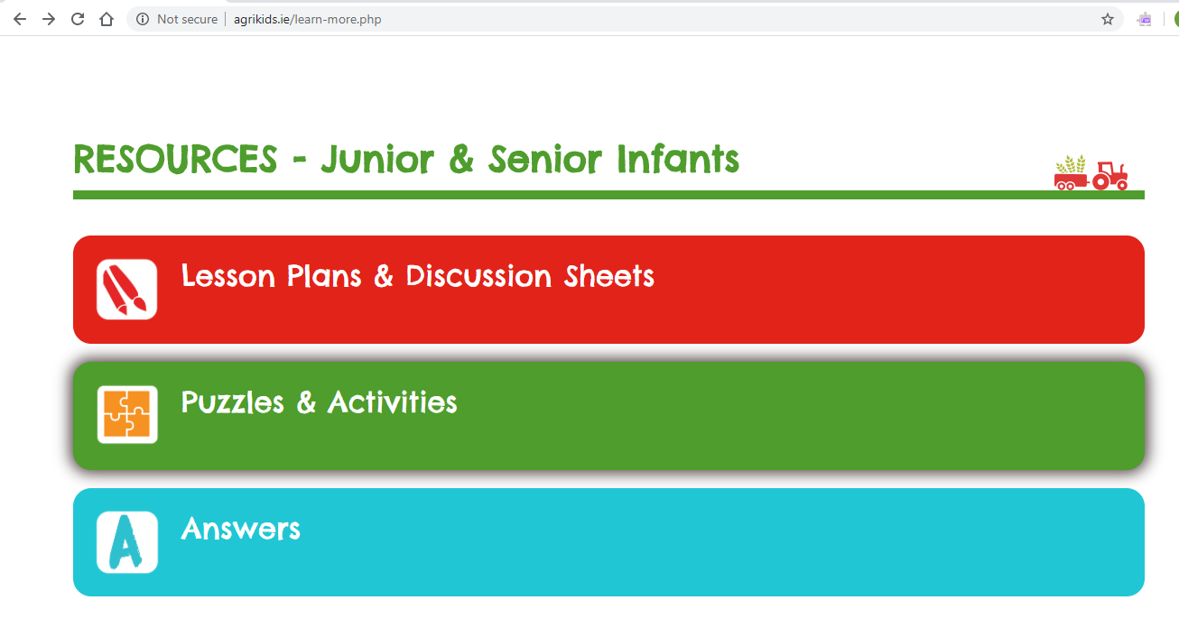
Farm safety videos
https://youtu.be/JfLFStdlFNw
https://youtu.be/BrethaH2naM
https://youtu.be/8UqoEeEsGFA
https://youtu.be/aRMeOnyBatk

Water Safety
- Read the book on the link below to your child
https://online.flowpaper.com/7efd0784/PAWS1ENGLISHWEB/#page=1
- On the website https://www.teachpaws.ie/ scroll down until you can click on Junior & Senior Infant’s lesson pack

- After clicking into the Junior and Senior Infant’s lesson pack go through each game & activity.
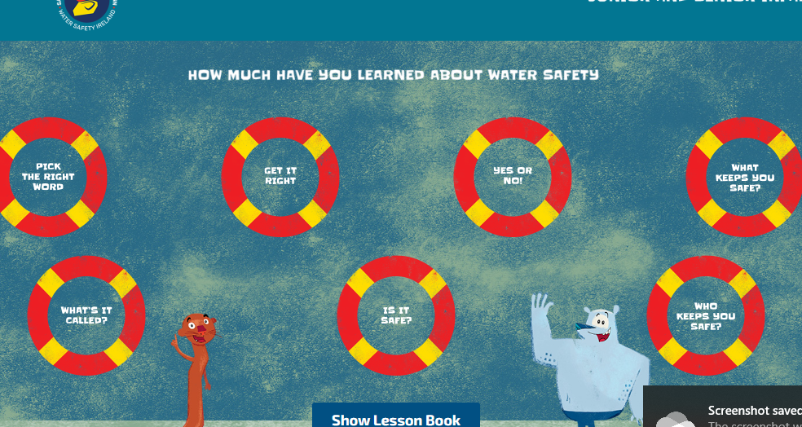

SUN SAFETY
