Week Monday June Wednesday 3rd – Friday 5th
Junior Infants
This week is wellbeing week in Scoil Chaitríona. Underneath I have included a list of daily activities for your child to take part in. Please send any photos/videos of your children engaging in these activities to the email ms.sheehysinfants@gmail.com to share on our school website/twitter account.
Junior Infants are finished their class reader; The Lost Ball. I would strongly encourage you to keep reading with your child; either with books you have at home or online resources; please see the list below;
https://www.oxfordowl.co.uk/for-home/find-a-book/library-page/ - you will need to sign up to this website free of charge.
https://www.readingbear.org/ - activities & games covering the main phonics and vocabulary
https://www.storylineonline.net/ - actors read children’s books aloud with illustrations on the screen
https://www.ictgames.com/mobilePage/literacy.html - Phonics, reading, spelling, writing, letter formation & non-fiction stories all aimed at 5-8 year olds
https://www.jollylearning.co.uk/resource-bank/ - presentations, word bank, activity sheets and more all based on the Jolly Phonics programme.
Wednesday  June 3rd | Wellbeing activities:  - Make a Bubble blower.  1.Cut the bottom off a plastic drink bottle.  - 2. Pull a sock over the bottom of the bottle and secure it in place with an elastic band.  - 3. Fill a basin with water and squirt in some washing up liquid.  - 4. Dip the sock covered bottle into your bubble mixture.  - 5. Blow through the top of the bottle and see what happens!  - 6. Have lots of fun making bubble snakes.  - (Hopefully it’s a windy day & the bubbles will get bigger & bigger!!)  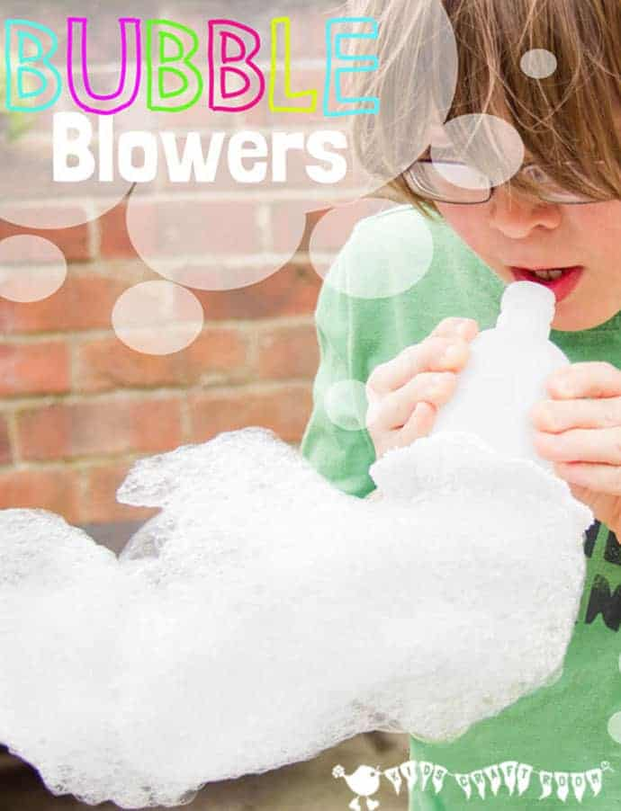  What makes me happy:  Think of two things today that made you happy. Draw a picture or/and write them down.  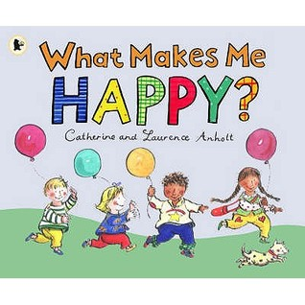  Maths:  - Play the interactive game: https://content.folensonline.ie/programmes/PlanetMaths/PMJI/resources/activities/pm_ji_114/index.html  - Complete pg. 113 + 114 in their Big Planet Maths Book (Add numbers & colour)  English:  Your child has the completed the first two groups of the tricky word list. Please revise these words and ensure your child knows them well progress in their reading & written work.  - List 1: I, the, he, she, me, we, be, was, to, do, of  - List 2: are, all, you, your, come, some, said, here, there & they  - The Lost Ball activity books, complete pg. 15– read, write, match & colour  - Jolly Phonics Pupils book 1- pg. 13; ‘d’.  - Jolly Phonics sounds are now complete – please revise sounds daily in their sounds copies & when reading encourage your child to try sound out/blend the words (except for the tricky words).  Gaeilge: An Leanbh Nua – (the new baby)  - Foclóir nua – Mamó, leanbh nua, cliabhán, ina codladh, traein, teileafón, bronntanas, bréagáin  - Watch video sent through email your email account  - Complete pg. 60 in their Céim ar Chéim workbook
Thursday  4th June | Wellbeing activities:  Meditation with Moovlee; https://www.youtube.com/channel/UCsSS5kMpKCaJ_HhTM9-HKHg/featured  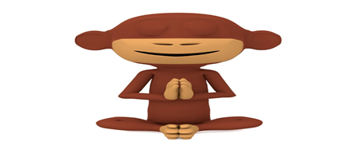  Name writing:  Children write their name using chalk on the ground outside & cover it with peddles  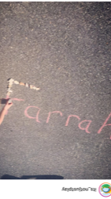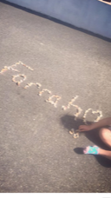  If weather isn’t permitting or you don’t have access to chalk, write your name in pencil on paper (maybe bubble writing) & colour it in with colours.  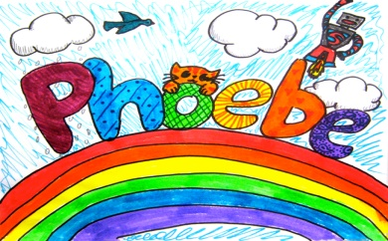  Maths:  - Play the interactive game: https://content.folensonline.ie/programmes/PlanetMaths/PMJI/resources/activities/pm_ji_115/index.html  - Complete pg. 115 + 116 in the big Planet Maths book  English:  Your child has the completed the first two groups of the tricky word list. Please revise these words and ensure your child knows them well progress in their reading & written work.  - List 1: I, the, he, she, me, we, be, was, to, do, of  - List 2: are, all, you, your, come, some, said, here, there & they  - Jolly Phonics sounds are now complete – please revise sounds daily in their sounds copies & when reading encourage your child to try sound out/blend the words (except for the tricky words).  - Complete pg. 59 of the Ready to Write A1 letter ‘v’.  - Jolly Phonics Pupils book 1- pg. 14; ‘g’.  Religion:  Theme: Thank you God for food  This week we are exploring the importance of food, looking at home some families are hungry and do not have enough food. We learn this week to be grateful for food.  - Watch the video: https://player.vimeo.com/video/80907594  - Complete Grow in Love, pg. 50.
Friday  5th June | Wellbeing activities:  Funky Friday (Homestyle)  Get outside, turn up the music and dance to your hearts’ content to a song you love. Why not get the whole family involved!!  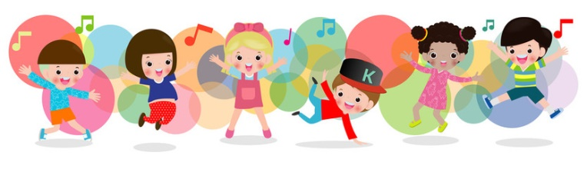  Counting those smiles  Count how many times you made someone smile today!!  Maths:  - Complete pg.117 + 118 of Big Planet Maths Book  English:  Your child has the completed the first two groups of the tricky word list. Please revise these words and ensure your child knows them well progress in their reading & written work.  - List 1: I, the, he, she, me, we, be, was, to, do, of  - List 2: are, all, you, your, come, some, said, here, there & they  - Jolly Phonics sounds are now complete – please revise sounds daily in their sounds copies & when reading encourage your child to try sound out/blend the words (except for the tricky words).  - Complete The Lost Ball Activity Book p.g.16 – read, match and colour  Religion:  Theme: Thank you God for food  This week we are exploring the importance of food, looking at home some families are hungry and do not have enough food. We learn this week to be grateful for food.  - Complete Grow in Love, pg. 51  Gaeilge: An Leanbh Nua – (the new baby)  - Foclóir nua – Mamó, leanbh nua, cliabhán, ina codladh, traein, teileafón, bronntanas, bréagáin  - Watch video sent through email your email account  - Complete pg. 61 in their Céim ar Chéim workbook

