Scoil Chaitríona, Cappamore, Co. Limerick.
Email:secretarysch1@gmail.comWeb:www.scoilchaitríonacappamore.com
Tel: 061-381774 Roll No: 20233L
RCN 20128234

S.E.N. POLICY

Contents
Introductory Statement
School Information
Overview
Rationale
Aims of the Policy
Inclusion
Identification of Educational Needs using the Continuum of Support
Roles and Responsibilities
Enrolment
Whole School Strategies to Minimise Learning Difficulties
Identifying pupils with additional needs
Information Gathering and Assessment
Inventory of Test Materials
NEPS Assessments and Referrals to/from outside agencies
Timetabling
Tracking, Recording & Reviewing Progress
Record of Differentiated Support in class
SEN Records
Health and Safety Issues
Supervision/ Child Protection
Implementation, Review and Ratification
Appendix 1: School Support Plan

Introductory Statement

This review of our SEN Policy was coordinated by the Principal, Deputy Principal/SENCO, in consultation with all relevant stakeholders. This review reflects the SEN allocation model and is in accordance with circular 0013/2017.

School Information

Scoil Chaitríona is a co-educational mainstream primary school under the patronage of the Diocese of Cashel Emily, catering for a full cross section of children. Our school also has two Autism Classes – Autism Class 1 and Autism Class 2. Special Facilities in Scoil Chaitriona include a ramped entrance and exit, specialised equipment for adapted living and two SEN Classes.

Overview

The purpose of this policy is to:
- provide practical guidance to staff, parents and other interested parties about our SEN procedures and practices.
- outline the framework for addressing additional needs in our school.
- fulfil DES circular 0013/17 – Circular to the Management Authorities of all Mainstream Primary Schools; Special Education Teaching Allocation, and new 2017 Guidelines for Primary Schools: Supporting Pupils with Special Educational Needs in Mainstream Schools
- fulfil scheme of grants towards the purchase of assistive technology, circular 0010/2013
- Scoil Chaitríona sets out to provide education for all its students, in line with legislation regarding students with SEN as listed below:

1. The Education Act (1998)
2. The Education Welfare Act (2000)
3. The Equal Status Act (2000)
4. The Education for Persons with Disabilities Bill (2003)
5. The Equality Act (2004)
6. The Data Protection Acts (1988, 1998 and 2003)
7. The Freedom of Education Acts (1997 and 2003)
8. The Education of Persons with Special Educational Needs Act (2004)

Rationale

We believe that all children have a right to an education which is appropriate to their individual needs. We strive to ensure that all our pupils feel that they are a valued part of our school community. This policy aims to outline how we enable children with Special Education Needs (SEN) and children whose first language is not English, to become fully integrated members of our school community to the best of their ability. This will be achieved by careful consideration of the needs of each child and by effective differentiation – either modifying the environment, the content, the activities, or by providing support that will help the child to participate to the best of his or her ability. The resources provided to support pupils with special educational needs, will be used to facilitate the development of a truly inclusive school.

Supports provided to pupils with special educational needs will be based on identified needs and be informed by regular reviews of progress (in consultation with parents and pupils) as outlined in the Continuum of Support Guidelines.

The class teacher has primary responsibility for the progress and care of all pupils in the classroom, including pupils with special educational needs. Pupils with the greatest levels of need will have access to the greatest level of support, and whenever possible, these pupils will be supported by teachers with relevant expertise who can provide continuity of support.
Aims of the Policy

This policy aims to outline our procedures and practices of how we:
- allocate the roles and responsibilities among our school community in relation to pupils with additional needs
- identify additional needs that our pupils may have
- allocate resources to effectively meet the needs of children with additional needs
- track, monitor, review and report on the progress of children with additional needs
- communicate information between the SET team, principal, staff and parents/guardians.

Inclusion

We are fully committed to the principle of inclusion and the good practice which makes it possible. Our policy as set out in this document, aims to enable children with SEN, children from minority groups and children whose first language is not English, to become fully integrated members of our school community. This will be achieved by careful consideration of the needs of each child and by either modifying activities or by providing support that will help the child to participate in them. As far as possible, therefore, it is our aim to minimise the difficulties that children may experience. We aim to achieve this by adopting three principles that are essential to developing a more inclusive curriculum.

Three Principles for Inclusion

- Setting Suitable Learning Challenges
We aim to give every child the opportunity to experience success in learning and to achieve as high a standard as possible. In order to do this, Scoil Chaitriona will use the 'Continuum of Support Process' as outlined in Table 1 below to identify educational needs. Identification of educational needs is central to setting suitable learning challenges for our SEN pupils. Using the continuum of support framework, our school will identify pupils' educational needs to include academic, social and emotional needs, as well as needs associated with physical, sensory, language and communication difficulties. It is important to look at a pupil's needs in context, and to use our resources to support this (for example, learning environment checklist, teacher checklist for whole-class structures and supports).
- Meeting Children's Diverse Learning Needs
We take into account the different backgrounds, experiences, interests and strengths that influence the way in which children learn when we plan our approaches to teaching and learning. In planning our support, the 'Planning Template' outlining the 6 point action plan below will be utilised.

- Overcoming Potential Barriers to Learning and Assessment for Individuals and Groups of Children

We recognise that a minority of children will have particular learning and assessment requirements that will create barriers to learning if we do not address them through special educational arrangements. Our SEN policy envisages a whole school approach that takes into account the roles of the Board of Management, the principal, class teacher, special education teacher and the parents.
In attempting to achieve the above objectives the BOM, principal and staff will take all reasonable steps within the limits of the resources available to fulfil the requirements outlined in this policy document.

Identification of Educational Needs using the Continuum of Support
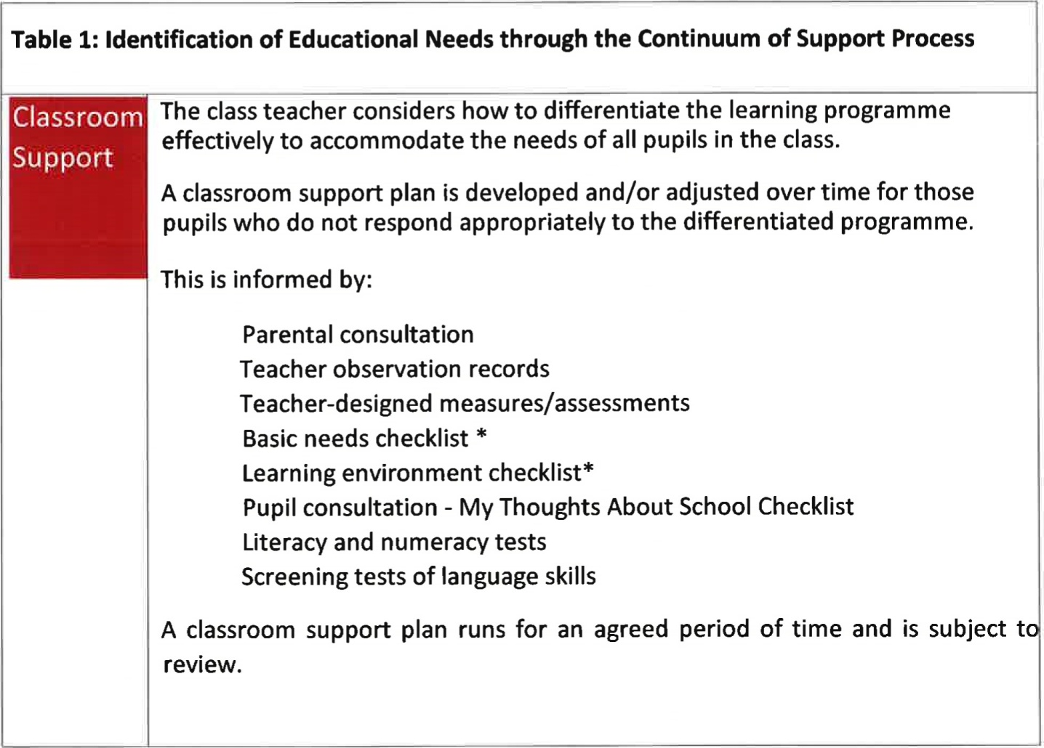
At this level, a support plan is devised and informed by:
Teacher observation records
Teacher-designed measures/assessments
Parent and pupil interviews
Learning environment checklist
Diagnostic assessments in literacy/numeracy
Formal observation of behaviour including ABC charts, frequency measures, functional assessment as appropriate, including screening measures for social, emotional and behavioural difficulties
A support plan at this level may detail suitable teaching approaches including team teaching, small groups or individual tuition.
A school support plan operates for an agreed period of time and is subject to review
This level of the continuum is informed by a detailed, systematic approach to information gathering and assessment using a broad range of formal and informal assessment tools, reports from outside professionals (as appropriate) and may include:
Teacher observation and teacher-designed measures
Parent and pupil interviews
Functional assessment
Results of standardised testing such as measures of cognitive ability, social, emotional and behavioural functioning, adaptive functioning etc
Data generated from this process is used to plan an appropriate intervention and can serve as a baseline against which to map progress.
A support plan at this level is likely to be more detailed and individualised, an to include longer term planning and consultation.

Planning Template to Guide the Allocation of Additional Teaching Supports for Pupils with Special Educational Needs (Primary Guidelines, P 19-20)

Action 1: Identification of pupils with special educational needs | Review existing information on pupils' needs, using school-based data and any information from parents and external professionals. Engage in additional screening and data gathering as required, using informal and formal assessment approaches (for example, teacher observations, information on social and emotional competence, standardised tests, diagnostic tests).  Identify all pupils with special educational needs in the school. Match their needs to the appropriate level on the Continuum of Support
Action 2: Setting targets | Based on individual needs, set clear learning targets for each pupil  at each level of the continuum of support.
Action 3: Planning teaching methods and approaches | Identify the level and type of intervention required to meet targets for each pupil on the continuum of support. Schools should consider methodologies best suited to promoting meaningful inclusion such as differentiation, heterogeneous grouping, team-teaching and small group teaching. They should also be mindful that the interventions and supports that they are using are evidence-informed.
Action 4: Organising early intervention and prevention programmes | Based on identified needs, choose evidence-informed early intervention/prevention programmes to address concerns. Identify time needed and staffing commitment required.
Action 5: Organising and deploying special education teaching resources | Cross-reference the needs of pupils at school support and school support plus levels and consider common needs that can be met by grouping to ensure effective and efficient teaching and learning approaches. Agree which teacher(s) will cater for these groups/individuals and when and where the teaching will take place.  Be mindful of the requirement that pupils with the greatest level of need should receive the greatest level of support from teachers with relevant expertise.
Action 6: Tracking, recording and reviewing progress | Establish a tracking and recording system, to ensure that the progress of all pupils in meeting their identified targets is monitored:  - At whole-school and classroom support level by all teachers  - At the school support and school support plus levels by class teachers and special education teachers.

Roles and Responsibilities

Board of Management
The BOM will fulfill its statutory duties towards pupils with special educational needs. It will ensure that the provision required is an integral part of the school development plan. Members will be knowledgeable about the school's SEN provision — funding, equipment and personnel. The BOM:
- Oversees the development, implementation and review of school policy on support for children with extra needs
- Provides adequate class accommodation and teaching resources.
- Provides a secure facility for storage of records.
Principal
The principal has overall responsibility for the day-to-day management of provision. He/She will work closely with the SEN co-ordinator and will keep the BOM informed about the working of this policy. It will be the role of the principal in collaboration with the SEN co-ordinator to:
- Develop inclusive whole-school policies and monitor their implementation
- Assign staff strategically to teaching roles, including special education roles
- Co-ordinate teachers' work to ensure continuity of provision for all
- Ensure that whole-school procedures are established to facilitate the effective involvement of parents, pupils and external professionals/agencies
- Ensure that effective systems are implemented to identify pupils' needs and that progress is monitored methodically
- Facilitate the continuing professional development of all teachers in relation to education of pupils with special educational needs, and ensure that all school staff (class teachers, special education teachers and special needs assistants) are clear regarding their roles and responsibilities in this area
Special Needs Co-ordinator
The Special Needs Co-ordinator will be responsible for:
- Overseeing the day-to-day operation of the SEN policy
- Co-ordinating provision for children with special educational needs
- Organises the timetable for support teaching
- Liaising with and advising fellow teachers and contributing to in-service training of staff
- Liaising with and advising SNAs with regard to supporting children with special needs
- Liaising with parents of children with special needs
- Monitoring and evaluating SEN provision
- Keeps a list of pupils who are receiving supplementary teaching
- Facilitating planning for class teacher with support teacher
- Supports the implementation of a tracking system at a whole-school level to monitor the progress of children who avail of additional support
- Keeps teachers informed about the external assessment services that are available and the procedures to be followed for initial referrals
- Advises parents on procedures for availing of special needs services
- Selects children for psychological assessment in consultation with bass and support teachers and with Ms Stephanie Donoghue (NEPS)
- Liaises with external agencies such as NEPS to arrange assessments of children with SEN
- Supports the Principal with liaising with SENO regarding all aspects of special education provision
- Stores confidential information (Psychological Assessment Reports etc.) regarding SEN children and shares same with principal, class teachers, support teachers, SNAs, other agencies where appropriate.
- Participates in and or oversees the drafting of IEPs, IPLPs and classroom support plans
- Arranges for exemptions from the study of Irish for pupils for whom this is appropriate.
The Role of the Class Teacher
Effective teaching and learning is critically important for all pupils, and especially for those with special educational needs. Meaningful inclusion implies that all pupils are taught in stimulating and supportive classroom environments where they are respected and valued. Mainstream class teachers have first-line responsibility for the education of all pupils in their classes. Accordingly, classroom teachers should ensure that they plan their lessons carefully to address the diverse needs within the classroom. This will include adapting their teaching approaches for some pupils whose individual progress, application, motivation, communication, behaviour or interaction with peers are causes for concern. This may require targeted interventions to develop relevant adaptive skills related to these needs. All mainstream class teachers will implement teaching approaches and methodologies that facilitate the meaningful inclusion of pupils with special educational needs. These include:
- Co-operative teaching and learning within mainstream classrooms
- Collaborative problem-solving activities
- Heterogeneous group work
- Differentiation
- Interventions to promote social and emotional competence
- Embedding Information and communications technology (ICT) in teaching, learning and assessment
Every pupil needs to be taught a broad and balanced curriculum that is appropriate to his/her developmental level. Pupils' levels of interest, attention, concentration and persistence should be gradually developed, extended and rewarded, using appropriate teaching strategies. To cater for the range of learning needs in any class, mainstream class teachers will regularly need to differentiate their lessons. This can be achieved by:
- Varying the level, structure, mode of instruction and pace of lessons to meet individual needs
- Adapting lessons to take account of pupils' interests
- Matching tasks to pupils' abilities and needs
- Adapting and utilising resources, including the use of technology
- Aspiring towards suitably challenging learning outcomes and assessing accordingly
Teachers can make lessons accessible to a broad range of pupils through the use of a variety of appropriate teaching approaches and methodologies, including active learning, small-group tuition, individual teaching, and scaffolded instruction. This may also require environmental adaptations to promote curricular access.
The Role of the Special Education Teacher
Special education teachers should be familiar with a wide range of teaching approaches, methodologies and resources to cater for particular learning styles and to meet a variety of needs. Teaching approaches will include a combination of team teaching initiatives, co-operative teaching, early intervention and small group or individual support. Depending on the learning needs identified, a pupil with special educational needs may be supported at classroom level, or through mainstream classroom placement with additional teaching delivered through in-class or withdrawal support models.
Some pupils with more complex and enduring needs may require specific methodologies, teaching approaches and/or learning activities. Such interventions should be based on careful identification of strengths and needs, including multi-disciplinary assessment when necessary.
The type of support offered depends on the child's individual needs and takes the form of:
- curriculum support
- life and/or social skills training
- physical training/gross motor development
- speech training/communication and/or language development
- behaviour modification programmes
- assistance with sensory modulation
- development of anger management strategies
- a combination of some/all of the above
Special education teachers, in consultation with class teachers, should plan their interventions carefully to address pupils' priority learning needs and to achieve the targets identified in the relevant continuum of support plan. Short-term planning should reflect the support plan targets and should break down the development of skills and content into small incremental steps to address each pupil's specific needs on a weekly basis. Outcomes for pupils should be routinely assessed, recorded and used to review progress. These outcomes should also be used to inform the targets for the next phase of intervention.
In addition to consultation around the individual needs of their child, parents also value receiving good information on the nature and type of the special educational needs provision available in the school. Our school will consult with parents when developing and reviewing polices relating to the education of children with special educational needs. This helps to ensure that parents understand the school's approaches and better enables them to support their children in transitioning through the school.
Parental Involvement
Good parental engagement is a critical factor in enhancing outcomes for pupils with special educational needs. Parental engagement is enhanced when parents are consulted in relation to their children's needs and strengths, on the supports and strategies being developed to support their children, and when they are involved in regular reviews of progress. The Continuum of Support process and use of the Student Support File provide valuable opportunities to engage with parents and to build a collaborative approach to identifying and responding to the needs of pupils with special educational needs. In addition to consultation around the individual needs of their child, parents also value receiving good information on the nature and type of the special educational needs provision available in the school. Our school will consult with parents when developing and reviewing polices relating to the education of children with special educational needs. This helps to ensure that parents understand the school's approaches and better enables them to support their children in transitioning through the school.
The Parents/Guardians of the pupils of Scoil Chaitriona can prepare for and support the work of the school by:
- Supervising, assisting with, showing interest in and signing homework.
- Reading and telling stories to their child/children.
- Listening to and giving supportive feedback on oral reading.
- Where their child is in receipt of supplementary teaching, implementing suggested home-based activities and discussing the outcomes with the child's teachers.
- Signing and returning consent forms to the school regarding withdrawal for support teaching.
- Talking positively about school and school work.
- Keeping the class teacher informed of any home factors which may be affecting their child's progress.
- Participating in activities organised that are designed to increase the involvement of parents in their children's learning.
- Helping children to develop their organisational skills.
- Helping children to look after school books and other resources which are loaned to the children for use at home.
- Supporting programmes and initiatives implemented by the school.
Enrolment
The school aims to meet the needs of any child whom the parent wishes to register at the school as long as a place is available and the admission criteria are fulfilled. The Ed. For Persons with Disabilities Act 2004 states that 'A child is entitled to attend the school which is most suited to his or her overall needs'.
Parents are required to notify the school of their child's special needs in advance of enrolment through the Home School liaison teacher or principal. The Board of Management will request a copy of the child's medical or psychological report. No child will be refused admission solely on the grounds that she has SEN except where the provision required is incompatible with that available in our school.

Whole School Strategies to minimise learning difficulties
Our strategies for preventing learning difficulties include:
- Prevention and Early Intervention Programs (Ready Set Go Maths, Aistear, station teaching, Literacy Lift Off, Phonics- Time for Sounds, Comprehension – Speaking and Listening)
- Children in JI & SI for whom English is an additional Language or newly arrived EAL students from 1st – 6th classes receive extra tuition from our EAL teacher
- The development of agreed approaches to the teaching of Literacy and Numeracy in order to ensure progression and continuity from class to class – Station Teaching incorporating Guided Reading with PM and Big Cat books from 1st -6th Class).
- Provision of additional support in language development and any relevant early literacy and mathematical skills to pupils who need it.
- Ongoing structured observation and assessment of the language, literacy and numeracy skills of pupils in the infant classes to facilitate early identification of possible learning difficulties.
- Close collaboration and consultation between the Infant Teacher and the SET team.
- Recording Observation-Checklists, Personal records, reading records, Teachers own observation.
- Promotion of literacy in school e.g. Print-rich environment, First Steps Writing Plan, Building Bridges Comprehension Plan, DEAR (Drop Everything and Read), Free Writing, visits to the local library, author visits.
- Promotion of Numeracy e.g. Ready Set Go Maths, use of Manipulatives, use of ipads, STEAM Week
- Parental involvement in promoting literacy and numeracy e.g. Homework Policy Guidelines for Parents, encouraging parents to bring their children to the local library
- Differentiation - adapting the learning environment.
- In-class support from the SET team.
- Withdrawing individuals/groups.
- Use of IT to support learning
- Use of AT to support learning

Information Gathering and Assessment
We believe it is very important to identify and assess children with special needs as early as possible so that effective interventions can be put in place.
In our school we carry out the following assessment procedures:
- Junior Infants: Observation, Checklists, BIAP, Two Peas in a Pod
- Senior Infants: Observation, Checklists, MIST, Drumcondra Early Numeracy , Literacy Lift Off benchmarking
- 1st class: Observation, Checklists, Schonell Spelling New Drumcondra Reading and Numeracy, PM Benchmarking
- 2nd class: Observation, Checklists, Schonell Spelling, New Drumcondra Reading and Numeracy, PM Benchmarking
- 3rd class: Observation, Checklists, Schonell Spelling, New Drumcondra Reading and Numeracy, PM Benchmarking.
- 4th class Observation, Checklists, Schonell Spelling , New Drumcondra Reading and Numeracy, PM Benchmarking.
- 5th class: Observation, Checklists, Schonell Spelling, New Drumcondra Reading and Numeracy, Pm Benchmarking.
- 6th class: Observation, Checklists, Schonell Spelling, New Drumcondra Reading and Numeracy, PM Benchmarking.

We continually review the assessment and screening tests that we use in order to balance the needs of our pupils and the need to provide information for appropriate support. Therefore we may deviate from the above list prior to the review date.

Note: The M.I.S.T. (Middle Infants Screening Test) is administered to all pupils in Senior Infants during the second term of the school year. Pupils who present with scores below a given point will do the follow up Forward Together programme involving parental & SEN support. After 6 weeks these pupils are re-tested (using M.I.S.T.) to measure progress made as a result of this early intervention.
Inventory of Test Materials
(not exhaustive, often reviewed)

Screening Tests
- Belfield Infant Assessment Profile (BIAP)
- MIST
- Early Drumcondra Numeracy
- New Drumcondra Literacy and Numeracy

Diagnostic Tests
In our school the following tests are available for administration:

- PM Benchmarking Kit
- Dolch
- Two Peas in a Pod
- Schonell
- CAT 4
- WIAT
- MALT
- SPAR

NEPS Assessments and Referrals to/from outside agencies

The school is granted a certain number of NEPS assessments on a yearly basis based on the number of pupils enrolled in the school. Children who are referred for a NEPs assessment by outside professionals will be put on the assessment list for consideration. The principal, deputy principal and SEN co-ordinators will use all available information and their professional judgement, under the guidance of the school’s NEPs psychologist, to prioritise who should receive an assessment based on the following criteria;
1. Children who require a placement in a special educational setting
2. Children with scores below the 10th percentile in standardized tests, who have not made notable progress after intervention
3. Children with significantly challenging behaviour needs
4. Children who have had an assessment recommended on a report from outside professionals
5. Children who have a discrepancy between scores in ability and academic performance
6. Children with multiple/complex needs

In addition, the school may recommend that the parent/guardian pursue a referral to CAMHS (Child and Adolescent Mental Health Service) or East Limerick Services. This can be of critical importance if an SNA is required to assist with a child’s inclusion.
Based on Teacher observation and documented evidence the teacher in consultation with the SET and SENCO, may advise parents to apply for assessments e.g. SLT, OT etc. through The Children’’s Disability Network Team using the Children’s Services Referral Form and the Additional Information Form.
Timetabling

When drawing up timetables it is important to remember that
- Timetables should be reviewed at the end of each station teaching term and the beginning of each new calendar term when station teaching recommences.
- Station Teaching is conducted over 8 week periods three times in the year – Sept Week 3, after Christmas, after Easter.
- Children may be taken in blocks of time for intensive tutition
- Children should not miss the same subject each time they are withdrawn
- Interruptions to classes/classrooms should be kept to a minimum where possible.

Tracking, recording and reviewing progress

Provision for pupils with special educational needs is enhanced through clear identification processes and careful planning of interventions to address academic and/or personal and social development needs. Identification of needs, planning, target-setting and monitoring of outcomes are essential elements of an integrated and collaborative problem-solving process.
We use a Student Support File to plan interventions and to track a pupil’s pathway through the Continuum of Support. It facilitates us in documenting progress and needs over time and assists us in providing an appropriate level of support to pupils, in line with their level of need. Our Student Support File is based on the NEPS template and is stored on the school server - Aladdin. All support files should include:
Student Support File
- Cover sheet with pupil’s details
- A timeline of actions
- Record of support received
- Standardised/ Diagnostic test scores
- Support plans (See below)
- Checklists

Support Plans
We use three different support plans for the three stages of support on the Continuum of Support.
Stage 1 – Classroom Support
A Support Plan at stage 1 is a Classroom Support Plan. This is a simple plan which is drawn up by the Class Teacher in collaboration with the SEN Class Coordinator which outlines the pupil’s additional educational needs and the actions, including individualised teaching and management approaches, which will be taken to meet the pupil’s needs. The plan may also include home-based actions to be taken by the pupil’s parents to support their child’s development. The Classroom Support Plan should include a review date. This could be at the end of a school term.

Stage 2 – School Support
A School Support Plan is at stage 2. This plan is drawn up by the class teacher and appointed SET teacher. It will set out the nature of the pupil’s learning difficulties, define specific teaching, learning and behavioural targets and set a timescale for review. The plan should, for the most part, be implemented within the normal classroom setting and complimented by focused school based intervention programmes. Depending on the nature of the needs and on the school context, additional teaching might be within a small group or individual or a combination of both either in class or on a withdrawal basis. Home-based actions may also be included. After the plan has been drawn up, it should become a working document through the careful monitoring of the pupil’s response to the actions taken.

Stage 3 – School Support Plus
A Support Plan at stage 3 is an Individual Education Plan. This plan is drawn up by the class teacher and appointed Special Education Teachers, in consultation with the child’s parents/guardians, professionals external to the school and (if appropriate) the child based on the information gathered. It will set out:

- The nature and degree of the pupil’s abilities, skills and talents
- The nature and degree of the pupil’s special educational needs and how those needs affect his/her educational development
- The present level of educational performance of the pupil
- The special educational needs of the pupil
- The special education and related support services to be provided to the pupil to enable the pupil to benefit from including:
- Strategies for supporting the pupil’s progress and inclusion in the classroom setting
- Individual and/or small group/special class interventions/programmes
- Specific methodologies/programmes to be implemented
- Specific equipment/materials and/or IT supports, if required to support learning and access to the curriculum
- Support required from a Special Needs Assistant (SNA), if appropriate
- The goals which the pupil is to achieve over a period not exceeding 12 months
- The pupil’s priority learning needs, long and short term targets to be achieved, the monitoring and review arrangements to be put in place

IEP meetings are coordinated by the child’s Special Education Teacher. Parents will be invited in November at Parent Teacher Meeting time and further meetings may be scheduled depending on the needs of the child.

Record of Differentiated Support in class
Sample Register of Pupils with Special Educational Needs who are in receipt of interventions through the Continuum of Support Framework
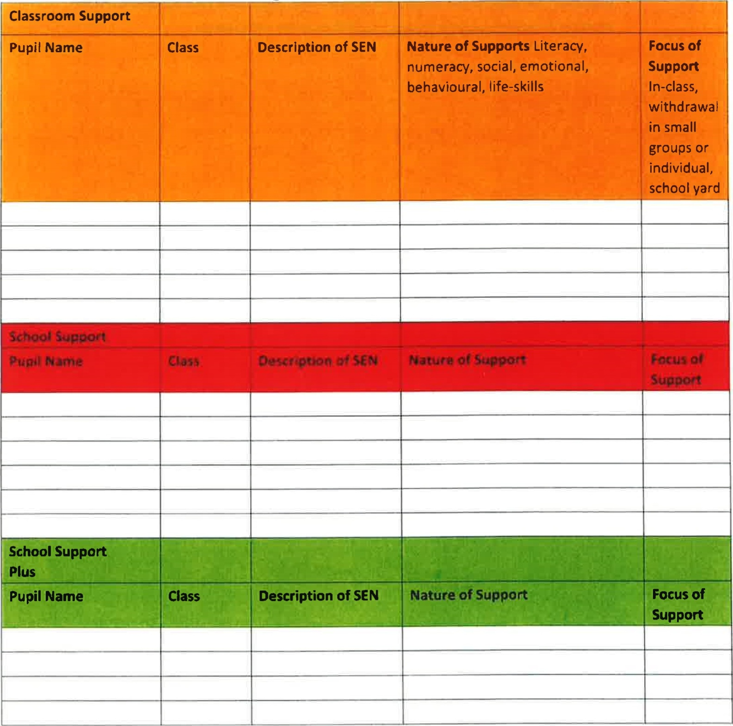
SEN Records

Pupil’s Files
All children have a file in the school whether they have SEN or not.
All pupils’ files are stored in a locked filing cabinet in the office. It is the responsibility of SETs to update and manage the files of the children on school support, school support plus and on classroom support. The files contain all information pertaining to the child including:
- Enrolment forms
- Birth certificates
- All standardised assessments
- Psychological Reports
- Copy of referrals made to outside agencies – it is the responsibility of class teachers to photocopy these.
- Copy of reports from outside agencies
- Record of SEN correspondence between parents, outside agencies and school staff

Notes re: meetings and intervention are also maintained on our password protected server – Aladdin.

Health and Safety Issues

Every staff member and pupil is entitled to a safe, secure environment and to be treated with due respect. All appropriate measures are taken to ensure the safety of each pupil with SEN. When a place is offered to a child with SEN, every effort will be made to ensure that the supports to which the child is entitled are in place as soon as possible. Staff members will be informed of any potential risks and, where necessary, individual plans will be drawn up and implemented.

Supervision/Child Protection

- Where pupils receive support on a one-to-one basis, the SET teacher/SNA is responsible for ensuring that both themselves and the pupil are visible through the glass panel in the door if using a SET room.
- Where the there is no glass panel, the door of the room should remain open.
- Where pupils are withdrawn for support, the SET teacher should collect and return children to their classrooms where appropriate.
- Where a child has access to an SNA, the SNA may withdraw the child from the class if a plan is in place with the class teacher (eg movement breaks, sensory room).

Implementation, Review and Ratification

This policy will be reviewed every three years.
This Policy was first drafted in 2020 and reviewed in January 2024 and will be implemented from it’s ratification.
Ratified by the Board of Management on ____________________________

Chairperson _______________________________

