*Scoil Chaitríona Takes the*

*Long Road to Croke Park*

A whistle stop trip around Ireland and the sites to be seen

**Over these two weeks, we have been staying within our 5km exercise limit and either running, walking or cycling 5km with our families. When we add all the kilometres up we can take the long way to Croke Park – just like we would have done on the 13th of December for the Hurling All Ireland which brought the Liam McCarthy Cup back to Limerick. On our journey we will pass by many iconic sites in Ireland. So, thanks to all who took part and let us now begin our journey in our home town of Limerick and visit Limerick’s most famous landmark – King John’s Castle.**

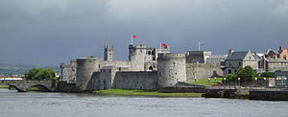

King John’s Castle, Co. Limerick

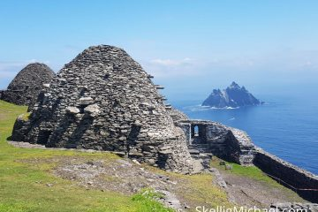

Skellig Michael, Co. Kerry

**The Skellig Islands** are 2 uninhabited, rocky small isalnds off the southwestern coast of Ireland. Skellig Michael is known for its well-preserved early Christian monastery. The site, reached by steep steps, includes stone beehive-shaped huts, oratories and crosses. The Skelligs is home to a large colony of gannets and puffins. The **Skellig Michael** scenes from the **Star Wars** film Episode VII “The Force Awakens” were filmed at the **islands** in 2014.

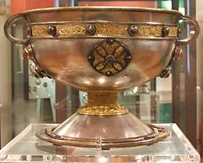

The Ardagh Chalice, Co. Limerick

**King John's Castle** (*Caisleán Luimnigh*) is a 13th-century castle located on [King's Island](https://en.wikipedia.org/wiki/King%27s_Island,_Limerick) in [Limerick](https://en.wikipedia.org/wiki/Limerick), [Ireland](https://en.wikipedia.org/wiki/Republic_of_Ireland), next to the [River Shannon](https://en.wikipedia.org/wiki/River_Shannon). Although the site dates back to 922 when the Vikings lived on the Island, the castle itself was built on the orders of [King John](https://en.wikipedia.org/wiki/John_of_England) in 1200. One of the best preserved Norman castles in Europe, the walls, towers and fortifications remain today and are visitor attractions. The remains of a [Viking](https://en.wikipedia.org/wiki/Viking) settlement were uncovered during archaeological excavations at the site in 1900.

**42km**

**The Ardagh Chalice** was found in late September 1868 by two boys, Jim Quin and Paddy Flanagan, digging in a potato field on the south-western side of a *rath* ([ring fort](https://en.wikipedia.org/wiki/Ringfort)) called [Reerasta](https://en.wikipedia.org/wiki/Ardagh_Fort" \o "Ardagh Fort), beside the village of [Ardagh, County Limerick](https://en.wikipedia.org/wiki/Ardagh,_County_Limerick" \o "Ardagh, County Limerick), Ireland. The chalice held a copper cup and four brooches. The age of the brooches found with the chalice is evidence that it was not buried until the [Viking](https://en.wikipedia.org/wiki/Viking) period. It was sold to George Butler, Catholic [Bishop of Limerick](https://en.wikipedia.org/wiki/Bishop_of_Limerick), by Quin's mother. You can see it on display in the National Museum of Ireland

**146km**

**167km**

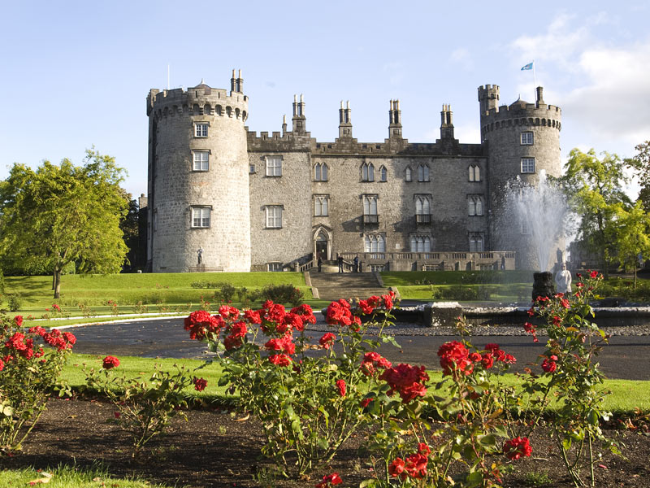

Kilkenny Castle, Co. Kilkenny

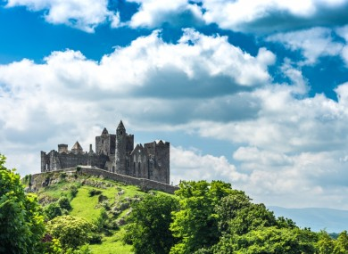

The Rock of Cashel Co. Tipperary

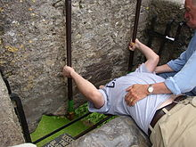

Kissing the Blarney Stone Co. Cork

The **Blarney Stone** is a block of [limestone](https://en.wikipedia.org/wiki/Carboniferous_limestone)built into the [battlements](https://en.wikipedia.org/wiki/Battlement) of [Blarney Castle](https://en.wikipedia.org/wiki/Blarney_Castle), [Blarney](https://en.wikipedia.org/wiki/Blarney), about 8 kilometres from [Cork](https://en.wikipedia.org/wiki/Cork_(city)), [Ireland](https://en.wikipedia.org/wiki/Republic_of_Ireland). According to legend, kissing the stone gives the kisser with *the*[*gift of the gab*](https://en.wiktionary.org/wiki/gift_of_the_gab) *(*skill at [flattery](https://en.wikipedia.org/wiki/Flattery)). The stone was set into a tower of the castle in 1446. The castle is a popular tourist site in Ireland, attracting visitors from all over the world to kiss the stone and tour the castle and its gardens. The word [*blarney*](https://en.wiktionary.org/wiki/blarney) has come to mean "clever, flattering, or coaxing talk". It has been described as follows: "Blarney is something more than mere flattery. It is flattery sweetened by humour and flavoured by wit”.

**98km**

1. The **Rock of Cashel** also known as Cashel of the Kings and St. Patrick's Rock, is a historic site located at [Cashel](https://en.wikipedia.org/wiki/Cashel,_County_Tipperary), [County Tipperary](https://en.wikipedia.org/wiki/County_Tipperary), [Irelan](https://en.wikipedia.org/wiki/Republic_of_Ireland)d. Originally the seat of the kings of Munster, according to legend St. Patrick himself came here to convert King Aenghus to Christianity. Brian Boru was crowned High King at Cashel in 978 and made it his capital. In 1101 the site was granted to the church and Cashel swiftly rose to prominence as one of the most important churches in the country.According to legend, the Rock of Cashel appeared when the devil took a bite from the mountain known *as the Devil's Bit, and spat it back out. It landed in the middle of Tipperary's countryside, and became the Rock of Cashel.*

**61km**

Built in the twelfth century, **Kilkenny** **Castle** was the principal seat of the “Butler Family” - earls, marquesses and dukes of Ormond for almost 600 years. Under the powerful Butler family, Kilkenny grew into a thriving and vibrant city.

The castle, set in extensive parkland, was remodelled in Victorian times. It was formally taken over by the Irish State in 1969 and since then has undergone ambitious restoration works. It now welcomes thousands of visitors a year.The central block includes a library, drawing room, nursery and bedrooms decorated in 1830s splendour.

**108km**

**57km**

And so we have arrived at our destination – Croke Park. Check out this short video for some of the main attractions and highlights of the history of Croke Park. <https://www.youtube.com/watch?v=Tev8OXCFcBs>



**We still need you to run walk or cycle your 5km- we have a lot of kilometres to cover this trip around Ireland. You can do it more than once and don’t forget to send your details and pictures to cappamorejuniorsandseniors@gmail.com**

**122km**

Newgrange is a Stone Age monument in the Boyne Valley, County Meath, Ireland. It was built about 3,200 BC (5,220 years ago) during the Neolithic period, which makes it older than Stonehenge and the Egyptian pyramids. Newgrange is a large circular mound with a stone passageway and chambers inside. The mound is ringed by large stones known as kerbstones some of which are engraved with artwork. On the mornings around the 21st of December, the rising sun shines directly along the long passage into the chamber for about 17 minutes and lights up the chamber floor. The sun enters the passage through a specially designed opening, known as a roofbox, directly above the main entrance.

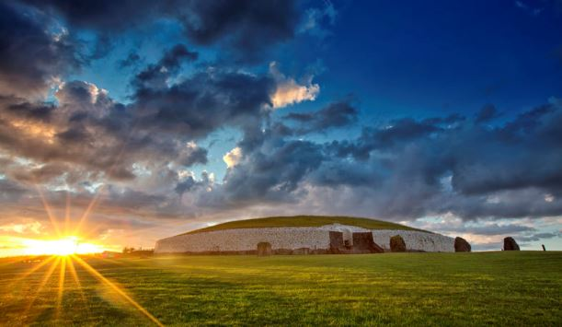

Newgrange, Co. Meath

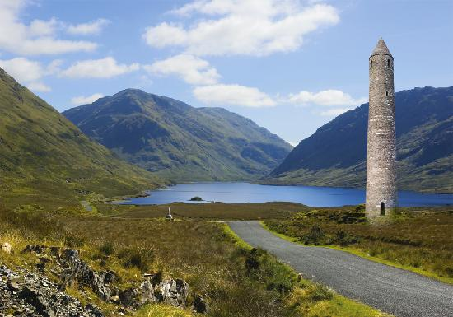

Glendalough Co. Wicklow

Hidden amongst the luscious greenery of the [Wicklow Mountains National Park](http://www.wicklowmountainsnationalpark.ie/) is one of the crown jewels of [Ireland's Ancient East](https://www.ireland.com/en-gb/Articles/regions/irelands-ancient-east/irelands-ancient-east). This is **Glendalough**, the monastery founded by St Kevin in the 6th century that became one of the great centres of learning in early Christian Ireland. The Valley of Glendalough was formed by grinding glaciers during the last Ice Age. The name Glendalough gives a clue as to what you'll find here – in Irish, it translates to "valley of the two lakes". The Upper and Lower lakes are beloved by visitors and provide an opportunity to explore, or even a chance to dip your toes in the cool waters.