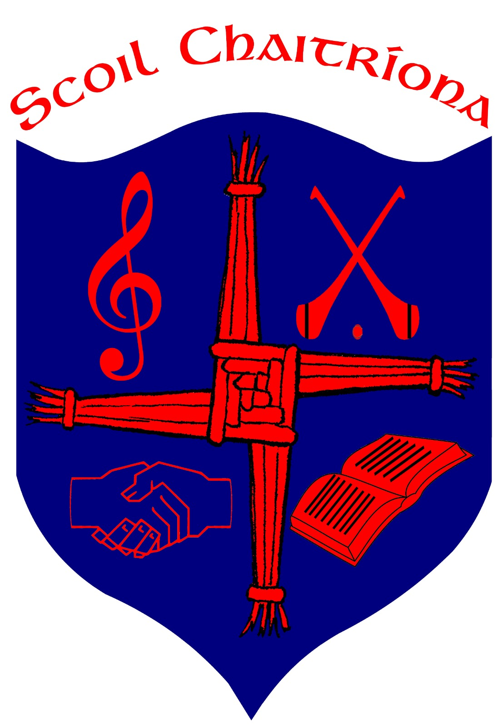
Scoil Chaitríona, Cappamore, Co. Limerick.
Email:secretarysch1@gmail.comWeb:www.scoilchaitríonacappamore.com
Tel: 061-381774 Roll No: 20233L
RCN 20128234

School Calendar 2023/ 2024
- School Opens: Wed 30th Aug 2023
- October Mid Term Break: Monday 30th October 2023 to Friday 3rd November 2023. School re-opens Monday 6th Nov 2023
- Christmas: Friday 22nd December 2023, which will be the final day of the school term.
All schools will re-open on Monday 8th January 2024
- St Brigid’s Bank Holiday: Monday 5th Feb 2024
- Feb Mid Term: School closed Thursday 15th February and Friday 16th February 2024
- St Patrick’s Day closure: Monday 18th March 2024
- Easter : All schools will close on Friday 22nd March 2024
All schools will re-open on Monday 8th April 2024
- May Bank Holiday: Monday 6th May 2024
- June Bank Holiday: Monday 3rd May 2024
- School closes: Fri 21st June 2024

