Scoil Chaitríona Sports Week Activities 2020

MONDAY -Dance Day
I love to dance. It makes me feel happy and more energetic. Today is your dance day. Before you start make sure you are wearing suitable clothing and have cleared a space at home so you don’t knock over your mum’s favourite vase. If any of the moves are too tough just do them very gently and move on. So get up, get moving, tie your hair up in a high pony and get everyone in your house dancing!!!!
Jnr Infants – 2nd Class
I know you guys love to dance. It is so much fun. You are going to love the dances I have picked out for you. Make sure to put lots of energy into your moves.
WARM UP
https://www.youtube.com/watch?v=26guG6wr5so This is a lovely warm up based on animal moves.
DANCE SECTION SELECTION
- https://www.youtube.com/watch?v=FP0wgVhUC9w – all our little Minions will love this.
- https://www.youtube.com/watch?v=KhfkYzUwYFk I don’t think you have ever heard this song before!!!
- https://www.youtube.com/watch?v=UP-ctUE4DHo – I love this one.
- https://www.youtube.com/watch?v=ziLHZeKbMUo – I like to move it, move it!!!
COOL DOWN
It is really important to cool down after all that dancing. This is lovely and relaxing
https://www.youtube.com/watch?v=xELgfiXSw-s
--------------------------------------------------------------------------------------------------------------------------------------
3rd to 6th Class
Today is your dance day. It will involve a warm up of your choice. The first one is a really good deep stretch for all the fabulous bendy dancers in our class. The second one is for our hip-hop dancers who like to look a bit cooler.
WARM UP
Warm Up 1 https://www.youtube.com/watch?v=PmIKrzDvJHs
Warm Up 2 https://www.youtube.com/watch?v=JcnM26EesXM
DANCE SECTION SELECTION
For our dance section I am giving you options to dance to. If you log on to https://imoves.com/ and set up account by clicking get free access. Just look at the section that says Most Popular and in that section find :
- Bollywood dancing
- Disco dancing
These dances are broken down for every step and are great fun
- https://www.youtube.com/watch?v=sNog54ovi8Q This is the song “Best day of my life” and just like in Go Noodle dance along and sing.
- https://www.youtube.com/watch?v=kiRpnDeAOlI This is a zumba dance and is very energetic. Try to keep up.
COOL DOWN
https://www.youtube.com/watch?v=M-d11QiWdm8 – this is a nice and easy cool down. It is really important to cool down after any activity.
I really hope you have enjoyed these activities today
Mrs. Nally
Tuesday-Balancing

Activity 1 - Walk the Line and individual balance
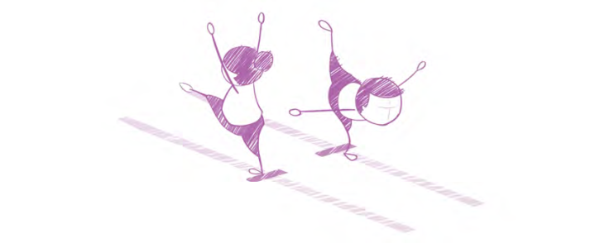
Pupils walk along a line on the floor (this could be a line painted on the floor, a strip of tape or a line of spot markers). Invite pupils to:
• turn fully around in the middle without losing balance or toppling off the line
• complete the task with their eyes closed
• hold a shape for a count of three as they balance on the line.

Individual balance
This should be aesthetically pleasing with non-support limbs extended, straightened and pointed away from the body where possible.
Pupils should be able to hold the balance for a minimum of 3 seconds.
See how many individual balancing acts you can perform; on 2 body parts, 3 body parts, 4 body parts, 5 body parts. 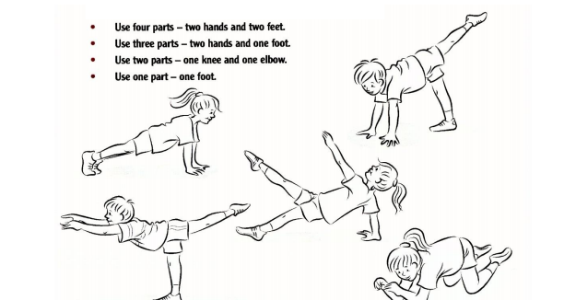

Activity 2 - Wheelbarrow Races 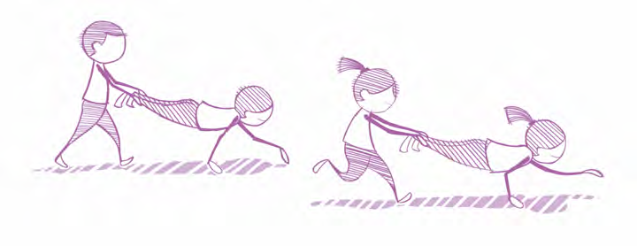
Arrange pupils in pairs. Set up two lines of cones, twenty metres apart and invite pupils to find some space along the line. One pupil adopts the high plank position and their partner lifts their legs below the knee. The pupil holding the high plank moves their hands to go forward, with their partner carrying their legs behind.

Activity 3 –Partner Balancing

Try out some partner balancing poses with a member of your family. How long can you hold it for? Can you make up your own balancing pose?
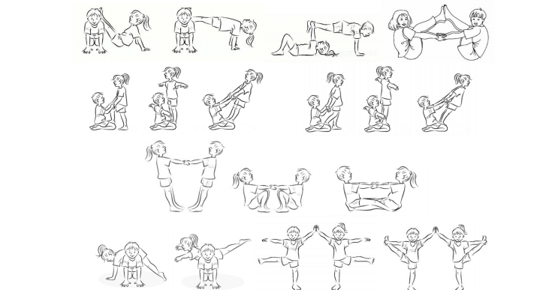

Wednesday- Kicking skills
We hope you enjoy practising your kicking skills. You should focus on the following:
- Your kicking leg should be back at least 90 .
- Move your kicking leg forward fast.
- Contact the ball at your shoelaces or instep.
- Swing the arm opposite your kicking leg forward and sideways.
- Follow through in the direction of the target.
- Keep your eyes on the ball at all times.
Watch the following video to see the above points in action and you will also see the different developmental stages the children progress through when learning to kick a ball. Scroll down to the kicking section.
https://www.scoilnet.ie/pdst/physlit/beyond/

Warm Up:
There are 10 activities here. You can pick and choose what you want to do or if you are feeling very energetic you can do all 10!!
https://www.activekids.com/soccer/articles/10-dynamic-warm-up-exercises-for-youth-athletes

Note: You can vary the difficulty depending on the age of the children.
Activity A:
https://vimeo.com/425128378

Activity B:
https://vimeo.com/425129960

Activity C:
https://vimeo.com/425131385

Cool Down:
https://www.youtube.com/watch?v=FjRAU4d9GKI

Thursday- Throwing / Caitheamh

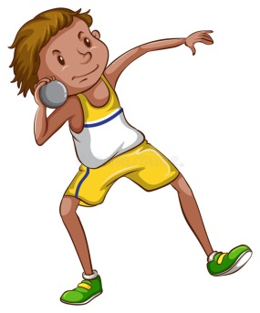
Activity 1 - Knock ‘em Down Pinball
Line up either side of a line of skittle targets as shown. You could also use cans of Beans or empty cereal boxes. Take turns to roll a ball, trying to knock over a target in the middle. If you successfully knock over a skittle, you can claim this skittle and bring it over to your side. Continue playing until all of the skittles have been claimed. Watch the video below.
https://youtu.be/_BwUf9mXm4Y

Activity 2 - Tennis ball Challenge

Work in pairs, one throwing and the other counting. The aim is to throw the ball against the wall and catch it again as many times as possible in 30 seconds.
https://youtu.be/KxD8V6xvsLk

Activity 3 - Bowling

Use cones or any suitable dividers to set up a bowling lane approximately five metres in length. At the end of the bowling lane place five skittles (or water bottles) as targets. Each bowler has three balls to knock over as many skittles as possible. Keep your score. The person that knocks over the most skittles wins. Increase difficulty by increase the distance between the thrower and the skittles or decreasing the width of the lane.
https://youtu.be/cg9gURRP63c

It is possible to increase or decrease the level of challenge in any task using STEP. Increase or decrease the space or distance, amend the task, change the equipment or add involve or different people in the game.

Friday-Virtual Sports Day
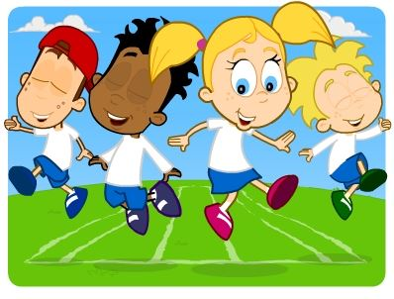

Activities for Junior Infants to 2nd Class:
- Egg and spoon race: Choose where your race starts and finishes. Balance an egg or potato on a spoon. Try not to drop it!
- Sack Race: Again, choose where you will start and finish. Use an old sack or a pillow case. Hop along to the finish line!
- Fill the bucket: Place the bucket a distance away e.g. 1 metre. See how many clothes pegs you can toss into the bucket in one minute.
- Welly Toss: See who can throw the welly the furthest. Mark the spot with a cone/shoe/other item.
- Long Jump: Stand with your legs together and jump. See who can jump the furthest.
- Balloon games – we played this one last year at sports day. Another task that requires good teamwork; in pairs, with a family member, you must get a balloon to the end of a 50 metre track by squashing it between their chests or tummies. You must not use your hands or feet to move the balloon and if you drop it you will have to go back to the beginning.

ACTIVITIES FOR SENIOR CLASSES FOR SPORTS DAY
PICK WHATEVER ACTIVITIES SUIT YOU AT HOME
- Egg and spoon race- you can use a potato instead. Play with the people at home.
- Wheelbarrow race – do this with your parent, just for fun
- Relay race – set this up in the garden or out on the green
- Balloon games – we played this one last year at sports day. Another task that requires good teamwork; in pairs, with a family member, you must get a balloon to the end of a 50 metre track by squashing it between their chests or tummies. You must not use your hands or feet to move the balloon and if you drop it you will have to go back to the beginning.
- Bucket Head Challenge -This race is perfect for a hot summer day. Each person needs to hold a bucket of water on their head whilst completing a tricky obstacle course, including going over hurdles, jumping through hoops and limboing under horizontal poles(just get someone to hold a sweeping brush). The winner is NOT the person who completes the course the quickest but the person who has the most water left in their bucket at the end.
- You Spin Me Right Round - A simple but fun game if you have a hula hoop at home– simply see who can hula-hoop for the longest. You could mix it up by using different parts of the body, such as arms and legs, rather than just your waist.
- Fancy Dress Relay – You need 4 fun items of clothing left at 10m, 20m, 30m and 40m away from the start line and the last stop is at 50 m with no item of clothing. Have little obstacles along the course to make it more interesting. On the start whistle the first runner will go to the 10m line and pick up the first item of fancy dress and put it on, go to the 20m line to pick up the next item and put it on, go to the 30m line to pick up item three and put it on, go to the 40m line to get the item and put it on. Run to the 50m line and then turn around. Return the items at the stops where you got them from. Time yourselves and the winner is the one with the best time.
- Be the waiter – use the same obstacle course from the fancy dress, get two trays and put plastic cups of water on the trays and try to balance them as you go around the obstacle course. Prepare for the spills.
- 5 Races in One - Do you want to mix up your 50m sprint race? Why not move in five different ways? You could run the first 10m, hop the second 10m, skip the third, jump the fourth, and run backwards to the finish line.

Healthy Snacks for after your Sports Day

STRAWBERRY ICE LOLLIES

Ingredients
- 400 g of strawberries
- 200mls of Skimmed milk
- 400mls of condensed milk

Method
- Hull strawberries and blitz in a food processor until smooth. Mix in milk and condensed milk.
- Pour the mixture into 12 ice-lolly moulds and attach the tops. Freeze for a minimum of 4 hrs until solid. Warm the moulds with your hands or under warm water to release the pops. Will keep in the freezer for up to 2 months.
FRUIT COCKTAIL KEBABS
Ingredients
- Any fruit you have – apples, bananas, grapes, raspberries, pineapple
- Kebab sticks
Method
1. Cut your fruit into segments.
2. Stick them on your kebab in a pattern and enjoy.

