Week Monday April 27th – Friday May 1st - Senior Infants
Please feel free to send photos of completed work to the email ms.sheehysinfants@gmail.com for feedback/correction throughout the week.
I understand that home-schooling is not easy and can be challenging, please do not feel under severe pressure to get all the work completed, just do whatever you can to keep your child on track. Please let me know if you have any questions or if there is anything I can do to help you or your child.
Monday | Maths:  This week we will be covering the topic Weight in maths.  Throughout this week encourage your child to use vocabulary such as; heavy, light, big, small, heavier, lighter, the same weight as….., balance  Monday’s Activities:  Aim: discuss weight using the terms ‘heavy’ and ‘light’ and help your child come to realise that weight cannot be assessed by size e.g. a large balloon can be quite light.  Ask some of the following questions to get your child thinking about the topic of weight:  - Name 3 light/heavy animals.   - Name 3 light/heavy types of fruit.   - Name 3 light/heavy vegetables.   - Name an animal which is lighter/much lighter than a dog.   - Name an animal which is heavier/much heavier than a dog.   - Name 2 heavy things in this room.   - Name 2 light things in this room.   - Name something heavier/lighter/about the same as this book.   - Which is heavier a golf ball or a tennis ball?   - Are heavy things always big?   - Can you name an object that is small and heavy and an object that is big and light?   - How can we discover the correct weight of an object? (using balance scales (or even kitchen scales/bathroom scales)  Now explore using the following objects to develop an understanding of the concept of weight by handling a variety of items:  (You do not need to use the items underneath, this is just to give you an idea. Ensure you gather a variety of items that are differ in size and weight)  - Hold up a book and a pencil, which is heavier/lighter?  - Hold up a shoe and a pencil, which is lighter/heavier?  - Hold up a bag and a rubber, which is heavier/lighter?  - Hold up a pencil case and a teddy bear, which is lighter/heavier?  - Hold up a stone and a spoon, which is lighter/heavier?  Children can record/draw these items on a page under the headings: heavy & light.  Play the games on these links:  http://data.cjfallon.ie/resources/19602/activity-82/index.html  http://data.cjfallon.ie/resources/19602/activity-82/index2.html  English:  - New words on word sheet: come, cross, coming, Finn’s, lead, hold, that, walking, pulling, cat (rows 3 + 4)  Revise rows 1 + 2 daily – Watch video link sent through email.  If your child is struggling with the words, write the words out on card/paper and stick them up around the house/their room or make a word wall like we would use in their classroom.  - Revision of Tricky Words Daily 1 - 60 (Please ensure your child knows these words as I will be starting a new list of words next week)  Play tricky words card game – write out all the tricky words on card/paper (even better if your child writes them out), place them face down on a table & take turns picking a word out. If you know the word you get to keep the card. Person with the most cards at the end is the winner.  This can also be done with the words from their reader.  - Reader – ‘Stop that dog’ pg. 8 + 9  - Phonics- looking at the different ways to make the sound er, ir & ur– watch and listen to the video/PowerPoint sent through email. Look at page 23 of their Jolly Phonics Pupils book and read the words only on the top of the page with the er, ir & ur sounds.  - In their Phonics copybook sent home last week –write at least three words in each column either from the list in the video or their own and put one word from each column into a sentence below.
Tuesday | Maths:  - Gather a variety of objects in the house, heavy and light objects which can be held in your hand. Blindfold your child if willing or they can blindfold you, taking turns to be blindfolded. Place an object or a container in each hand of the blindfolded person. Objects should be an obviously light or an obviously heavy object. Examples include, a piece of string, paperclip, a large stone, large bottle of liquid. Child/adult state which hand is holding the heavier object or container.  - Play I Spy – this game can be for the whole family. The children ‘spy’ objects around the classroom, heavier than or lighter than a visible chosen item. For example, I spy with my little eye, something heavier than my pencil, book, plastic bear. Something lighter than my bag, my bottle of water etc.  - Complete pg. 126 in their big Planet Maths book  English:  - New words on word sheet: come, cross, coming, Finn’s, lead, hold, that, walking, pulling, cat (rows 3 + 4)  Revise rows 1 + 2 daily  - Revision of Tricky Words Daily 1 – 60 (Please ensure your child knows these words as I will be starting a new list of words next week)  Play tricky word/ words from reader Bingo – draw 6 – 9 boxes on a page, get your child & whoever else is playing to write a tricky word into each box. Call out the tricky words randomly & whoever gets them all crossed out wins.  - Reader – ‘Stop that dog’ pg. 10  - Ready to write B1 pg 48 – letter r. Please ensure your child follows the correct letter formation as outlined on the page.  - Phonics- In their Phonics Pupils workbooks complete p.g. 23 match the words to the pictures and colour  Gaeilge:  - Foclóir nua (new words for this week): sa ghairdín, Coinín na Cásca, ciseán, ubh Chásca, i bhfolach  - Watch video sent through email your email account  - Complete pg. 50 in their Céim ar Chéim workbook  Religion:  Theme: Places to pray -  - Ask your child can they think of any places that you can pray in?  - Where do they like to pray?  - What kind of things can/do you pray for?  - Who can you pray for/to?  Watch the video - Where do you like to pray to God: https://player.vimeo.com/video/132806484  - Complete the pg. 42 in their Grow in Love book
Wednesday | Maths:  - Introduce your child to weighing scales of some sort; food scales, bathroom scales, balance scales if available – This is what we use to get the correct weight of an item. Place any item on the scales & show your child how we read scales.  - Play the weight games on this links below, here the child will get to see a balance scales in use.  http://data.cjfallon.ie/resources/19602/activity-81/index.html  http://data.cjfallon.ie/resources/19602/activity-81/index2.html  English:  - New words on word sheet: come, cross, coming, Finn’s, lead, hold, that, walking, pulling, cat (rows 3 + 4)  Revise rows 1 + 2 daily  - Revision of Tricky Words Daily 1 – 60 (Please ensure your child knows these words as I will be starting a new list of words next week)  Play ‘hangman’ using tricky words and reader words only. Have the words displayed in front of your child for support.  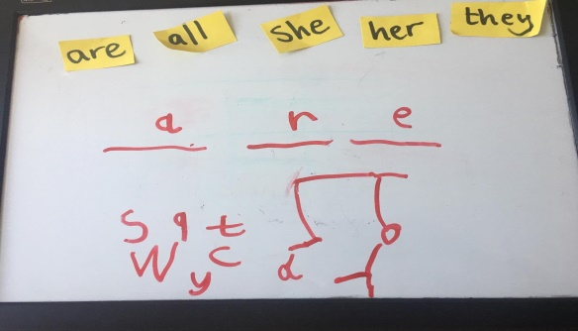  - Reader – ‘Stop that dog’ pg. 11  - Phonics- Dictation in their Pupils Phonics book pg. 24. Watch the video sent on through email and support your child with the writing of the words rub, man, get, land, test, long, mouth, bench, yard, and toothbrush.  Encourage your child to listen to the sounds in the words, whether they are individual sounds or diagraphs. Use the lines on the page to write the words.  Religion:  Theme: Places to pray -  - Talk about the church being a place to pray  - Watch the video – The Church – a place to pray https://player.vimeo.com/video/161311356  - Complete pg. 43 of Grow in Love activity book
Thursday | Maths:  - Complete pg. 127 of the Big Planet Maths book. If you do not have a balance scales at home, use any weighing scales, you may also have to replace the use of cubes if not available. Any object of similar weight will do e.g. piece of lego, marble, a coin or even a square of chocolate!  English:  - New words on word sheet: come, cross, coming, Finn’s, lead, hold, that, walking, pulling, cat (rows 3 + 4)  Revise rows 1 + 2 daily  - Revision of Tricky Words Daily 1 – 60 (Please ensure your child knows these words as I will be starting a new list of words next week)  Play Teacher/parent vs. Student  Kids love pointing out when the grown-ups have got it wrong and it’s a great test to see if they’ve Learned the tricky words. Take turns reading the words and award a point for the correct answer (of course, mummy gets it wrong all the time – so your child gets double the practice).  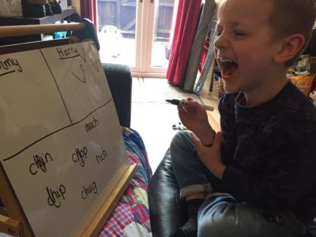  - Reading – ‘Stop that Dog’ pg. 12 + 13  - Phonics- Pupils Phonics book p.g. 24. Underground letter; f,g,j,p,q,y watch video sent through email.  Say and trace over the tricky words; where, who & which.  Put the three tricky words into sentences in their Tricky word copies. Please encourage your child to use their best handwriting (tall & underground letters as previously covered) and use the lines on the page to support their writing.  Gaeilge:  - Foclóir nua (new words for this week): sa ghairdín, Coinín na Cásca, ciseán, ubh Chásca, i bhfolach  - Watch video sent through email your email account  - Complete pg. 51 in their Céim ar Chéim workbook
Friday | Maths:  Play the following games:  http://data.cjfallon.ie/resources/19602/activity-83/index.html (use a household scales)  http://data.cjfallon.ie/resources/19602/activity-83/index2.html  English:  - New words on word sheet: come, cross, coming, Finn’s, lead, hold, that, walking, pulling, cat (rows 3 + 4)  Revise rows 1 + 2 daily  - Revision of Tricky Words Daily 1 – 60 (Please ensure your child knows these words as I will be starting a new list of words next week)  As you cook, clean or garden, use mud or flour to trace, chalk etc. to write/trace your tricky words outside.  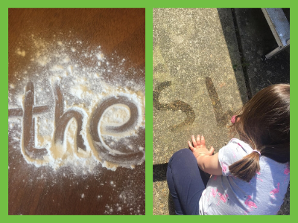  - Reading ‘Stop that Dog’ pg. 1-13  - Ready to write B1 pg. 49 – Capital letter R. Remind your child that capital letters always start at the top of the page and follow the correct formation as outlined.  - Write & post a short letter/postcard/card to say hello to someone your child has not seen in a long time (grandparent, aunt/uncle, cousin, friend etc.) Tell them how they are and what activities they have been up to.  Encourage their best handwriting – use a capital letter to start sentences and where needed e.g. days of the week, names etc. Use full stops when a sentence is finished.

