Week Wednesday June 3rd – Friday June 5th
Senior Infants
This week is wellbeing week in Scoil Chaitríona. Underneath I have included a list of daily activities for your child to take part in. Please send any photos/videos of your children engaging in these activities to the email ms.sheehysinfants@gmail.com to share on our school website/twitter account.

Senior Infants are finished their class reader; Stop that Dog. I would strongly encourage you to keep reading with your child; either with books you have at home or online resources; please see the list below;
https://www.oxfordowl.co.uk/for-home/find-a-book/library-page/ - you will need to sign up to this website free of charge.
https://www.readingbear.org/ - activities & games covering the main phonics and vocabulary
https://www.storylineonline.net/ - actors read children’s books aloud with illustrations on the screen
https://www.ictgames.com/mobilePage/literacy.html - Phonics, reading, spelling, writing, letter formation & non-fiction stories all aimed at 5-8 year olds
https://www.jollylearning.co.uk/resource-bank/ - presentations, word bank, activity sheets and more all based on the Jolly Phonics programme.
Wednesday June 3rd | Wellbeing activities:  - Make a Bubble blower.  1.Cut the bottom off a plastic drink bottle.  - 2. Pull a sock over the bottom of the bottle and secure it in place with an elastic band.  - 3. Fill a basin with water and squirt in some washing up liquid.  - 4. Dip the sock covered bottle into your bubble mixture.  - 5. Blow through the top of the bottle and see what happens!  - 6. Have lots of fun making bubble snakes.  - (Hopefully it’s a windy day & the bubbles will get bigger & bigger!!)  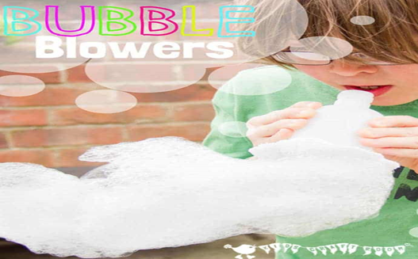  What makes me happy:  Think of two things today that made you happy. Draw a picture or/and write them down.  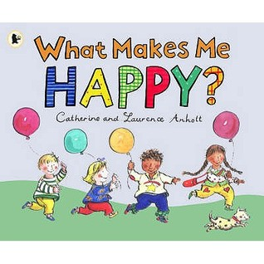  Maths:  Money  - Complete pg. 113 Big Planet Maths Book  English:  - If you feel your child does not know their Tricky Words 1 - 60 off please continue with them.  - New Tricky words this week are: mother & father  Revise daily - cover, after, every, of, eight, love, once, upon, always, also (along with the old list 1-60)  New tricky word list:  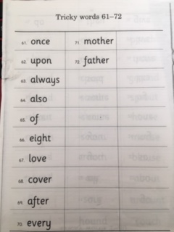  - Phonics Pupils Book 2- pg. 33, revision of the ‘ai’ sound. Read the ‘ai’ sounding words at the top of the page that use ai, ay or a_e to make the ‘ai’ sound.  - Complete the sentence & picture matching activity; read the sentences and identify which picture it belongs to. Write the sentence under the picture & colour.  Gaeilge: An Leanbh Nua – (the new baby)  - Foclóir nua – Mamó, leanbh nua, cliabhán, ina codladh, traein, teileafón, bronntanas, bréagáin  - Watch video sent through email your email account  - Complete pg. 60 in their Céim ar Chéim workbook
Thursday June 4th | Wellbeing activities:  Meditation with Moovlee; https://www.youtube.com/channel/UCsSS5kMpKCaJ_HhTM9-HKHg/featured  Name writing:  Children write their name using chalk on the ground outside & cover it with peddles  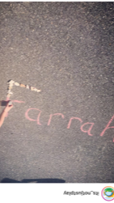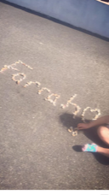  If weather isn’t permitting or you don’t have access to chalk, write your name in pencil on paper (maybe bubble writing) & colour it in with colours.  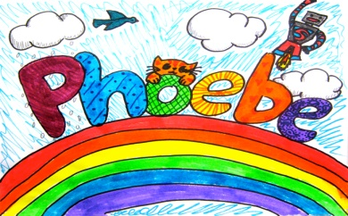  Maths:  Money  - Complete pg. 114 in their Big Planet Maths Book  English:  - If you feel your child does not know their Tricky Words 1 - 60 off please continue with them.  - New Tricky words this week are: mother & father  Revise daily - cover, after, every, of, eight, love, once, upon, always, also (along with the old list 1-60)  - Ready to write B1 pg 59 – letter capital V. Please ensure your child follows the correct letter formation as outlined on the page.  - Phonics Pupil’s Book pg. 32 - Say and trace over the tricky words; want & because.  - Complete dictation of words: rack, wax, spoon, roast, morning, mushroom, sixteen, shout, stood, perch.  Religion:  Theme: Thank you God for food  This week we are exploring the importance of food, looking at home some families are hungry and do not have enough food. We learn this week to be grateful for food.  - Watch the video: https://player.vimeo.com/video/80907594  - Complete Grow in Love, pg. 50.
Friday June 5th | Wellbeing activities:  Funky Friday (Homestyle)  Get outside, turn up the music and dance to your hearts’ content to a song you love. Why not get the whole family involved!!  Counting those smiles  Count how many times you made someone smile today!!  Maths:  Money  - Complete pg. 128 in their Big Planet Maths Book  English:  - If you feel your child does not know their Tricky Words 1 - 60 off please continue with them.  - New Tricky words this week are: mother & father  Revise daily - cover, after, every, of, eight, love, once, upon, always, also (along with the old list 1-60)  - Ready to write B1 pg 60 – letter w. Please ensure your child follows the correct letter formation as outlined on the page.  Religion:  Theme: Thank you God for food  This week we are exploring the importance of food, looking at home some families are hungry and do not have enough food. We learn this week to be grateful for food.  - Complete Grow in Love, pg. 51  Gaeilge: An Leanbh Nua – (the new baby)  - Foclóir nua – Mamó, leanbh nua, cliabhán, ina codladh, traein, teileafón, bronntanas, bréagáin  - Watch video sent through email your email account  - Complete pg. 61 in their Céim ar Chéim workbook

