Week Tuesday May 5th – Friday 8th
Senior Infants
Please feel free to send photos of completed work to the email ms.sheehysinfants@gmail.com for feedback/correction throughout the week.
I understand that home-schooling is not easy and can be challenging, please do not feel under severe pressure to get all the work completed, just do whatever you can to keep your child on track. Please let me know if you have any questions or if there is anything I can do to help you or your child.
Tuesday | Maths:  This week we will be covering the topic Number in maths. We will be comparing and ordering numbers 1-10 along with adding numbers together starting on the higher number.  Monday’s Activities:  Using a deck of cards or cards with number wrote out on them play a game of higher or lower. Cards are divided among a group of players. The first card is turned over. The player must guess whether the next card's value will be higher or lower than the previous card's value. Ace is low, i.e. represents the value 1. If a value is repeated immediately, e.g. two 9's in a row, it is neither higher nor lower and the player loses. (Children have played this game in school already)  Additional games on the links below:  https://content.folensonline.ie/programmes/PlanetMaths/PMSI/resources/activitya/pm_si_118a/index.html  https://content.folensonline.ie/programmes/PlanetMaths/PMSI/resources/activities/pm_si_118b/index.html  - Complete pg. 118 in their Big Planet Maths Book  English:  - New words on word sheet: after, play, back, pool, mud, stuck, muddy, shakes, now, market (rows 5 + 6)  Revise rows 1-4 daily – Watch video link sent through email.  If your child is struggling with the words, write the words out on card/paper and stick them up around the house/their room or make a word wall like we would use in their classroom.  - If you feel your child does not know their Tricky Words 1 - 60 off please read them & play the word games outlined below daily. I am sending out a new list of Tricky words 61-72. Please ignore the word list below if your child is still working on the older tricky words.  - New Tricky words this week are: once & upon  Play tricky words card game – write out all the tricky words on card/paper (even better if your child writes them out), place them face down on a table & take turns picking a word out. If you know the word you get to keep the card. Person with the most cards at the end is the winner.  This can also be done with the words from their reader.  - Reader – ‘Stop that dog’ pg. 11  - Phonics- looking at the different ways to make the sound ue, ew, u_e– watch and listen to the video/PowerPoint sent through email. Look at page 25 of their Jolly Phonics Pupils book and read the words only on the top of the page with the ue, ew, u_e sounds.  - In their Phonics copybook sent home last week –write at least three words in each column either from the list in the video or their own and put one word from each column into a sentence below.  Some games/activities for diagraphs:  https://content.folensonline.ie/programmes/SoundsMakeWords/SI/resources/demonstrations/SMW_SI_DEMO_%20ue_001/index.html  https://content.folensonline.ie/programmes/SoundsMakeWords/SI/resources/games/SMW_SI_GAME_021/index.html
Wednesday | Maths:  Aim: Make sure your child is starting on the bigger number when adding the two numbers together.  - http://data.cjfallon.ie/resources/19602/activity-72/index2.html (Play this game to revise adding on using a number line.)  - Open the big Planet Maths book on page 119 & highlight the number line on the top of the page.  Look at the teddy bear holding the cards and ask your child to pick out which number is the highest and add the two numbers together using the number line.  Remember to ensure your child is starting with the bigger number.  English:  - New words on word sheet: after, play, back, pool, mud, stuck, muddy, shakes, now, market (rows 5 + 6)  Revise rows 1-4 daily  - If you feel your child does not know their Tricky Words 1 - 60 off please read them & play the word games outlined below daily. I am sending out a new list of Tricky words 61-72. Please ignore the word list below if your child is still working on the older tricky words.  - New Tricky words this week are: once & upon  Play tricky word/ words from reader Bingo – draw 6 – 9 boxes on a page, get your child & whoever else is playing to write a tricky word into each box. Call out the tricky words randomly & whoever gets them all crossed out wins.  - Reader – ‘Stop that dog’ pg. 12 + 13  - Ready to write B1 pg 50 – letter s. Please ensure your child follows the correct letter formation as outlined on the page.  - Phonics- In their Phonics Pupils workbooks complete p.g. 25 read the sentence, draw and colour the pictures.  Gaeilge:  - Watch video sent through email your email account  - Complete pg. 52 in their Céim ar Chéim workbook  Religion:  Here we learn about what takes place in the Church and we take a look inside a church, learning about the important items in the church.  Watch the video – The Church:  https://player.vimeo.com/video/132808030  https://player.vimeo.com/video/132809129  https://player.vimeo.com/video/132809351  - Complete pg. 44
Thursday | Maths:  - Complete pg. 120 big Planet Maths book  English:  - New words on word sheet: after, play, back, pool, mud, stuck, muddy, shakes, now, market (rows 5 + 6)  Revise rows 1-4 daily  - If you feel your child does not know their Tricky Words 1 - 60 off please read them & play the word games outlined below daily. I am sending out a new list of Tricky words 61-72. Please ignore the word list below if your child is still working on the older tricky words.  - New Tricky words this week are: once & upon  Play ‘hangman’ using tricky words and reader words only. Have the words displayed in front of your child for support.  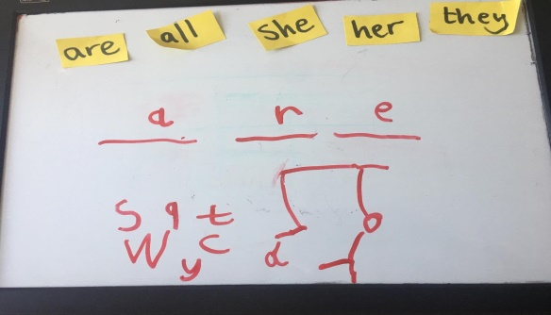  - Reader – ‘Stop that dog’ pg. 14  - Phonics- Dictation in their Pupils Phonics book pg. 24. Watch the video sent on through email and support your child with the writing of the words rub, man, get, land, test, long, mouth, bench, yard, and toothbrush.  Encourage your child to listen to the sounds in the words, whether they are individual sounds or diagraphs. Use the lines on the page to write the words.  Religion:  Theme: The Church -  Talk about the Local Church; St. Michael’s Church. Chat to your child about times they have been to the church:  Why they were there?  What they can remember about the Church?  If they like the church?  Maybe even take a walk to the church.  - Complete pg. 45 of Grow in Love activity book
Friday | Maths:  - Play: http://data.cjfallon.ie/resources/19602/activity-73/index2.html to practice adding three numbers together.  - Complete pg. 121 of Big Planet Maths book  English:  - New words on word sheet: after, play, back, pool, mud, stuck, muddy, shakes, now, market (rows 5 + 6)  Revise rows 1-4 daily  - If you feel your child does not know their Tricky Words 1 - 60 off please read them & play the word games outlined below daily. I am sending out a new list of Tricky words 61-72. Please ignore the word list below if your child is still working on the older tricky words.  - New Tricky words this week are: once & upon  Play Teacher/parent vs. Student  Kids love pointing out when the grown-ups have got it wrong and it’s a great test to see if they’ve Learned the tricky words. Take turns reading the words and award a point for the correct answer (of course, mummy gets it wrong all the time – so your child gets double the practice).  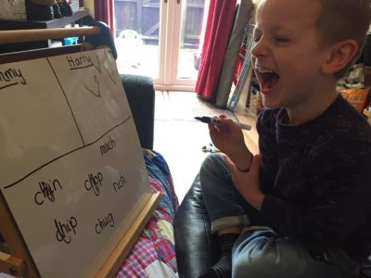  - Reading – ‘Stop that Dog’ pg. 1 - 15  - Phonics- Pupils Phonics book p.g. 24. Underground letter; f,g,j,p,q,y  Say and trace over the tricky words; where, who & which.  Put the three tricky words into sentences in their Tricky word copies. Please encourage your child to use their best handwriting (tall & underground letters as previously covered) and use the lines on the page to support their writing.  Gaeilge:  - Watch video sent through email your email account  - Complete pg. 53 in their Céim ar Chéim workbook

