STEM (Science, Technology, Engineering & Maths) Activities
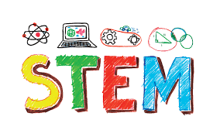
I would like your children to try out these STEM activities over the course of the week. I would love to see the end results, so send on any photos you have. Enjoy!!!

Activity 1: Colour Changing Walking Water
This experiment is simple to set up and only requires items that you probably already have in your kitchen.
Enjoy!

How Does the Walking Water Science Experiment Work?
The water appears to defy gravity, but it in reality it moves because of a process called capillary action. The adhesive forces between the water and the paper towel are stronger than the cohesive forces inside the water. As a result, the water travels up and across the paper towel out of one glass and into another.
Equipment needed:
- Three glasses of equal height
- Water
- Food Colouring (colours of your choice, this experiment just uses two)
- Paper Towels

Step 1 – Prepare two strips of paper towel between 1 and 2 inches wide and set them aside. 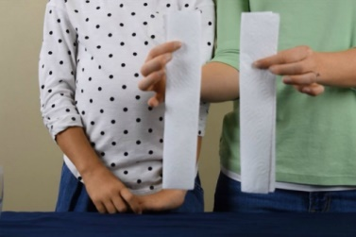
Step 2 – Next, Position your three empty glasses about 2-3 inches apart. Pour water into the two outside glasses until they are halfway full. Leave the middle glass empty.
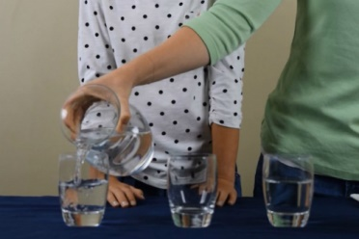
Step 3 – Add a few drops of food colouring into the water. Stir the food colouring until the water is all one colour. Helpful Tip: Use one food colouring in one glass and one in the other.
Step 4 - Take one of the strips of paper towel that you prepared in step 1. Place one end of the paper towel into the first glass of coloured water. Then place the other end into the glass that is empty.
Step 5 - Take the other strip of paper towel that you prepared in step 1. Place one end of the paper towel into the second glass of coloured water. Then place the other end into the glass that is empty.
Step 6 - Observe the experiment right away. Do you notice that the water is “walking” up the paper towel? Now, leave the glasses alone and come back to check on them in an hour or two.

- Tip: The longer you wait to check on the glasses, the more water will have moved to the middle glass. The water will stop moving over when all of the cups are filled with the same amount of water.

Activity 2: Cardboard lung model
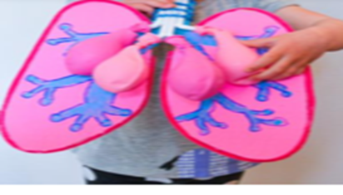
https://www.youtube.com/watch?v=0giiDDBJVQU – Watch this video first to see how the lungs work and then make your lung model.

Materials needed:
Cardboard
Scissors
Paint & paint brushes/colours
Bendable straws
Balloons
Tiny rubber bands
Clear tape
Instructions:
Step 1: Draw the shape of your lungs (x2) and the tube (trachea) that connects them onto a piece of cardboard and cut them out. Paint or colour your lungs pink/red.
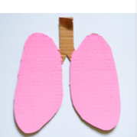
Step 2: Draw the bronchi and bronchioles onto the lungs – these tubes in each lung branch out like tree branches (see picture). Paint/colour these blue and at the end of each branch paint/colour a blue dot to represent the Alveoli (tiny air sacs where your lungs transfer oxygen and carbon dioxide with your blood).
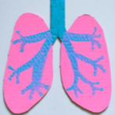
Step 3: Get between 2 - 4 straws and bend them at an angle. If using four straws, two will need to be longer than the others (cut them to size). Line them up so the bent sections point in opposite directions (see photo). Once they are lined up, tape them together with clear tape.
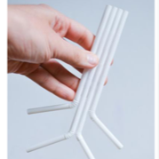

Step 4: Gently attach a balloon to the bent end of each straw with a tiny rubber band. Make sure the rubber band isn’t too tight or air won’t be able to get into the balloons.
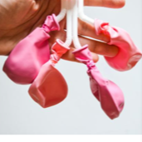
Step 5: Tape your straws to your cardboard lungs so that a little bit of the straws sticks up above the end of the cardboard. You will want to tape the straws so that the balloons are over the lung section of your model. (See photo)
Optional – Wrap a pipe cleaner around the straws to represent the ridges that are in our real trachea.
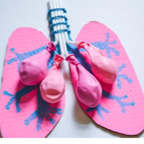

Step 6: Blow gently into your straws an watch them fill with air just like our lungs do when we breathe in. when you stop blowing into the straws the lungs will deflate as the air rushes out, back up the trachea
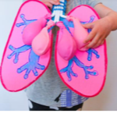

Activity 3: Build a Bird’s nest
Go outside into your garden/yard and sit very quietly for a minute. What can you hear? Can you hear birds nearby? What does a bird live in?
Birds live in nests that they make with their beaks, weaving different materials together.
I challenge you today to make a bird’s home using your clever fingers.
Key questions before starting:
- What materials will you use?
- How will your nest stay firm & stable?
- Where would be the best place to build your best?

What you need:
Paper plate
Scissors
String or twine
Sticks and twigs of different sizes
Grass
Feathers
Leaves
Bark
Straw
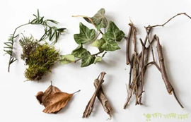
There is no right or wrong way to build a bird’s nest, what is important is that the children get an opportunity to try out their own ideas and problem solve.
