22nd -26th JUNE 2020
Dear Parents and Children,
We have come to the end of our work for the year. We have done our best under the circumstances. You have been wonderful, both parents and children alike, to keep going with the work. It will stand to you when you go back. Don’t worry if you did not manage to keep up with all the work – we will be doing a lot of revision once we go back in September. Remember to keep your books- especially your maths.
To finish off I am including some websites for you to look at to keep you safe over the summer. There are important messages in these websites and games and quizzes for you to play.
I want to thank you for staying committed to your education. You are an inspiration and I know you will be back in September full of enthusiasm and more eager to learn than ever. I hope you appreciate all the efforts your parents have made to keep you going. It has definitely not been easy for them. Remember they are not trained as teachers. Parents, you deserve a round of applause for all your work. Thank you.
I would like to wish you all a happy, safe and fun filled summer. We will see you back in Scoil Chaitríona on Monday 31st August 2020.
Best wishes and virtual hugs to you all
Denise Nally

FARM SAFETY

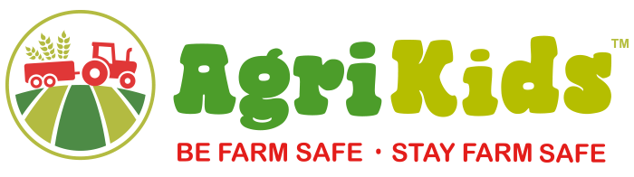
http://www.agrikids.ie/learn-more.php

WATER SAFETY
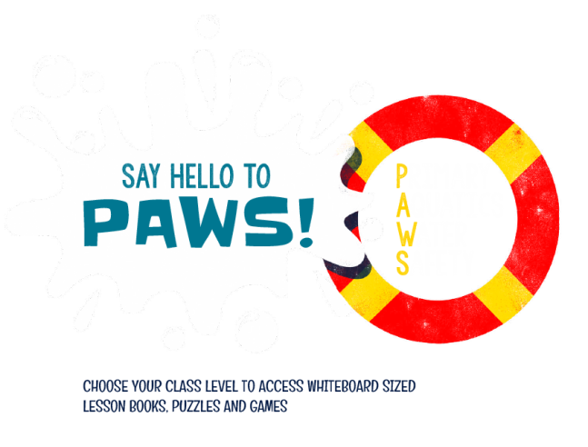
http://paws.edco.ie/third-and-fourth-classes/
http://paws.edco.ie/fifth-and-sixth-classes/
SUN SAFETY
