Work for 4th/5th & 6th Class: 5th May – 7th May 2020
Dear parents and children,
I hope this note finds you all well and safe and that you did something enjoyable for the bank holiday weekend. This week we are going to press pause on the school work. We won’t do as much as we have been doing. It will give people a chance to take a breather. It will give others a chance to catch up on schoolwork at their own pace. The activities I am assigning will be easy and enjoyable and this week I want you to spend time thinking about how this time is affecting you and the planet around you.
With all the good weather we have been having, you need to get out and enjoy the sunshine and soak up the Vitamin D while still following the guidelines we have been given of social distancing and staying within 2km. Read a book in the garden, listen to music, play a game of cards outside with your family, make up your own dance routine to a song ( I know a lot of you are good at that) listen to audiobooks (David Walliams books are available free online).
Enjoy doing these activities. We will press pause again at the June Bank Holiday week. So refresh yourself and be ready to get back to work next week. I miss you all very much and look forward to when we can see each other again.
Thinking of you all
Denise Nally
Email: mrsdnally@gmail.com
__________________________________________________________________________________
The following is the work for next week:
5th May – 7th May 2020
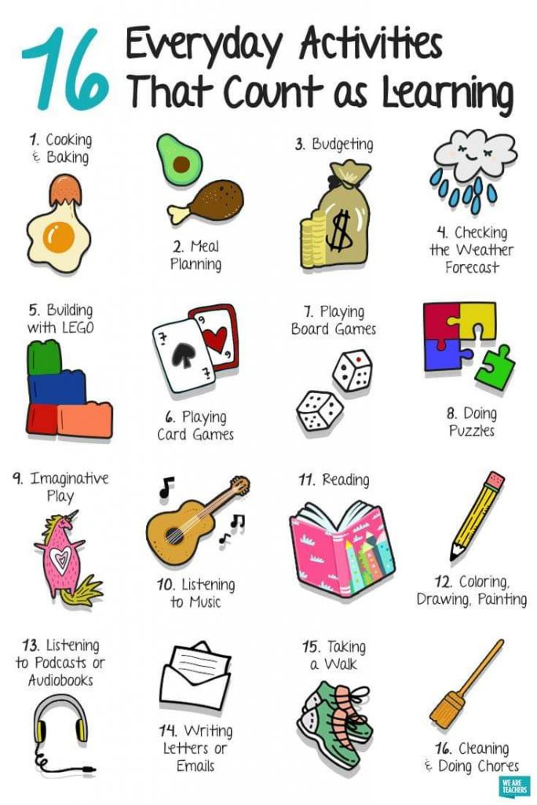
Maths :
- Play Hit the Button on Topmarks online –keep practising your tables.
- Play Mental Up and Prodigy too. A fun way of doing maths.

English:
- Watch the Disney movie “Inside Out”. It’s a movie that explores feeling in challenging times. Think about how this movie makes you feel and how you are feeling at the moment. Maybe you could write a poem on this theme and share it with me. Or maybe write a letter to someone special - an aunt or a grandparent to share how you are feeling at the moment.
SESE:
- Watch the following clips: Think about how we need to take care of our planet and maybe how it has been affected by the worldwide lockdown.
- https://www.youtube.com/watch?v=t7Q7y_xjR5E
- https://www.youtube.com/watch?v=Om42Lppkd9w
- https://www.youtube.com/watch?v=BzKs0FYSxmo
Create an information poster outlining the main causes of pollution and ways we can combat it
STEM/ ICT:
- Look up https://www.codingireland.ie/WeeklyChallenge. They set weekly challenges with step by step guidelines that teach you coding through the Scratch programme. This was something I had planned on doing with you this year.
Go Noodle:
- Keep doing your Go Noodle activities
Joe Wicks
- Joe Wicks is still posting his activity sessions every weekday. Make sure you stay active and healthy.
Journal:
- Keep doing your diary at home. This will be a part of history in the future.

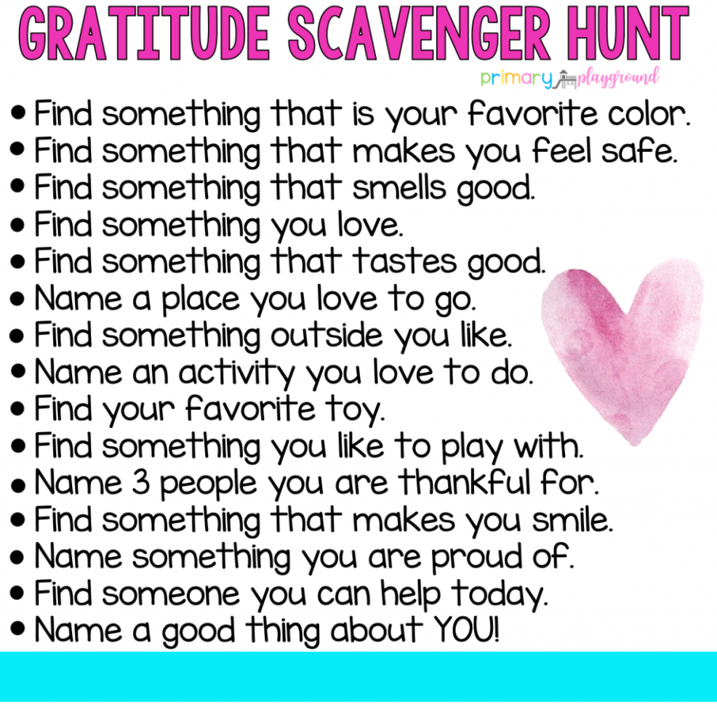
Music:
- Look up the song “Rise Up” by Andra Day. Let it lift your spirits.
Meditation:
- If you have Spotify look up “Peace Out”. It is very relaxing at night time.
RTE Home School Hub
- This is a fantastic resource and covers all subjects on the curriculum. It is well worth watching this and taking part in the activities it offers.
SPHE:
- For this month, I would like you to find a jar and label it “Things I am grateful for”. Every day write down one thing you feel grateful for – it could be the nice dinner you have in the evening, the cosy bed you sleep in, the hug you got from your mum, the sunny day - anything. Acknowledge that you have a lot to be grateful for no matter how small it is.

Art and craft
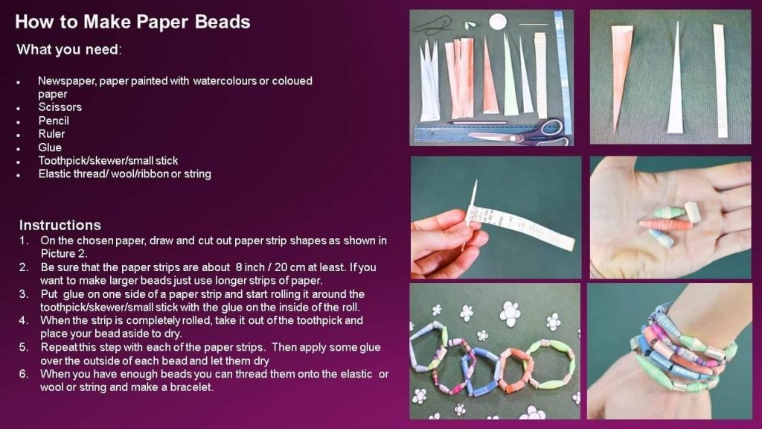

If you as parents are finding things tough during this period and need some advice Barnardos offer a confidential helpline offering support during this crisis : Barnardos Parent Helpline 1800910123
Take a look at gov.ie and the In This Together Section. It offers helpful advice and tips on maintaining mental wellbeing, staying connected and staying active.
Also as your children are now depending more on technology for their entertainment and education please be mindful of what they are looking up and who they are speaking to online. Webwise is an internet usage website that gives lots of good advice to parents.
Remember that if you have any questions don’t hesitate to contact me and there is no pressure to do everything.

