Work for 4th Class: 11th – 15th May 2020
Dear parents and children,
Monday morning comes around all too soon. I hope you enjoyed the activities for our “pause week” and tried something different. So I hope you come back with renewed enthusiasm this week. It is important that we keep working away at the core subjects of English, Irish and Maths. It will really stand to you when we come back. We did get the news that on May 18th teachers will be allowed back into the school (fingers crossed) so we will aim to get all your school books out to you in the following days.
I know it is hard to stay motivated but you have to try to keep your spirits up and keep filling your day with purposeful activities. It’s not all about the academics. Remember the activity poster I gave you last week of activities that are still teaching you something. Make a timetable for your schoolwork and have time to do more enjoyable activities.
I saw some fabulous pictures and videos of you at work and play while we are apart. It is so good to see your smiling faces. Keep them coming. Keep your eye on the website and remember, the majority of answers for the week’s work are on the school website which are posted on a Friday.
Please email me to let me know how your children are doing and if there is anything I can do to help them.
Thinking of you all
Denise Nally
Email: mrsdnally@gmail.com
__________________________________________________________________________________
The following is the work for next week:
11th – 15th May 2020
Maths :
- Tables Champion: Week 26
- Play https://www.topmarks.co.uk/maths-games/hit-the-button or https://mathsframe.co.uk/en/resources/resource/543/Maths-Penalty-Shoot-out it’s for practising your tables.
- New Wave Mental Maths: Week 29
- Planet Maths:Access Planet Maths 4 at https://www.folensonline.ie/
Go to Topic 21 Patterns Pg 128

Day | Pg | Activity
Monday | 128 | - Look at the pictures. Google patterns in nature  - Draw your own coloured patterns.  - Follow the pattern given and continue it and then create your own.
Tuesday | 129 | - Draw the patterns into your copy and fill in the missing colours.  - Draw the patterns and draw what comes next.  - Continue the pattern given
Wednesday | 130 | - Fill out the next three terms in the number and letter pattern. If you are finding it tricky write the difference between the numbers or letters between the numbers e.g.  -50 -50 -50  400, 350, 300, 250  (B) The puzzle is tricky – I’m not giving you any clues.  (C) Don’t draw out 100 squares. Go to https://mathszone.co.uk/count-and-understand/read-write-numbers/spot-100-square/ and click on the 100 square and drag the colours over to make the patterns in this section.
Thursday | 131 | Don’t do the activities on this page.  - Play the pixel art game on https://www.crazygames.com/game/color-pixel-art-classic
Friday | 132 | These are revision activities on the chapter. Do your best.  I’ll post the answers at the weekend.
- If you cannot access this do not worry we will be going over everything again once we get back to school. Look up the website Topmarks and pick “Patterns” in the category section and the age group to suit you.
- Remember to keep practising your tables.
- Play Mental Up and Prodigy too. A fun way of doing maths.
- For children on other maths books work on your Mental Maths and New Wave Mental Maths and work on the online maths games.

English:
- Reading: WorldBookonline.com – this is free at the moment - try to access this through scoilnet.ie. Find a book that interests you. Read every day.
- Go back into the Folens website https://www.folensonline.ie/ and go to the library and find New Treasury 4. Go to contents and find
Section 12– Poetry – Colour
Day | Activity
Monday | Read the poem on pg 72 and answer questions on Section A pg 73. Do section B no 1. Make it very colourful
Tuesday | Pg 73 figure out the crossword. Pg 74 Word Study: a thesaurus gives us words which have the same or are similar in meaning e.g. : huge – enormous, gigantic, colossal. Put the words in Section B which are similar in meaning together.  Do the Blue Star activity. Use an online thesaurus.
Wednesday | Pg 74 examine the three ways the letters “ch” make different sounds. Put them into the correct columns. Pg 75 Pronouns. Read the explanation at the top of the page. It is quite good. Do section A
Thursday | Pg 75 Pronouns Section B and C
Friday | Pg 76 Metaphors: The explanation for metaphor is on the top of the page. Do Section A. Pg 77 Poetry read this section and write your own poem about “School” or “Home”

- Read at Home: Week 28 do the questions orally
- Spelling List: List 24 - learn (put into sentences if you can’t access the New Treasury 4). Ask your parents to test you orally.
- WOW Words: gourmet, impeccable, malevolent, offend, refrain

- Gaeilge:
- Rí Rá: Aonad 24 (Look up words in dictionary)
- Seo Leat 4: Go to the website: https://my.cjfallon.ie/dashboard/student-resources. Then pick -Primary -4th Class – Gaeilge –Seo Leat –Seo Leat 4. Follow the online instructions. Go to the online book. Chapter 18 An Bláthanna Deasa pg 100
- Read the vocabulary and try your best to understand it. Use your dictionary. It’s is available on line as well (foclóir.ie). The interactive option of the book gives you the pronunciation of the words. Do your best. Do Section A, - answer the questions. Section B match the sentences to their correct ending. Do section C and D. In Section E you are adding a “h” to the word because “mo” comes before it.
- For those who cannot access this use Duolingo online and keep practising a little irish every day.
- Also practise your vocabulary every day download the Cúla 4 app on your phone and practise the words and phrases.
After this I’m making a choice box. Pick what you want to do:
Fact of the Day:  - Look up a new fact every day | Go Noodle:  - Go Noodle activities | Joe Wicks  - Joe Wicks is a fantastic trainer and is posting brilliant lessons on You Tube. Aim to do one a day.
Journal:  - Keep a diary of your time at home. This will be your creative writing and it will be something you will always remember. | Music:  - Look up the song “Don’t stop Believing” by Journey. Rock out in the kitchen. This is one of my favourite songs. | Meditation:  - The Gratitiude Tree – guided meditation. Look it up on You Tube
Art:  - Find a picture at home like a flower or an animal. Cut it in half vertically. Stick it on a page and draw the other side yourself – this is symmetry. | SPHE:  - Continue with your Gratitude Jar | Science  - Magic Ink. See the attached activity. If you use an iron it is better than a lamp

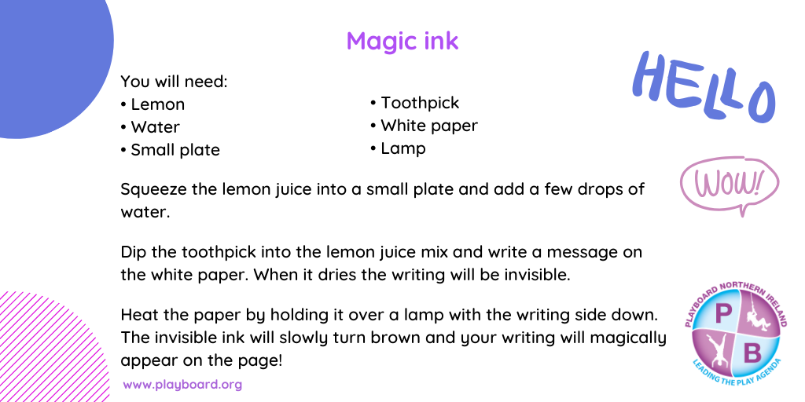
STEM/ ICT:
- Look up https://www.codingireland.ie/WeeklyChallenge. They set weekly challenges with step by step guidelines that teach you coding through the Scratch programme. This was something I had planned on doing with you this year.
RTE Home School Hub
- This is a fantastic resource and covers all subjects on the curriculum. It is well worth watching this and taking part in the activities it offers.
Scoilnet.ie
- This website covers all areas of the curriculum and can have support activities for topics you are covering in maths/english/irish according to your class. Just use the filters on the home page. It also has a wealth of information for children who may be interested in doing independent project work.

If you as parents are finding things tough during this period and need some advice Barnardos offer a confidential helpline offering support during this crisis : Barnardos Parent Helpline 1800910123
Take a look at gov.ie and the In This Together Section. It offers helpful advice and tips on maintaining mental wellbeing, staying connected and staying active.
Also as your children are now depending more on technology for their entertainment and education please be mindful of what they are looking up and who they are speaking to online. Webwise is an internet usage website that gives lots of good advice to parents.
Remember that if you have any questions don’t hesitate to contact me and there is no pressure to do everything.

