Work for 4th Class: 18th – 22nd May 2020
Dear parents and children,
How are you all doing? You are all so brilliant to keep going through this time and I hear great reports from your parents that you are keeping up with your work. Well done to you all. I am so proud of you. I suppose you know by now that we will not be back until September at the earliest. This saddens me terribly as I will not get to see you all before the summer. I wish things were different for all of us but we have to keep going and keep our spirits up and get the best out of this time.
For the next two weeks we will be doing work as normal, but in the month of June we will be pulling back and doing less in the core subjects and more fun activities - like what we would be doing in June if we were at school. We want you to enjoy yourselves.
I will be going into school to organise your books on Monday and all your books will be returned to you in the coming days. Please do not throw out any of your school books as we will be revising when we come back in September. For now, keep going and doing your best. You are wonderful and I really miss you all.
Please email me to let me know how your children are doing and if there is anything I can do to help them.
Thinking of you all
Denise Nally
Email: mrsdnally@gmail.com
__________________________________________________________________________________
The following is the work for next week:
18th – 22nd May 2020
Maths :
- Tables Champion: Week 27
- Play https://www.topmarks.co.uk/maths-games/hit-the-button or https://mathsframe.co.uk/en/resources/resource/543/Maths-Penalty-Shoot-out it’s for practising your tables.
- New Wave Mental Maths: Week 30
- Planet Maths:Access Planet Maths 4 at https://www.folensonline.ie/
Go to Topic 22 Length and Perimeter Pg 133. This week we are looking at
perimeter. I want you to think of perimeter like the fence around the field or a
frame around a picture. What length of wood would you need to create a
fence around a field . We measure length in meters (m) and centimetres (cm).
There are 100 centimetres (cm) in a meter.

Day | Pg | Activity
Monday | 133 | (B) Answer the problems – you are using repeated addition or will you multiply instead?  (C) Use your ruler and draw these shapes. In (b) draw your own triangle freehand and then measure each side with a ruler and put the measure over the line.
Tuesday | 134 | (A) If all the sides are the same length then you can just multiply by the amount of sides. If it’s a square then you multiply by 4, if it’s a triangle, you multiply by 3, a pentagon, you multiply by 5, etc. You are now working out perimeter.  (B) Work out the perimeter in each of these problems. In number 5 you have to work in reverse to figure out the length if you are given the perimeter. So therefore you have to divide the perimeter by the amount of sides. e.g a square has a perimeter of 24. There are four sides so you divide 24 by 4 and get 6. 6cm is your length.  (C) Use the same method for working out the lengths. In number 4 the square is 8cm in length. You have to work out the perimeter first and then multiply by 3.
Wednesday | 135 | (A) You have to use your ruler and measure each side in each shape and then add them together. Think about the measure of the opposite sides. Aren’t they the same? Think about how we could do this faster instead of adding every side. If the opposite sides are the same could you add the long side (length) and the short side (width) and then multiply by two. Perimeter = (length + width) x 2  (B) Using the formula (l + w) x 2 = perimeter, then work out the perimeter of these rectangles.  In no. 4 work out the perimeter first and then add the two semicircle lengths to it.
Thursday | 136 | (A) Count the length of squares in each shape to work out the perimeter. In no. 2 draw the shapes using your ruler.  (B) do no. 1 and no. 2 from this.
Friday | 132 | These are revision activities on the chapter. Do your best.  I’ll post the answers at the weekend.
- If you cannot access this do not worry we will be going over everything again once we get back to school. Look up the website Topmarks and pick “Perimeter” – play Perimeter Explorer to create shapes and explore their perimeter.
- Remember to keep practising your tables.
- Play Mental Up and Prodigy too. A fun way of doing maths.
- For children on other maths books work on your Mental Maths and New Wave Mental Maths and work on the online maths games.

English:
- Reading: WorldBookonline.com – this is free at the moment - try to access this through scoilnet.ie. Find a book that interests you. Read every day.
- Go back into the Folens website https://www.folensonline.ie/ and go to the library and find New Treasury 4. Go to contents and find
Section 13– Exploration – How Do Cows Chew the Cud?
Day | Activity
Monday | Read the piece on pg 78 and answer questions on Section A pg 79. Do section B no 2. Make it very funny.
Tuesday | Pg 79 Vocabulary section – pick the word closest in meaning. Ph 80 Word Study – Prefixes are letters we put in front of words and they change the meaning of the word, e.g obey – disobey. Do this section.
Wednesday | Pg 80 Phonics. No.1 Put the words in the correct box – hard “g” and soft “g”. Pg 81 Prepositions – these are words that tell us about the position of someone or something e.g. over , under, on through, Do Section A
Thursday | Pg 81 Prepositions Section B and C
Friday | Pg 82 Cause and Effect. In a sentence we have the reason why something happened and what happened – I got wet (effect) because I went out in the rain (cause). Cause can also be at the start of a sentence and effect at the end. Read Section A and think about what is the cause and what is the effect – you t have to write this. In Section B write the cause for No. 1-5.In Section C write the effect for No. 1-5.
- Read at Home: Week 29 do the questions orally
- Spelling List: List 25 - learn (put into sentences if you can’t access the New Treasury 4). Ask your parents to test you orally.
- WOW Words: find 5 words in the dictionary that you never knew about and read their definition

Gaeilge:
- Rí Rá: Aonad 25 (Look up words in dictionary)
- Seo Leat 4: Go to the website: https://my.cjfallon.ie/dashboard/student-resources. Then pick -Primary -4th Class – Gaeilge –Seo Leat –Seo Leat 4. Follow the online instructions. Go to the online book. Chapter 19 An Damhán Alla (The Spider) pg 106
- Read the vocabulary and try your best to understand it. Use your dictionary. It’s is available on line as well (foclóir.ie). The interactive option of the book gives you the pronunciation of the words. Do your best. Do Section A, - answer the questions Do section C ( ruaille buaile means to cause chaos). In Section D you are answering the question “An ndeachaigh” - this is the question “Did you go ?” Your answer is either Chuaigh or Ní dheachaigh.
- For those who cannot access this use Duolingo online and keep practising a little irish every day.
- Also practise your vocabulary every day. Download the Cúla 4 app on your phone and practise the words and phrases.
After this I’m making a choice box. Pick what you want to do:
Fact of the Day:  - Look up a new fact every day | Go Noodle:  - Go Noodle activities | Joe Wicks  - Joe Wicks is a fantastic trainer and is posting brilliant lessons on You Tube. Aim to do one a day.
Journal:  - Keep a diary of your time at home. This will be your creative writing and it will be something you will always remember. | Music:  - Look up the song “High Hopes” by Kodaline. Google their appearance on the Late Late Show. Inspiring. | Meditation:  - The Gratitude Tree – guided meditation. Look it up on You Tube
Art:  - Cut out a large heart shape in cardboard and make holes 1cm apart all over and fill each hole with a daisy from your garden. Make sure the whole heart is covered in daisies. | SPHE:  - Continue with your Gratitude Jar | Art  Look at the attachment after this box
Drama
- Look up the link https://gaietyschool.com/wp-content/uploads/2020/04/Star-Wars.pdf . There are loads of great ideas for drama games and activities to do with the people at home
STEM/ ICT:
- Look up https://www.codingireland.ie/WeeklyChallenge. They set weekly challenges with step by step guidelines that teach you coding through the Scratch programme. This was something I had planned on doing with you this year.

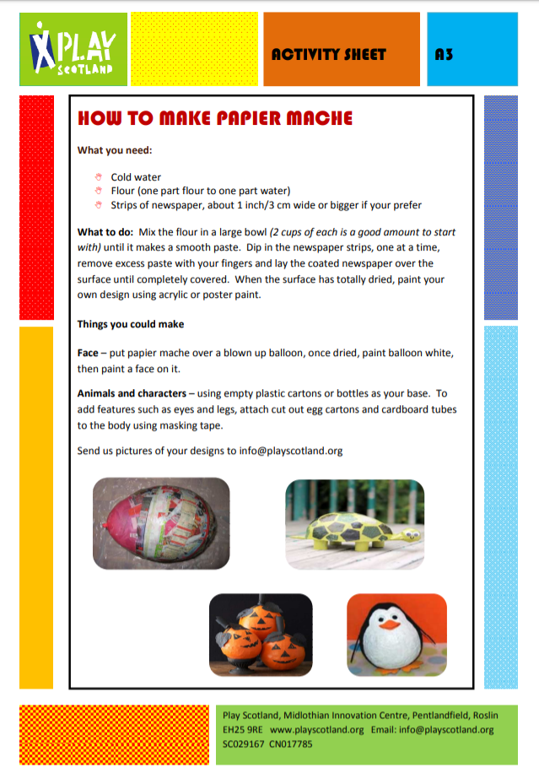
RTE Home School Hub
- This is a fantastic resource and covers all subjects on the curriculum. It is well worth watching this and taking part in the activities it offers.
Scoilnet.ie
- This website covers all areas of the curriculum and can have support activities for topics you are covering in maths/english/irish according to your class. Just use the filters on the home page. It also has a wealth of information for children who may be interested in doing independent project work.

If you as parents are finding things tough during this period and need some advice Barnardos offer a confidential helpline offering support during this crisis : Barnardos Parent Helpline 1800910123
Take a look at gov.ie and the In This Together Section. It offers helpful advice and tips on maintaining mental wellbeing, staying connected and staying active.
Also as your children are now depending more on technology for their entertainment and education please be mindful of what they are looking up and who they are speaking to online. Webwise is an internet usage website that gives lots of good advice to parents.
Remember that if you have any questions don’t hesitate to contact me and there is no pressure to do everything.

