Work for 4th Class: 3rd -5th June 2020
Dear parents and children,
I hope you all had a lovely bank holiday weekend and got to enjoy the beautiful sunshine. As I said to you last week we are pulling back on the core subjects for the next few weeks and giving you more enjoyable activities to do. However we are going to just keep going with the maths and if you could still read every day that would be brilliant. The libraries are opening for click and collect and I have given you details for ordering e books also.
For this first week in June we are looking at Wellness and Mindfulness. I have some really nice activities for you to do at home. In week 2 we are doing a Family Sports Week and planning a Virtual Sports Day on the Friday. We hope you will participate in this with your family at home. In week 3 we will be have a Science and Technology week so save up some bits and pieces at home like toilet rolls and cartons.
You have all worked so hard and we are so proud of you. Thank you for all the efforts you have put into keeping going with your education. We are still waiting for news from the Department of Education as to what school life will look like in September. When we know and have a plan in place we will let you all know. Please keep an eye on your emails and the school website.
Also I know books are practically finished but please do not throw them away yet. Hold onto them for September for revision. We are organising a book drop at the school for children who have books on loan – like the Word Wise book, the History and Geography books or if you have cards from the Comprehension Box. We will have more details next week. For now, enjoy the sunshine and the fresh air and stay well.
Please email me to let me know how your children are doing and if there is anything I can do to help them.
Thinking of you all
Denise Nally
Email: mrsdnally@gmail.com
__________________________________________________________________________________
The following is the work for next week:
3rd – 5th June 2020
Maths :
- Play https://www.topmarks.co.uk/maths-games/hit-the-button or https://mathsframe.co.uk/en/resources/resource/543/Maths-Penalty-Shoot-out it’s for practising your tables.
- Planet Maths: Planet Maths 4
Go to Topic 24 TIME 2 Pg 143. This week we are looking at
time. We will be looking at adding and taking away time. The most important
thing to remember in time is that we don’t add it or take it away like normal
numbers. We have to remember the limit in time is 60. We carry on an hour
once we reach 60 mins.

Day | Pg | Activity
Wednesday | 143  144 | (B) check the difference between the times and continue the pattern. Do no. 1 and 2  (C) no. 1. - do the same here and do (a) and (c)  no. 2 - do a,c,e,g,i  no. 3 - do a,c,e,g,i,k – remember there are 60 mins in an hour.  We are moving on to adding time now. You have to keep hours and mins separate when you add them.  hrs mins  2 45  + 1 30  3 75( change the 75mins into 1hr and 15mins – add the  1hr to the hour side and leave the 15 mins under  the mins side)  = 4hrs 15 mins  (A) Do no. 1 (a) Do no. 2 (a,c,e)  (B) Answer the questions here.
Thursday | 145  146 | (A) We are subtracting time here. Do no 1 (a,c,e) and no 2 (a,c,e,)  (B) When you are taking time away and the minutes on the bottom line are greater than the minutes on the top then you have to borrow an hour and pass it over to the minutes e.g.  hrs mins hrs mins  4 15 → 3 75  - 2 50 -2 50 (now you can take 50 away from  75)  Do no. 1 (a,c) and 2 (a,c,e)  Do no. 5  (A) Look at the time table. Answer any four questions from this section  (B) Answer any four questions.
Friday | 147 | (A) This is the revision page – do your best.
- Look up the website Topmarks and pick “Time” – there are lots of games here to revise and reinforce the concept of time.
- Play Mental Up and Prodigy too. A fun way of doing maths.
- For children on other maths books work on your Mental Maths and New Wave Mental Maths and work on the online maths games.

English:
- Please read every day
- Because we didn’t get to finish our novel Wonder, look up https://www.librariesireland.ie/elibrary/ebooks and try to either read it or listen to it. If you don’t have your library number give Mark a ring and he can help you.

WELLNESS WEEK.
This week we are focussing on your wellbeing and mindfulness – keeping you in a happy place and knowing how to go there.
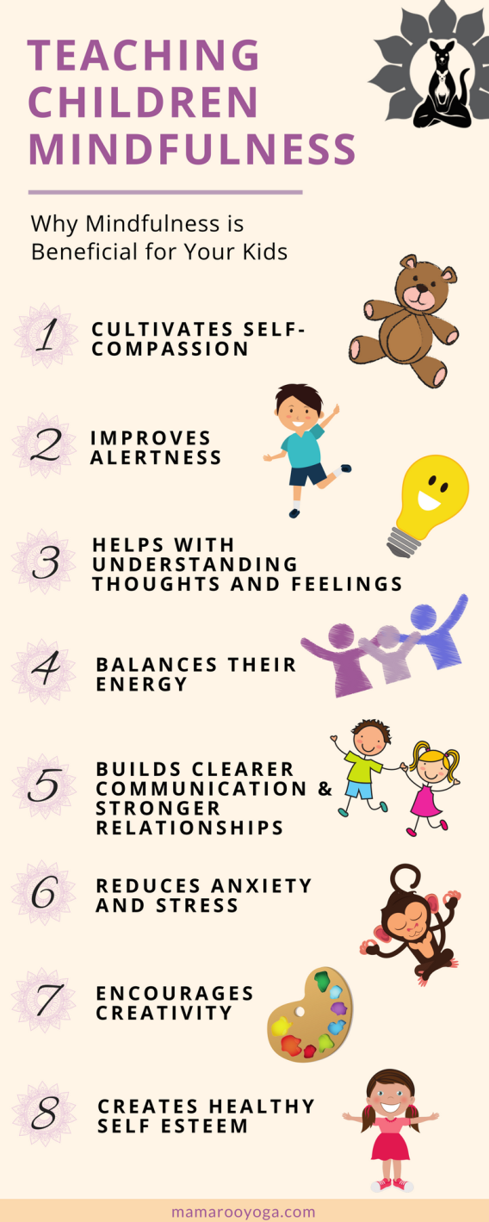

Wednesday
- Start your day with a breathing exercise. It’s just 15 mins https://www.youtube.com/watch?v=Bk_qU7l-fcU. Think about how this breathing exercise makes you feel.
- Look up Cosmic Kids Yoga https://www.youtube.com/watch?v=wBdMZMEKq-s and do the Stella the Stick Yoga. Wear loose clothing and have a clear space. It’s about 20 mins.
- Keep going with your Gratitude Jar but start a new one now - My Hope Jar – this is where you write out something you would like to do when life gets back on track again. What do you hope for and wish for??? It could be going to the beach and seeing the ocean, it could be playing with your cousins, it could be going to the zoo with your family. Fill it up for the next month.

Thursday
- Do this exercise this morning first thing in the morning. Do it during the day if you feel tense.
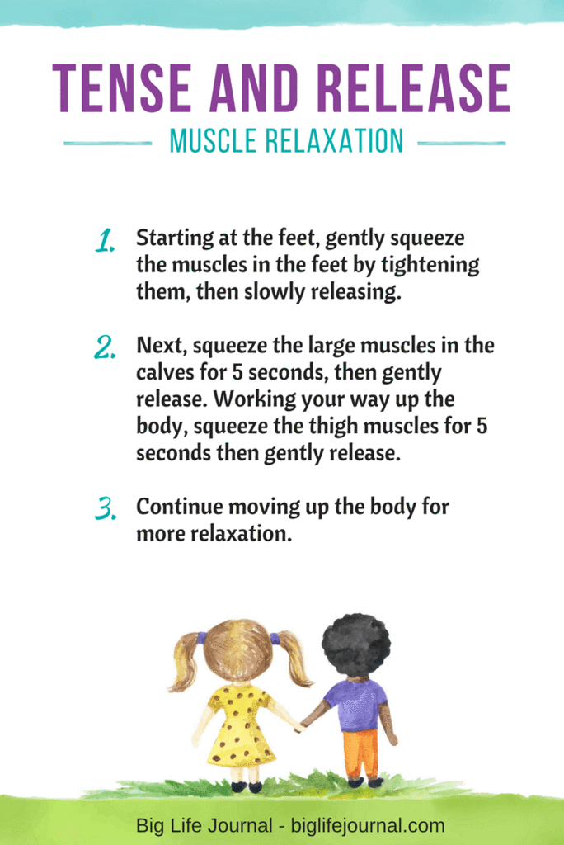
- Today ring or text 5 people who matter to you and tell them you were thinking about them and ask them to do the same the following day.
- Before you go to sleep tonight listen to this guided meditation and let it help you go peacefully to sleep https://www.youtube.com/watch?v=DWOHcGF1Tmc

Friday
- This morning start with the breathing exercise from Wednesday https://www.youtube.com/watch?v=Bk_qU7l-fcU.
- Today we are going to do an art activity based on your breath. You just need paper and colours. At the start of your day draw what you think your breath looks like - is it a swirling wind, is it like a tail of a kite flying away. Pick a colour that reflects how your breath is at that time – is it calm, is it tired, are you out of breath, are you tense. Do this 5 times during the day and put a collage together of the 5 times you drew your breath. What colours did your use? What kind of lines do you use? Can you see where you were calm and where you were tense?
- Finally give everyone in your home a hug today and tell them how grateful you are for them and love them.
- Finish your day with a guided body scan to help with relaxation https://soundcloud.com/mindfulmagazine/body-scan-meditation-for-kids

Just a few extra ideas for the month of JUNE to keep you busy if you are bored.
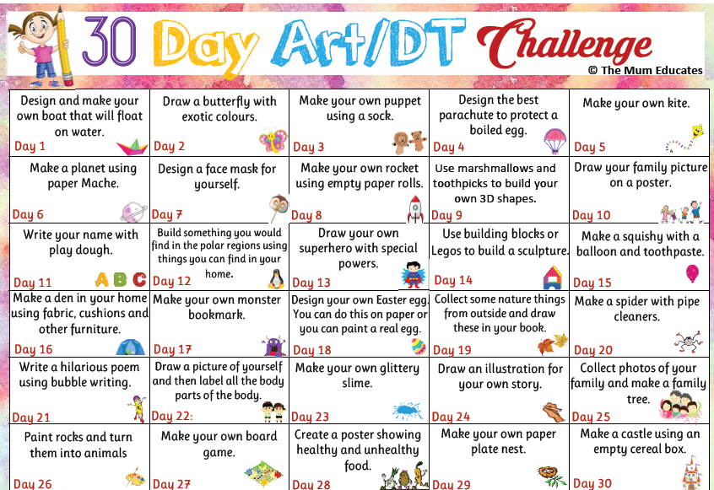

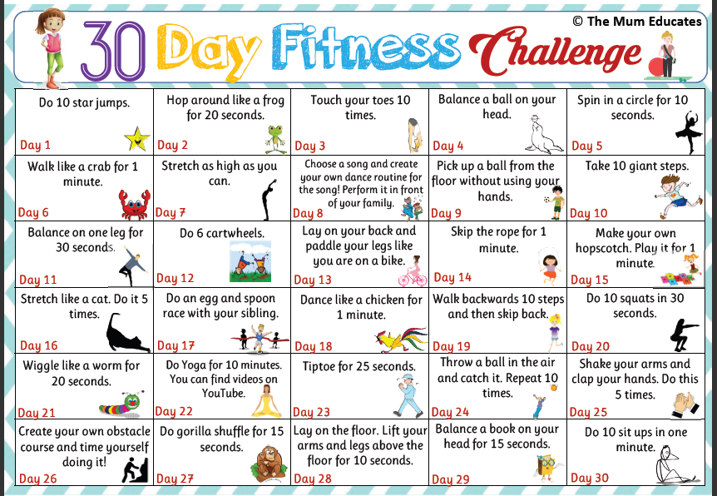

If you as parents are finding things tough during this period and need some advice Barnardos offer a confidential helpline offering support during this crisis : Barnardos Parent Helpline 1800910123
Take a look at gov.ie and the In This Together Section. It offers helpful advice and tips on maintaining mental wellbeing, staying connected and staying active.
Also as your children are now depending more on technology for their entertainment and education please be mindful of what they are looking up and who they are speaking to online. Webwise is an internet usage website that gives lots of good advice to parents.
Remember that if you have any questions don’t hesitate to contact me and there is no pressure to do everything.

