Work for 5th Class: 15th - 19th June 2020
Dear parents and children,
Time is ticking away and we are getting closer and closer to the end of term. I hope you enjoyed the Sports Week. The teachers have been very busy writing school reports and these should be with you next week. Booklists and the school calendar will follow in the coming weeks. We still are awaiting word from the Department before we finalise our calendar. It should come this week.
This week is our STEM week and I have one easy STEM activity a day for you to do using items you can very easily find around the house. Please try them. I did the Pringles one and then I ate it.
We are still working away on the maths and I hope you are all continuing to read every day. It is really important that you read every day.
Please email me to let me know how your children are doing and if there is anything I can do to help them.
Thinking of you all
Denise Nally
Email: mrsdnally@gmail.com
__________________________________________________________________________________
The following is the work for next week:
15th – 19th June 2020
Maths :
- Play https://www.topmarks.co.uk/maths-games/hit-the-button or https://mathsframe.co.uk/en/resources/resource/543/Maths-Penalty-Shoot-out it’s for practising your tables.
- Planet Maths: Planet Maths 5
Go to Topic 27 CAPACITY Pg 176. This week we are looking at capacity.
This is just about how much liquid a container can hold. We measure capacity
in millilitres and litres. There are 1,000mls in a litres.
Day | Pg | Activity
Monday | 176 | (B) Look at containers around your house that hold liquids – milk and juice cartons, washing up liquid bottles etc. Estimate first how much they hold and then look at their capacity. Also estimate and then measure the capacity of various items around your home e.g. a glass, a cup, a saucepan, spoon and measure with a measuring jug. Keep this information- you will need it for Tuesday.
Tuesday | 177 | (A) a graduated cylinder is similar to a jug. It measures liquid. Do (2,4,6,8,10)  (B) Do 1,4,8  (C) use the containers you used in (B) on Monday and calculate the difference between your estimate and the actual capacity.
Wednesday | 178 | (A) 1,000ml is a litre. 1/10 of a litre would be 100ml, 1/100 of a litre would be 10ml. 1/1000 of a litre would be 1ml. Do no. 1 and 3  (B) do no. 1,3,5  (C) to work out the fraction put the amount over 1,000 and break it down. In no 7 the “e” stands for estimated. Write them as a decimal and a fraction. Do no 1,3,5,7
Thursday | 179 | (A) Problem solving - do any 4 questions. These are tricky.
Friday | 180 | (A) This is the revision page – Do B,C,D only
- Look up the website Topmarks and pick Capacity –play Coconut ordering for capacity. Also https://primaryfacts.com/5236/volume-and-capacity-games-maths-games-for-kids/
- Play Mental Up and Prodigy too. A fun way of doing maths.
- For children on other maths books work on your Mental Maths and New Wave Mental Maths and work on the online maths games.

English:
- Please read every day
- Because we didn’t get to finish our novel Wonder, look up https://www.librariesireland.ie/elibrary/ebooks and try to either read it or listen to it. If you don’t have your library number give Mark a ring and he can help you.
MONDAY

Make a Pringle Ring

Can you build a ring using only Pringles chips?
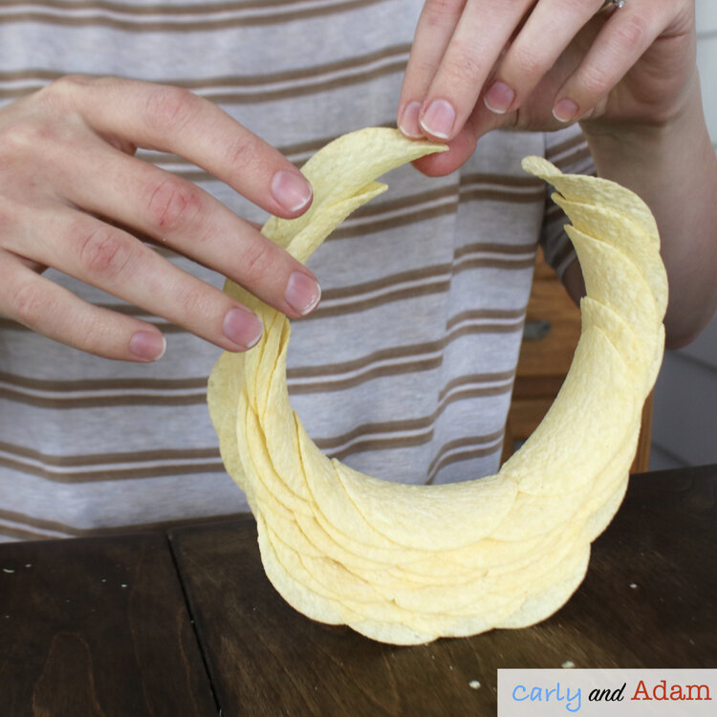
The Pringles Ringle is an engineering challenge with the goal of creating a ring using only Pringles chips, no tape or glue allowed!
This challenge requires a lot of patience as well as careful and precise chip placement. Although, the hardest part of the challenge is not eating all of the chips before finishing the ring.
TUESDAY

Apple Tower STEM Challenge
With this challenge students must design a tower that can support the weight of an apple. To build their apple tower students can use straws, tape, and scissors.
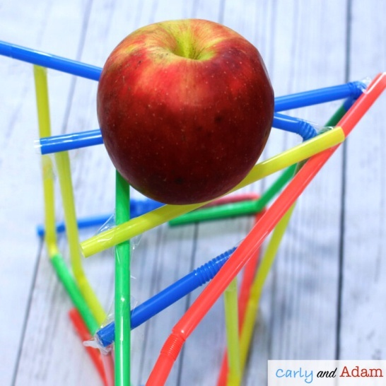
Challenge : see how tall you can build your tower!
WEDNESDAY

Apple Oxidation Experiment
Why do apples turn brown?
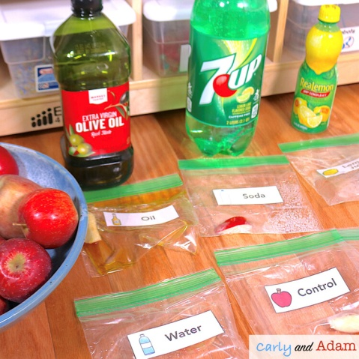
For this experiment you learn about chemical changes as you observe apple oxidation. Test different items such as water, oil, soda, vinegar, and lemon juice to see what is the best way at preventing the apples from turning brown. You need plastic zip lock bags, slices of apple and the liquids mentioned above. Put a tablespoon of each liquid in a bag with a slice of apple and label them. Watch how they react and see how long each slice lasts before it oxidises or turns brown.

THURSDAY
MAKE YOUR OWN HOVERCRAFT
https://www.sfi.ie/site-files/primary-science/media/pdfs/col/sci_at_home_make_hovercraft.pdf
This is a fun activity and you should be able to find all the equipment at home.

FRIDAY
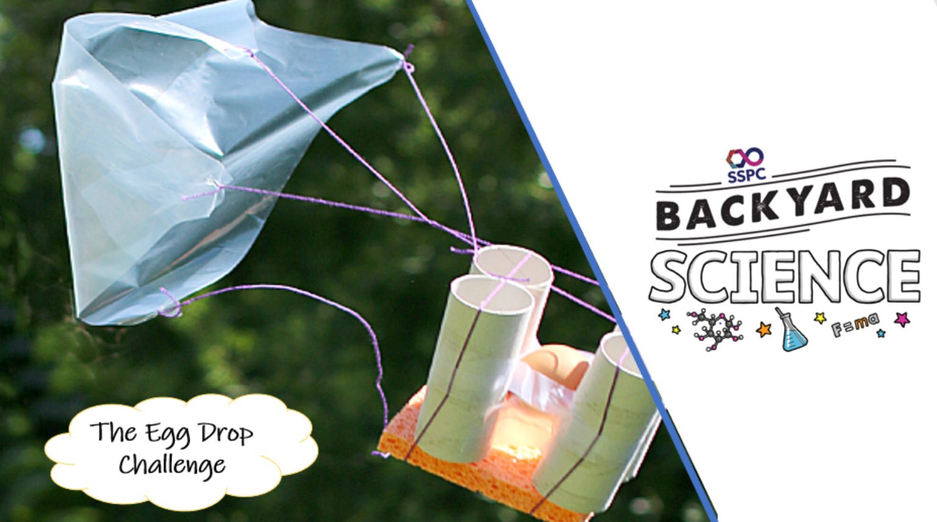

Do this one outside. You have to design a contraption made of recyclable materials to build a protective device for an egg. You can use tape or glue or twine to hold materials together. You must try to make sure your egg does not break when you drop it out of your highest window.
Watch this clip for inspiration https://www.youtube.com/watch?v=nsnyl8llfH4
Please send pictures of you as young scientists.

