Work for 5th Class: 11th – 15th May 2020
Dear parents and children,
Monday morning comes around all too soon. I hope you enjoyed the activities for our “pause week” and tried something different. So I hope you come back with renewed enthusiasm this week. It is important that we keep working away at the core subjects of English, Irish and Maths. It will really stand to you when we come back. We did get the news that on May 18th teachers will be allowed back into the school (fingers crossed) so we will aim to get all your school books out to you in the following days.
I know it is hard to stay motivated but you have to try to keep your spirits up and keep filling your day with purposeful activities. It’s not all about the academics. Remember the activity poster I gave you last week of activities that are still teaching you something. Make a timetable for your schoolwork and have time to do more enjoyable activities.
I saw some fabulous pictures and videos of you at work and play while we are apart. It is so good to see your smiling faces. Keep them coming. Keep your eye on the website and remember, the majority of answers for the week’s work are on the school website which are posted on a Friday.
Please email me to let me know how your children are doing and if there is anything I can do to help them.
Thinking of you all
Denise Nally
Email: mrsdnally@gmail.com
__________________________________________________________________________________
The following is the work for next week:
11th – 15th May 2020
Maths :
- Tables Champion: Week 26
- Play https://www.topmarks.co.uk/maths-games/hit-the-button or https://mathsframe.co.uk/en/resources/resource/543/Maths-Penalty-Shoot-out it’s for practising your tables.
- New Wave Mental Maths: Week 29
- Planet Maths: Access Planet Maths 5 at https://www.folensonline.ie/ We are doing chapter 23 this week – Rules and Properties. We are not doing ch 22 The Circle as you really need to be in school to do this. Follow the plan for the week to the best of your ability.
Day | Pg | Activity
Monday | 143 | (B) Fill in the missing shapes and add the next four shapes  (C) Write the next three numbers in the sequence. If you are finding this tricky figure out the difference between the numbers e.g.  -6 -7 -8  90 84 77 69  (D) Fill in the missing numbers in the sequences.
Tuesday | 144 | (A) Fill in the missing symbols.  (B) Draw the next 4 terms.  (C) Describe what is happening in each of these patterns. These are tricky.  (D) Describe these also. They are trickier. They could include multiplication and division as well as addition and subtraction. Remember you can increase and decrease in addition +1,+2,+3,+4 or -1,-2,-3,-4-
Wednesday | 145 | (A) (B)Look at the blue box and see how you can figure out these problems in two different ways. Take the example 15-6-4 = 5 or 13. The way you get the answer is directly take 6 from 15(=9) and then take 4 and get 5. Or you could take 4 from 6 first and get 2 and then take 2 from 15 and get 13. You can see it in two ways. You can so the first part of the problem first or the second part of the problem first. Some of the answers in B will be the same.  (C) (D) To stop this confusion we use brackets to guide us. Do what is in the brackets first.
Thursday | 146 | My favourite term in maths is BOMDAS – Brackets Of Multiplication, Division, Addition and Subtraction. This gives you the order of what to do first when you don’t have brackets. If you are given 13 x 4 + 11 you put brackets around (13 x 4) and do this first. Then add on 11. If you were given 121÷11 -5 = (121÷11) -5 and work it out. If you were given 150 - 100÷5 =150 –(100÷5) and work it out.  (A) do section A- figure out where to put the brackets and work them out  (B) figure out where to put the brackets and use a calculator to work them out.
Friday | 147 | This is the revision section. Do as much as you are able to do.
- If you cannot access this do not worry we will be going over everything again once we get back to school. Look up the website Topmarks - Patterns to give yourself some extra practice. Pick an age appropriate activity.
- Remember to keep practising your tables.
- Play Mental Up and Prodigy too. A fun way of doing maths.
- For children on other maths books work on your Mental Maths and New Wave Mental Maths and work on the online maths games.

English:
- Reading: WorldBookonline.com- this is free at the moment– try to access this through scoilnet.ie. Find a book that interests you. Read every day
- https://my.cjfallon.ie/dashboard/student-resources In Word Wise 5 Unit 15 -
Day | Activity
Monday | Read pg 72 , Answer questions on pg 73 Section A and do the true or false in Section B
Tuesday | Pg 73 Section C find the opposite meaning in the article  Pg 74 Similes are used to compare two things using like or as e.g. as cold as ice, fight like cats and dogs. Do section A  Metaphors are like Similes but you don’t use like or as. Do Section B
Wednesday | Pg 74 Collective nouns – Section C – write your own sentences.  Pg 75 Antonyms – these are words opposite in meaning to another e.g. big/small, happy/sad Do Section A and B
Thursday | Pg 75 Homonyms - these are words that are spelt the same and sound the same but have different meanings – e.g. left( like your left hand) or left( to leave a place) Do Section C
Friday | Oral Language: pg 77 play the memory game and guess what it is game with someone in your house

- Read at Home: Week 27 –answer the questions orally.
- Spelling List: List 24 learn. Ask your parents to test you orally.
- WOW Words: gourmet, impeccable, malevolent, offend, refrain
Gaeilge:
- Rí Rá: Aonad 24(Look up words in dictionary)
- Seo Leat 5: Go to the website: https://my.cjfallon.ie/dashboard/student-resources. Then pick -Primary -5th Class – Gaeilge –Seo Leat –Seo Leat 5. Follow the online instructions. Go to the online book. Chapter 17 An Margadh Saothair( The Sale of Work – charity sale) pg 96
- Work your way through the vocabulary and think about how you would use them in sentences to describe the pictures. Use your dictionary. It’s is available on line as well ( foclóir.ie). The interactive option gives you the pronunciation of the words. Do your best. Section A – draw simple pictures to match the phrase given. Do your best. We are going to revise some vocabulary and grammar – go to pg 120. Go back over Dathanna, Uimhreacha, duine, beirt, etc. Pg 121 laethanta na seachtaine, na Míonna, na séasúir, pg 122 buncheisteanna, ceisteanna coitianta (Common questions)
- For those who cannot access this use Duolingo online and keep practising a little irish every day.
- Also to practise your vocabulary every day download the Cúla 4 app on your phone and practise the words and phrases
After this I’m making a choice box. Pick what you want to do:
Fact of the Day:  - Look up a new fact every day | Go Noodle:  - Keep doing your Go Noodle activities | Joe Wicks  - Joe Wicks is a fantastic trainer and is posting brilliant lessons on You Tube. Aim to do one a day.
Journal:  - Keep a diary of your time at home. This will be your creative writing and it will be something you will always remember. | Music:  - Look up the song “Don’t stop Believing” by Journey. Rock out in the kitchen. This is one of my favourite songs. | Meditation:  - The Gratitiude Tree – guided meditation. Look it up on You Tube
Art:  - Find a picture at home like a flower or an animal. Cut it in half vertically. Stick it on a page and draw the other side yourself – this is symmetry. | SPHE:  - Continue with your Gratitude Jar | Science  - Magic Ink. See the attached activity. If you use an iron it is better than a lamp

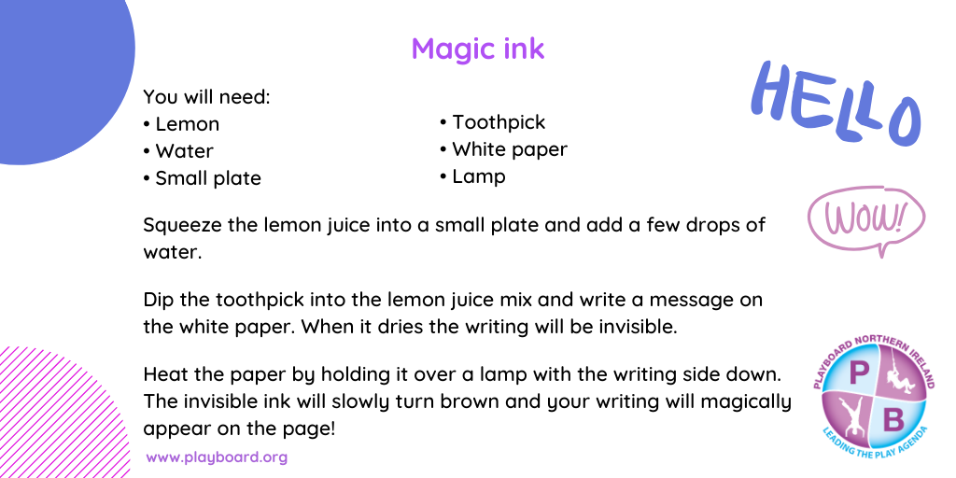
STEM/ ICT:
- Look up https://www.codingireland.ie/WeeklyChallenge. They set weekly challenges with step by step guidelines that teach you coding through the Scratch programme. This was something I had planned on doing with you this year.
RTE Home School Hub
- This is a fantastic resource and covers all subjects on the curriculum. It is well worth watching this and taking part in the activities it offers.
Scoilnet.ie
- This website covers all areas of the curriculum and can have support activities for topics you are covering in maths/English /Irish according to your class. Just use the filters on the home page. It also has a wealth of information for children who may be interested in doing independent project work.

If you as parents are finding things tough during this period and need some advice Barnardos offer a confidential helpline offering support during this crisis : Barnardos Parent Helpline 1800910123
Take a look at gov.ie and the In This Together Section. It offers helpful advice and tips on maintaining mental wellbeing, staying connected and staying active.
Also as your children are now depending more on technology for their entertainment and education please be mindful of what they are looking up and who they are speaking to online. Webwise is an internet usage website that gives lots of good advice to parents.
Remember that if you have any questions don’t hesitate to contact me and there is no pressure to do everything.

