Work for 5th Class: 18th – 22nd May 2020
Dear parents and children,
How are you all doing? You are all so brilliant to keep going through this time and I hear great reports from your parents that you are keeping up with your work. Well done to you all. I am so proud of you. I suppose you know by now that we will not be back until September at the earliest. This saddens me terribly as I will not get to see you all before the summer. I wish things were different for all of us but we have to keep going and keep our spirits up and get the best out of this time.
For the next two weeks we will be doing work as normal, but in the month of June we will be pulling back and doing less in the core subjects and more fun activities - like what we would be doing in June if we were at school. We want you to enjoy yourselves.
I will be going into school to organise your books on Monday and all your books will be returned to you in the coming days. Please do not throw out any of your school books as we will be revising when we come back in September. For now, keep going and doing your best. You are wonderful and I really miss you all.
Please email me to let me know how your children are doing and if there is anything I can do to help them.
Thinking of you all
Denise Nally
Email: mrsdnally@gmail.com
__________________________________________________________________________________
The following is the work for next week:
18th – 22nd May 2020
Maths :
- Tables Champion: Week 27
- Play https://www.topmarks.co.uk/maths-games/hit-the-button or https://mathsframe.co.uk/en/resources/resource/543/Maths-Penalty-Shoot-out it’s for practising your tables.
- New Wave Mental Maths: Week 30
- Planet Maths: Access Planet Maths 5 at https://www.folensonline.ie/ We are doing chapter 24 Weight pg 152 this week Follow the plan for the week to the best of your ability.
Day | Pg | Activity
Monday | 152 | (A) Rank these items from lightest to heaviest –orally.  (B) Fill in the table in this section. How would you weigh these things and would you use grams or kilograms?
Tuesday | 153 | (A) How heavy are these items ?  (B) There are 1,000 grams in a kilogram. To show these as a decimal you can do it in the following way. 1 g – 0.001kg, 10grams – 0.010kg (zero at the end is unnecessary) 15 grams – 0.015 kg, 700 g- 0.700 kg (zeros at the end are unnecessary) 789g – 0.789 kg, 2,345 g -2.345 kg.  (C) Half of a kilogram is 500 grams – you divide 1,000 by 2. To work out a quarter you divide by 4 – remember to work out a fraction of a number you divide by the bottom of the fraction and multiply by the top.  (D) Use you fraction/decimal sheet to work out your decimals and mark them in pencil on the scales.
Wednesday | 154 | This section is about you estimating weight by looking at an item.  (A) Look at each item and the suggested weights – which one is the closest.  (B) Find 10 things around your house that you can weigh. Estimate the weight of it, weigh it and then see what is the difference.
Thursday | 146 | Don’t do this page. Instead follow the link and play  https://www.ictgames.com/mobilePage/mostlyPostie/index.html
Friday | 147 | This is the revision section. Do as much as you are able to do.
- If you cannot access this do not worry we will be going over everything again once we get back to school. Play the game for Thursday to give yourself some practice with weight and do the activity for Wednesday.
- Remember to keep practising your tables.
- Play Mental Up and Prodigy too. A fun way of doing maths.
- For children on other maths books work on your Mental Maths and New Wave Mental Maths and work on the online maths games.

English:
- Reading: WorldBookonline.com- this is free at the moment– try to access this through scoilnet.ie. Find a book that interests you. Read every day
- https://my.cjfallon.ie/dashboard/student-resources In Word Wise 5 Unit 16 – THE MONTHS
Day | Activity
Monday | Read the poem The Months on pg 78 , Answer questions on pg 79 Section A and do match the words in Section B
Tuesday | Pg 79 Read the box to remind you what a homophone, synonym and antonym are. Do section C  Pg 80 In our language words are divided into the categories of male or female – e.g. brother is male, and sister is female. Do Section A
Wednesday | Pg 80 Do Section B and Section C. In Section put animal families together e.g. mother, father, boy, girl
Thursday | Pg 81 Rhyming Words – Do Section A and Section B
Friday | Poetry: Write a rhyming poem about the days of the week. Send them on to me. I’d love to read them

- Read at Home: Week 29 –answer the questions orally.
- Spelling List: List 25 learn. Ask your parents to test you orally.
- WOW Words: find 5 words in the dictionary that you never knew about and read their definition

Gaeilge:
- Rí Rá: Aonad 25 (Look up words in dictionary)
- Seo Leat 5: Go to the website: https://my.cjfallon.ie/dashboard/student-resources. Then pick -Primary -5th Class – Gaeilge –Seo Leat –Seo Leat 5. Follow the online instructions. Go to the online book. Chapter 18 Bláthanna agus Beacha ( Flowers and Bees) pg 96
- Work your way through the readin and do your best to translate it. Use your dictionary. It’s is available on line as well ( foclóir.ie). The interactive option gives you the pronunciation of the words. Do your best. Section A – answer the questions. In Section D do the second section “Rith Mugall ar fud na háite” – Mugall ran all over the place. We are going to revise some vocabulary and grammar – go to pg 123. Go back over Mothucháin (Feelings), pg 124 Réamhfhocail, Gluaiseacht, Comparáidí
- For those who cannot access this use Duolingo online and keep practising a little irish every day.
- Also to practise your vocabulary every day. Download the Cúla 4 app on your phone and practise the words and phrases
After this I’m making a choice box. Pick what you want to do:
Fact of the Day:  - Look up a new fact every day | Go Noodle:  - Go Noodle activities | Joe Wicks  - Joe Wicks is a fantastic trainer and is posting brilliant lessons on You Tube. Aim to do one a day.
Journal:  - Keep a diary of your time at home. This will be your creative writing and it will be something you will always remember. | Music:  - Look up the song “High Hopes” by Kodaline. Google their appearance on the Late Late Show. Inspiring. | Meditation:  - The Gratitude Tree – guided meditation. Look it up on You Tube
Art:  - Cut out a large heart shape in cardboard and make holes 1cm apart all over and fill each hole with a daisy from your garden. Make sure the whole heart is covered in daisies. | SPHE:  - Continue with your Gratitude Jar | Art  Look at the attachment after this box
Drama
- Look up the link https://gaietyschool.com/wp-content/uploads/2020/04/Star-Wars.pdf . There are loads of great ideas for drama games and activities to do with the people at home
STEM/ ICT:
- Look up https://www.codingireland.ie/WeeklyChallenge. They set weekly challenges with step by step guidelines that teach you coding through the Scratch programme. This was something I had planned on doing with you this year.

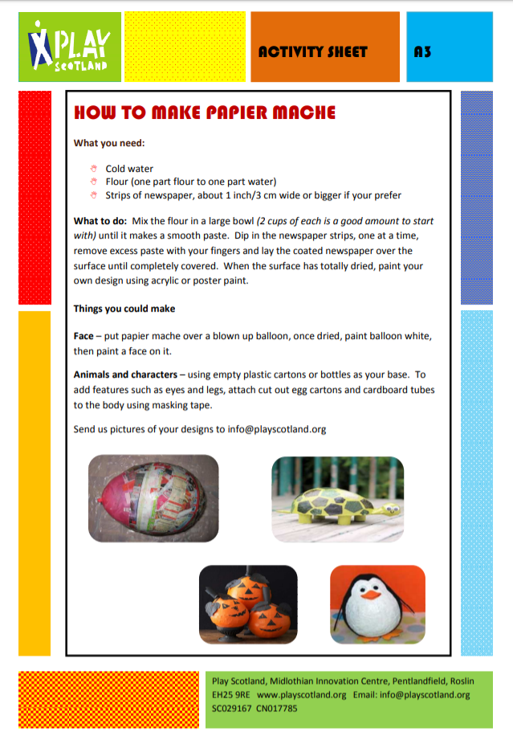
RTE Home School Hub
- This is a fantastic resource and covers all subjects on the curriculum. It is well worth watching this and taking part in the activities it offers.
Scoilnet.ie
- This website covers all areas of the curriculum and can have support activities for topics you are covering in maths/english/irish according to your class. Just use the filters on the home page. It also has a wealth of information for children who may be interested in doing independent project work.

If you as parents are finding things tough during this period and need some advice Barnardos offer a confidential helpline offering support during this crisis : Barnardos Parent Helpline 1800910123
Take a look at gov.ie and the In This Together Section. It offers helpful advice and tips on maintaining mental wellbeing, staying connected and staying active.
Also as your children are now depending more on technology for their entertainment and education please be mindful of what they are looking up and who they are speaking to online. Webwise is an internet usage website that gives lots of good advice to parents.
Remember that if you have any questions don’t hesitate to contact me and there is no pressure to do everything.

