Work for 6th Class: 15th - 19th June 2020
Dear parents and children,
Time is ticking away and we are getting closer and closer to the end of term. I hope you enjoyed the Sports Week. The teachers have been very busy writing school reports and these should be with you next week. Booklists and the school calendar will follow in the coming weeks. We still are awaiting word from the Department before we finalise our calendar. It should come this week.
This week is our STEM week and I have one easy STEM activity a day for you to do using items you can very easily find around the house. Please try them. I did the Pringles one and then I ate it.
We are still working away on the maths and I hope you are all continuing to read every day. It is really important that you read every day.
Well done to you all on our Transition to Secondary School workshop. I was so overwhelmed seeing you all. I couldn’t stop smiling and all I wanted was to be back in the classroom having fun with you all and preparing for your graduation. Your graduation Phase 1 will happen on Wednesday 24th. It will not be the usual one – you will not be in school. It will be at home but we will mark it in a special way. I will be in touch with your parents about it. We will have you back to school again when it is safe to mark your graduation Phase 2 with friends and family hopefully.
Please email me to let me know how your children are doing and if there is anything I can do to help them.
Thinking of you all
Denise Nally
Email: mrsdnally@gmail.com
__________________________________________________________________________________
The following is the work for next week:
15th – 19th June 2020
Maths :
- Play https://www.topmarks.co.uk/maths-games/hit-the-button or https://mathsframe.co.uk/en/resources/resource/543/Maths-Penalty-Shoot-out it’s for practising your tables.
- Planet Maths: Planet Maths 6
Go to Topic 28 AVERAGES AND CHARTS Pg 174. This week we are looking at
averages and using charts to find out information and record information.
Day | Pg | Activity
Monday | 174 | (B) Remember to find an average add the numbers and divide the answer by the amount of numbers you have. E.g 4,6,8 – add them and get 18. Because there are 3 numbers we divide by 3.  Do no. 1 (a,c,e,g) Do no. 2 (a,c,e) Do no. 3  (C) work out the average for only two events – your choice  (D) To find out a number when you are given an average you multiply by the amount of numbers you had so e.g. if you had 4 numbers and the average is 15 and three of the numbers are 12, 24 and 10. You multiply 15 by 4 and get 60. You reverse the operation. Take away the numbers you were given from 60 and you get the fourth number 60-(12+ 24+10) = 14 Do 1 and 3
Tuesday | 175 | (A) Do all of A  (B) Look across the line horizontally to pick the best 5 scores for each player. You only have to do 3 players.  (C) Look across the line horizontally to pick the fastest 4 scores for each player. You only have to base it on Whiz Kid, The Arrow and Missile Man .
Wednesday | 176 | Large amounts of information are recorded on spreadsheets.  (A) answer this orally  (B) do this.. in no.3 the annual sales are calculated by adding the 4 quarters for a product. Read each product horizontally. Just do solar battery chargers, solar lights and recycled glass bottles. In no. 4 to calculate the average add the 4 quarters for each product and divide by 4. Only do the products I mentioned in 3. You don’t have to do 5.
Thursday | 177 | (A) This is too tricky to teach remotely – read this. It is about breaking up the full rotation of a circle 360◦ into fractions. I’m not going to ask you to answer questions on it. Try to make sense of it.
Friday | 178 | (A) This is the revision page – Do B,C,D only
- Look up the website Topmarks and pick Bamzooki to practice averages .
- Play Mental Up and Prodigy too. A fun way of doing maths.
- For children on other maths books work on your Mental Maths and New Wave Mental Maths and work on the online maths games.

English:
- Please read every day
- Because we didn’t get to finish our novel Wonder, look up https://www.librariesireland.ie/elibrary/ebooks and try to either read it or listen to it. If you don’t have your library number give Mark a ring and he can help you.
MONDAY

Make a Pringle Ring

Can you build a ring using only Pringles chips?
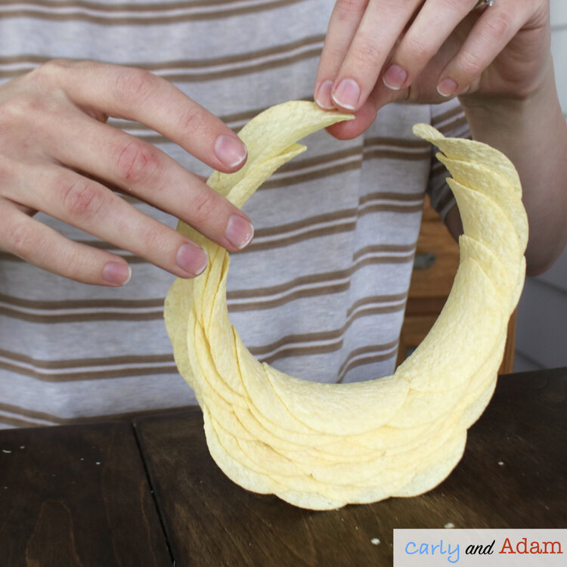
The Pringles Ringle is an engineering challenge with the goal of creating a ring using only Pringles chips, no tape or glue allowed!
This challenge requires a lot of patience as well as careful and precise chip placement. Although, the hardest part of the challenge is not eating all of the chips before finishing the ring.
TUESDAY

Apple Tower STEM Challenge
With this challenge students must design a tower that can support the weight of an apple. To build their apple tower students can use straws, tape, and scissors.
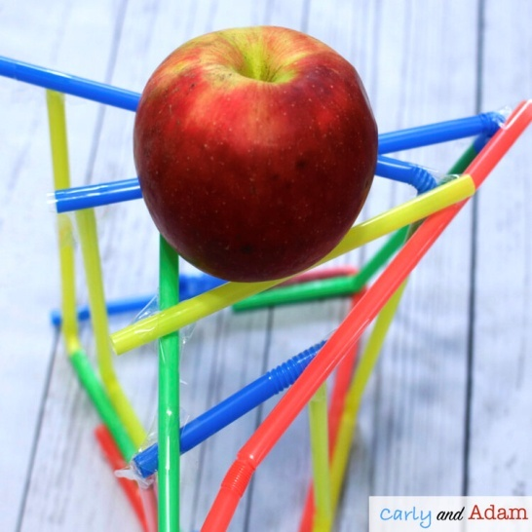
Challenge : see how tall you can build your tower!
WEDNESDAY

Apple Oxidation Experiment
Why do apples turn brown?
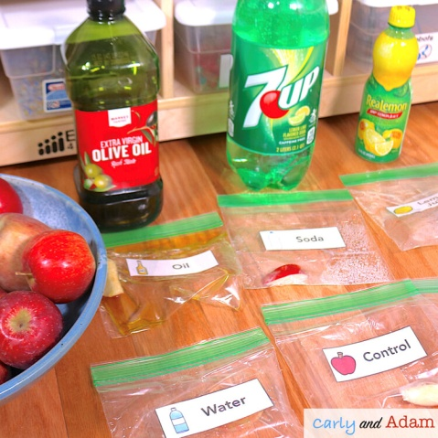
For this experiment you learn about chemical changes as you observe apple oxidation. Test different items such as water, oil, lemonade, vinegar, and lemon juice to see what is the best way at preventing the apples from turning brown. You need plastic zip lock bags, slices of apple and the liquids mentioned above. Put a tablespoon of each liquid in a bag with a slice of apple and label them. Watch how they react and see how long each slice lasts before it oxidises or turns brown.

THURSDAY
MAKE YOUR OWN HOVERCRAFT
https://www.sfi.ie/site-files/primary-science/media/pdfs/col/sci_at_home_make_hovercraft.pdf
This is a fun activity and you should be able to find all the equipment at home.

FRIDAY
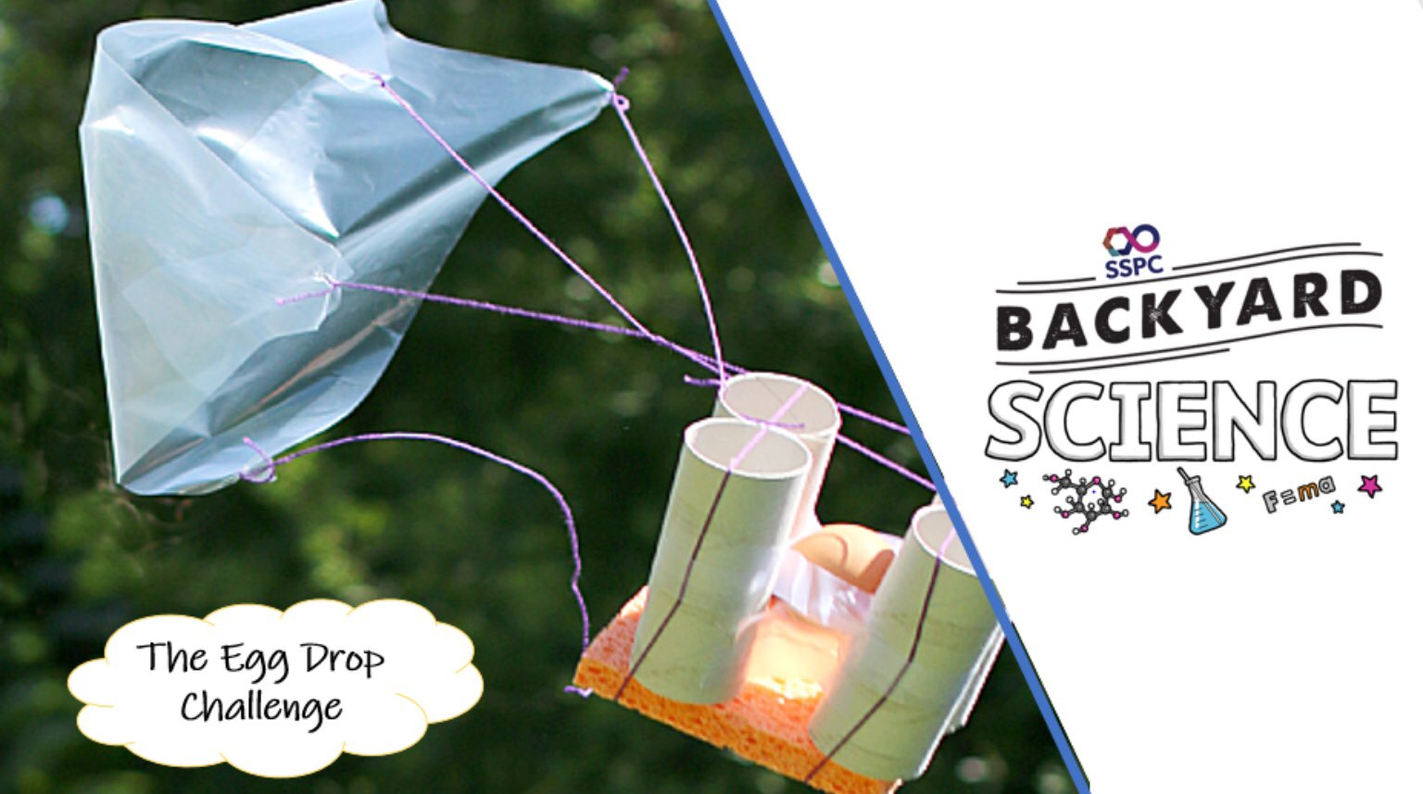

Do this one outside. You have to design a contraption made of recyclable materials to build a protective device for an egg. You can use tape or glue or twine to hold materials together. You must try to make sure your egg does not break when you drop it out of your highest window.
Watch this clip for inspiration https://www.youtube.com/watch?v=nsnyl8llfH4
Please send pictures of you as young scientists.

