Work for 6th Class: 11th – 15th May 2020
Dear parents and children,
Monday morning comes around all too soon. I hope you enjoyed the activities for our “pause week” and tried something different. So I hope you come back with renewed enthusiasm this week. It is important that we keep working away at the core subjects of English, Irish and Maths. It will really stand to you when we come back. We did get the news that on May 18th teachers will be allowed back into the school (fingers crossed) so we will aim to get all your school books out to you in the following days.
I know it is hard to stay motivated but you have to try to keep your spirits up and keep filling your day with purposeful activities. It’s not all about the academics. Remember the activity poster I gave you last week of activities that are still teaching you something. Make a timetable for your schoolwork and have time to do more enjoyable activities.
I saw some fabulous pictures and videos of you at work and play while we are apart. It is so good to see your smiling faces. Keep them coming. Keep your eye on the website and remember, the majority of answers for the week’s work are on the school website which are posted on a Friday.
Please email me to let me know how your children are doing and if there is anything I can do to help them.
Thinking of you all
Denise Nally
Email: mrsdnally@gmail.com
__________________________________________________________________________________
The following is the work for next week:
11th – 15th May 2020
Maths :
- Tables Champion: Week 26
- Play https://www.topmarks.co.uk/maths-games/hit-the-button or https://mathsframe.co.uk/en/resources/resource/543/Maths-Penalty-Shoot-out it’s for practising your tables.
- New Wave Mental Maths: Week 29
- Planet Maths: Access Planet Maths 6 at https://www.folensonline.ie/ We are doing chapter 22 Directed Numbers pg 136. Directed numbers are about positive and negative numbers. Positive numbers go above zero. Negative numbers go below zero. Think about when the weather gets really cold and the weather forecaster says it is minus 3 degrees. That is a negative numbers. You can also think about it when you dive underwater and go 100 feet below sea level – that is a negative number.

Day | Pg | Activity
Monday | 136 | (A) Look at the picture and familiarise yourself with water levels above and below zero.  (B) Draw a number line and remember that positive numbers are to the right of the number line and negative numbers are to the left.  (C) Write what temperature is on the thermometer. Draw your own thermometers and mark the temperatures.
Tuesday | 137 | (A) Start at zero each time. Follow the frog jumps up and down.  (B) This is the same as the frog jumps. Positive means you move to the right, negative means you move to the left.  (C) use the number line and figure these out as well. Do every second one.  (D) put in the correct symbol. Do every second one. Remember ‹ is less than and › is greater than.  (E) Put these in order. Do every second one.  (F) Leave this out
Wednesday | 138 | (A) Answer the questions. For no. 7 remember to get your average you add the different stations together and then divide by the number of stations. Be careful you have to add the positive numbers and take away the negative numbers.  (B) Profit is money we make and loss is money we lose. Break even means you did not make a profit or a loss. Answer the questions.
Thursday | 139 | (A) Read the blue box about bank accounts. When you spend more than you have you are said to be overdrawn. Your money is now overdrawn or you are in the red. This is a negative number. Follow the accounts to see how much they have left.  (B) These problems are tricky. Use a positive and negative number line to help you.  Challenge yourself - follow the rules and try this if you want.
Friday | 140 | This is a revision page . Do A,B,C and D
- Try to work your way through the chapter. Do not stress about it. Try your best.
- If you cannot access this do not worry we will be going over everything again once we get back to school. Look up Topmarks Negative Numbers online and play some of the games to play games on negative numbers.
- Play Mental Up and Prodigy too. A fun way of doing maths.
- Keep going over your tables.
- For children on other maths books work on your Mental Maths and New Wave Mental Maths and work on the online maths games.

English:
- Reading: WorldBookonline.com – this is available for free at the moment. Try to access this through scoilnet.ie. Find a book to read. Read everyday.
- You have Word Wise 6 with you so continue with the next unit. Unit 15 Newspaper Articles
Day | Pg | Activity
Monday | 72,73 | Read the Newspaper Articles on pg 72 and 73and answer the question on Section A. Do Section B – true or false
Tuesday | 73,74 | Section C – put words into sentences  Pg 74 Metaphors – these compare two things without using the words like or as. E.g. cold feet, cabin fever, night was falling. Do Section A and B
Wednesday | 74 | Section C there are mistakes in these sentences – some are spellings and some are grammatical. Do your best.
Thursday |  | For the next two days I am setting you a challenge. In this you will have to follow instructions and learn how to play the game of chess online. Go to the website http://www.helpmykidlearn.ie/activities/10-12 . Make sure you are in the age bracket 10-12. Look down the left side for “Click for play activities”. Find “Chess Online”. To learn how to play go to https://www.chess.com/learn-how-to-play-chess and then use the website to play your first game when you have followed all the instructions. This activity is about you following instructions and learning a new game at the same time, that makes you think logically and also teaches you to think strategically. I’d love to know how you get on with it.
Friday |  | This will take quite an amount of time to look at the tutorial videos. It is something you can dip in and out of when you feel like it. This is an activity that you can do at your leisure.

- Read at Home: Week 27 –answer the questions orally.
- Spelling List: List 24 learn. Ask your parents to test you orally.
- WOW Words: gourmet, impeccable, malevolent, offend, refrain
Gaeilge:
- Rí Rá: Aonad 24(Look up words in dictionary)
- Seo Leat 5: Go to the website: https://my.cjfallon.ie/dashboard/student-resources. Then pick -Primary -5th Class – Gaeilge –Seo Leat –Seo Leat 5. Follow the online instructions. Go to the online book. Chapter 17 An Margadh Saothair( The Sale of Work – charity sale) pg 96
- Work your way through the vocabulary and think about how you would use them in sentences to describe the pictures. Use your dictionary. It’s is available on line as well ( foclóir.ie). The interactive option gives you the pronunciation of the words. Do your best. Section A – draw simple pictures to match the phrase given. Do your best. We are going to revise some vocabulary and grammar – go to pg 120. Go back over Dathanna, Uimhreacha, duine, beirt, etc. Pg 121 laethanta na seachtaine, na Míonna, na séasúir, pg 122 buncheisteanna, ceisteanna coitianta (Common questions)
- For those who cannot access this use Duolingo online and keep practising a little irish every day.
- Also to practise your vocabulary every day download the Cúla 4 app on your phone and practise the words and phrases
After this I’m making a choice box. Pick what you want to do:
Fact of the Day:  - Look up a new fact every day | Go Noodle:  - Go Noodle activities | Joe Wicks  - Joe Wicks is a fantastic trainer and is posting brilliant lessons on You Tube. Aim to do one a day.
Journal:  - Keep a diary of your time at home. This will be your creative writing and it will be something you will always remember. | Music:  - Look up the song “Don’t stop Believing” by Journey. Rock out in the kitchen. This is one of my favourite songs. | Meditation:  - The Gratitiude Tree – guided meditation. Look it up on You Tube
Art:  - Find a picture at home like a flower or an animal. Cut it in half vertically. Stick it on a page and draw the other side yourself – this is symmetry. | SPHE:  - Continue with your Gratitude Jar | Science  - Magic Ink. See the attached activity. If you use an iron it is better than a lamp

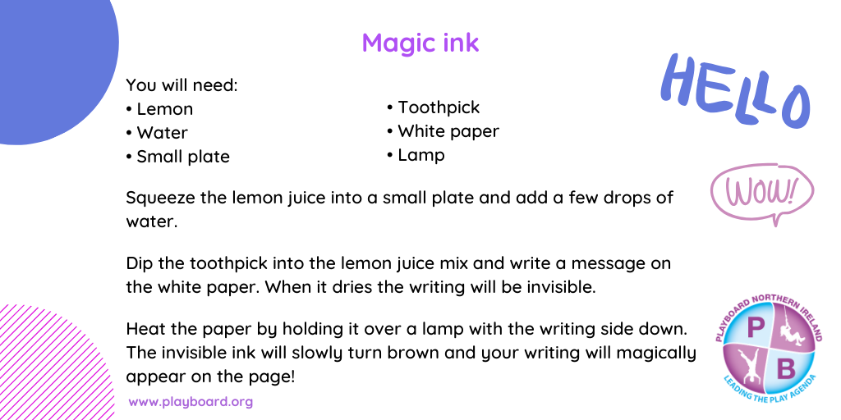
STEM/ ICT:
- Look up https://www.codingireland.ie/WeeklyChallenge. They set weekly challenges with step by step guidelines that teach you coding through the Scratch programme. This was something I had planned on doing with you this year.
RTE Home School Hub
- This is a fantastic resource and covers all subjects on the curriculum. It is well worth watching this and taking part in the activities it offers.
Scoilnet.ie
- This website covers all areas of the curriculum and can have support activities for topics you are covering in maths/English /Irish according to your class. Just use the filters on the home page. It also has a wealth of information for children who may be interested in doing independent project work.

If you as parents are finding things tough during this period and need some advice Barnardos offer a confidential helpline offering support during this crisis : Barnardos Parent Helpline 1800910123
Take a look at gov.ie and the In This Together Section. It offers helpful advice and tips on maintaining mental wellbeing, staying connected and staying active.
Also as your children are now depending more on technology for their entertainment and education please be mindful of what they are looking up and who they are speaking to online. Webwise is an internet usage website that gives lots of good advice to parents.
Remember that if you have any questions don’t hesitate to contact me and there is no pressure to do everything.

