Work for 6th Class: 18th – 22nd May 2020
Dear parents and children,
How are you all doing? You are all so brilliant to keep going through this time and I hear great reports from your parents that you are keeping up with your work. Well done to you all. I am so proud of you. I suppose you know by now that we will not be back until September at the earliest. This saddens me terribly as I will not get to see you all before the summer. I wish things were different for all of us but we have to keep going and keep our spirits up and get the best out of this time.
For the next two weeks we will be doing work as normal, but in the month of June we will be pulling back and doing less in the core subjects and more fun activities - like what we would be doing in June if we were at school. We want you to enjoy yourselves.
I will be going into school to organise your books on Monday and all your books will be returned to you in the coming days. Please do not throw out any of your school books as we will be revising when we come back in September. For now, keep going and doing your best. You are wonderful and I really miss you all.
Please email me to let me know how your children are doing and if there is anything I can do to help them.
Thinking of you all
Denise Nally
Email: mrsdnally@gmail.com
__________________________________________________________________________________
The following is the work for next week:
18th – 22nd May 2020
Maths :
- Tables Champion: Week 27
- Play https://www.topmarks.co.uk/maths-games/hit-the-button or https://mathsframe.co.uk/en/resources/resource/543/Maths-Penalty-Shoot-out it’s for practising your tables.
- New Wave Mental Maths: Week 30
- Planet Maths: Access Planet Maths 6 at https://www.folensonline.ie/ We are not doing the chapter on the circle Ch 23 as you need to do that one with supervision and most of you do not have your mathematical sets with you. We are moving to Ch 24 Using Percentages. Remember a percentage means out of 100. This is a tough chapter. Parts of it are very challenging. All you can do is your best.

Day | Pg | Activity
Monday | 150 | (B) Profit is the money you make on something. E.g. a shopkeeper buys a television from a wholesaler for €200 and sells it for €250. He makes a profit of €50. Do no 1.  In no. 2 you have to work out percentage profit. You do this by putting the profit over the cost price and breaking it down- like a fraction. In my example the profit was €50. The cost price was €200. 50/200 breaks down to ¼. Change the fraction to a percentage – ¼ is 25%. That is your percentage profit. So for no. 2 work out the percentage profit on the clock and see which item had the greater percentage profit – the clock or the chair.  (C)Work out the profit on each item. Use the formula profit divided by cost price, as a fraction, to work these out and then answer the other questions.
Tuesday | 151 | (A) Work out the selling price by adding the profit. Then work out the percentage profit like yesterday.  (B) To work out 8% you can multiply by 0.08 and add it on to the cost price. Then round your answer to the nearest euro.  (C) Loss is the opposite of profit. To work out percentage loss you make a fraction by putting the loss over the cost price and change it to a percentage. E.g. a coat cost €40. It was sold for €36 at a sale. The loss was €4. I put 4/40 and break it down to 1/10. This is 10%. Work out these answers.  (D) Work out the percentage loss using the same method and answer the questions.
Wednesday | 138 | (A) We have done this before – cancelling numbers with numbers below the line. Look at the example in the blue box. It is good.  (B) You have to use the skill from A to be able to do this section. We are working out the cost price now.  Think of the cost price of a coat as 100% . The profit is 25%. So when it was sold at a profit it was 125%.  If the selling price was €45 then that = 125%.  1% = €45/125.  To work out 100% (which is cost price) , do you remember we multiply by 100 over 1. The same idea here. We just multiply the top line by 100. Keep cancelling numbers.  (Cancel 100 with 125) ↘  100% = 45 x 100 = 45 x4 = 9 x 4 = €36 – that is cost price  125 5 1 ↖(Cancel 45 with 5)  Just do B, there is enough in that.
Thursday | 139 | (A) When you earn interest you are getting money from the bank because you have an account with them. The higher the interest rate the more money you get. To work out interest change your percentage to a decimal and multiply. 3% = 0.03 Do no. 1 and 2  (B) In this section you just work out the interest you earn first and then multiply by the number of years. Do no. 1  (C) To calculate the amount you work out the interest you earn, then what it will be after how many years and then add it on to what you had in the bank originally. The example in the blue box is good.  Just do No. 1
Friday | 140 | This is a revision page . Do B and D
- Try to work your way through the chapter. Do not stress about it. Try your best.
- If you cannot access this do not worry we will be going over everything again once we get back to school. Look up Topmarks Percentages online and there are loads of games to play on the topic of percentages.
- Play Mental Up and Prodigy too. A fun way of doing maths.
- Keep going over your tables.
- For children on other maths books work on your Mental Maths and New Wave Mental Maths and work on the online maths games.

English:
- Reading: WorldBookonline.com – this is available for free at the moment. Try to access this through scoilnet.ie. Find a book to read. Read everyday.
- You have Word Wise 6 with you so continue with the next unit. Unit 16 Oliver Twist
Day | Pg | Activity
Monday | 78,79 | Read the excerpt on pg 78 and on pg 79, answer the question on Section A. Do Section B – pick the word nearest in meaning
Tuesday | 79,80 | Section C – do cloze test.  Pg 80 Singular and Plural – follow the rules in the box given to you on the top of the page. Do section A
Wednesday | 80 | Section B, Section C9 remember compound words are made up of two words – Sea/side, tea/spoon
Thursday | 81 | Prefixes are letters that come before a word that change it’s meaning. Do section A , B, and C – you don’t have to put them into sentences in section C
Friday | 81 | Phonics: Put the words in the correct category depending on what kind of a “y” sound they make.  Keep going at the chess from last week. Maybe you are ready to have a game.
- Read at Home: Week 28 –answer the questions orally.
- Spelling List: List 25 learn. Ask your parents to test you orally.
- WOW Words: find 5 words in the dictionary that you never knew about and read their definition
Gaeilge:
- Rí Rá: Aonad 25 (Look up words in dictionary)
- Seo Leat 5: Go to the website: https://my.cjfallon.ie/dashboard/student-resources. Then pick -Primary -5th Class – Gaeilge –Seo Leat –Seo Leat 5. Follow the online instructions. Go to the online book. Chapter 18 Bláthanna agus Beacha ( Flowers and Bees) pg 96
- Work your way through the readin and do your best to translate it. Use your dictionary. It’s is available on line as well ( foclóir.ie). The interactive option gives you the pronunciation of the words. Do your best. Section A – answer the questions. In Section D do the second section “Rith Mugall ar fud na háite” – Mugall ran all over the place. We are going to revise some vocabulary and grammar – go to pg 123. Go back over Mothucháin (Feelings), pg 124 Réamhfhocail, Gluaiseacht, Comparáidí
- For those who cannot access this use Duolingo online and keep practising a little irish every day.
- Also to practise your vocabulary every day. Download the Cúla 4 app on your phone and practise the words and phrases
After this I’m making a choice box. Pick what you want to do:
Fact of the Day:  - Look up a new fact every day | Go Noodle:  - Go Noodle activities | Joe Wicks  - Joe Wicks is a fantastic trainer and is posting brilliant lessons on You Tube. Aim to do one a day.
Journal:  - Keep a diary of your time at home. This will be your creative writing and it will be something you will always remember. | Music:  - Look up the song “High Hopes” by Kodaline. Google their appearance on the Late Late Show. Inspiring. | Meditation:  - The Gratitude Tree – guided meditation. Look it up on You Tube
Art:  - Cut out a large heart shape in cardboard and make holes 1cm apart all over and fill each hole with a daisy from your garden. Make sure the whole heart is covered in daisies. | SPHE:  - Continue with your Gratitude Jar | Art  Look at the attachment after this box
Drama
- Look up the link https://gaietyschool.com/wp-content/uploads/2020/04/Star-Wars.pdf . There are loads of great ideas for drama games and activities to do with the people at home
STEM/ ICT:
- Look up https://www.codingireland.ie/WeeklyChallenge. They set weekly challenges with step by step guidelines that teach you coding through the Scratch programme. This was something I had planned on doing with you this year.

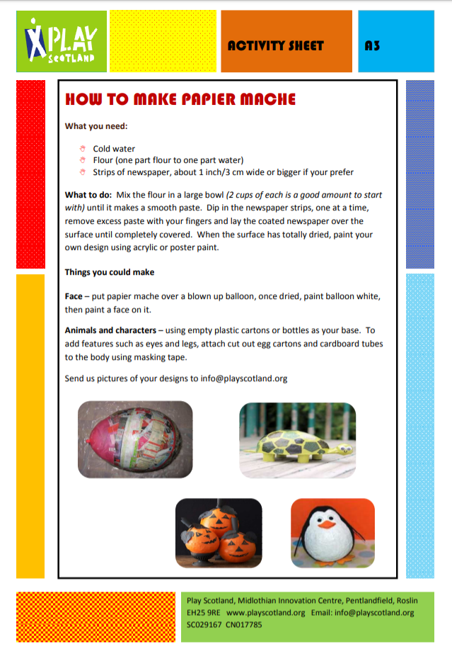
RTE Home School Hub
- This is a fantastic resource and covers all subjects on the curriculum. It is well worth watching this and taking part in the activities it offers.
Scoilnet.ie
- This website covers all areas of the curriculum and can have support activities for topics you are covering in maths/english/irish according to your class. Just use the filters on the home page. It also has a wealth of information for children who may be interested in doing independent project work.

If you as parents are finding things tough during this period and need some advice Barnardos offer a confidential helpline offering support during this crisis : Barnardos Parent Helpline 1800910123
Take a look at gov.ie and the In This Together Section. It offers helpful advice and tips on maintaining mental wellbeing, staying connected and staying active.
Also as your children are now depending more on technology for their entertainment and education please be mindful of what they are looking up and who they are speaking to online. Webwise is an internet usage website that gives lots of good advice to parents.
Remember that if you have any questions don’t hesitate to contact me and there is no pressure to do everything.

